World Health Organization

Vaccination Coverage Cluster Surveys:

Reference Manual Annexes

DRAFT Updated July 2015

Annex A: Glossary of terms

Annex B1: Steps to calculate a cluster survey sample size for estimation or classification

Annex B2: Sample size equations for estimation or classification

Annex B3: Sample size equations for comparisons between places or subgroups and comparisons over time

Annex C: Survey budget template

Annex D: An example of systematic random cluster selection without replacement and probability proportional to estimated size (PPES)

Annex E: How to map and segment a primary sampling unit

Annex F: How to enumerate and select households in a two-stage cluster sample

Annex G: Tips for high-quality training of survey staff

Annex H: Sample survey forms

Annex I: Using information and communication technology (ICT) for digital data capture

Annex J: Calculating survey weights

Annex K: Using software to calculate weighted coverage estimates

Annex L: Estimation of coverage by age 12 months using documented records and caretaker history

Annex M: Graphical display of coverage results

Annex N: Examples of classifying vaccination coverage

Annex O: Missed opportunities for vaccination (MOV) analysis

# Annex A: Glossary of terms

|  |  |
| --- | --- |
| 1-sided test | A statistical test when the difference tested is directionally specified beforehand; for example, testing whether vaccination coverage is higher in one area than in another. For vaccination coverage, in the language of statistical hypothesis tests, the null hypothesis (H0) for a 1-sided test is that coverage is on one side of a threshold and the alternative hypothesis is that coverage is on the other side of that threshold. For example, H0: coverage for DTPCV3 < 80% and the alternative hypothesis (HA): coverage ≥80%. Likewise, the null hypothesis could be that coverage in stratum A is equal to that in stratum B, and the alternative hypothesis could be that coverage in A is greater than coverage in B. |
| 2-sided test | A statistical test when the difference tested is not directionally specified beforehand; for example, testing whether vaccination coverage equals a specific value. In the language of hypothesis testing, the null hypothesis for a 2-sided test is that coverage is equal to a specific value, and the alternative hypothesis is that it is not equal to (either below or above) that value. Likewise, the null hypothesis could be that coverage in stratum A is equal to that in stratum B, and the alternative would be that coverage is not equal, but the alternative would not specify which of the two is higher. |
| Alpha (α) | In parameter estimation, *alpha* is the probability value used to define the precision for estimated confidence intervals. Alpha is typically set to 0.05 and the corresponding confidence intervals are 95% confidence intervals, where 95% = 100 x (1 – α)%.  In hypothesis testing, *alpha* is the probability of making a Type I error: rejecting the null hypothesis when in fact the null hypothesis is true. |
| Beta (β) | In hypothesis testing, *beta* is the probability of making a Type II error: failing to reject the null hypothesis when in fact the null is false. |
| Classification (of coverage) | A quantitative process of assigning a descriptive label to the estimated level of vaccination coverage. Labels might include high, low, adequate, inadequate, above the threshold, below the threshold or indeterminate.  Classification rules that use a single coverage threshold to divide results into two categories often provide one strong conclusion and one weak conclusion. This manual recommends using three classification outcomes: likely to be higher than the threshold, likely to be lower than the threshold, and indeterminate due to limited sample size. |
| Cluster | A collection of elements (for example, households, communities, villages, census enumeration areas, etc.) grouped within defined geographical or administrative boundaries. |
| Cluster survey | A survey in which the population under study is divided into an exhaustive and mutually exclusive set of primary sampling units (clusters), and a subset of those clusters is randomly selected for sampling. |
| Confidence bounds | In this manual, *confidence bounds* mean 1-sided confidence limits. The upper confidence bound (UCB) is the upper limit of the 100 x (1 – α)% confidence interval whose lower limit is 0%; the lower confidence bound (LCB) is the lower end of the 100 x (1 – α)% confidence interval whose upper limit is 100%. Alpha is usually set to 0.05, so we say that we are 95% confident that the population parameter falls above the LCB, or we say that we are 95% confident that it falls below the UCB. |
| Confidence interval (CI) | A range or interval of parameter values around a point estimate that is meant to be likely to contain the true population parameter. If the experiment were repeated without bias many times, with data collected and analysed in the same manner and confidence intervals constructed for each repetition, 100 x (1 – α)% of those intervals would contain the true population parameter.  Stakeholders may have trouble interpreting the confidence interval. Reports often state that the survey team is “95% confident” that the true coverage in the target population falls within the 95% confidence interval obtained from the sample. This may be an acceptable way to present results to policymakers. Strictly speaking, the confidence interval actually means, “If this survey were repeated a very large number of times, using the same target population, the same design, the same sampling protocol, the same questions, and the same analysis, and if a confidence interval were calculated using the same technique, then 95% of the intervals that resulted from those many surveys would indeed contain the true population coverage number”.    We cannot know whether the sample selected for a given survey is one of the 95% of samples that generates an interval containing the true population parameter, or whether it is one of the 5% of samples for which the entire confidence interval lies above or below the true population parameter. However, for practical purposes (and in the absence of important biases), it is acceptable to use the data with the assumption that the true unknown coverage figure is within the estimated 95% confidence interval from the survey sample. |
| Confidence level | A level of confidence is set when computing confidence limits. A level of 95% (or 0.95) is conventionally used but it can be set higher or lower. A level of confidence of 95% implies that 19 out of 20 times the results from a survey using these methods will capture the true population value. |
| Confidence limits | The upper and lower limits of a confidence interval. The interval itself is called the *confidence interval* or *confidence range*. Confidence limits are so called because they are determined in accordance with a specified or conventional level of confidence or probability that these limits will, in fact, include the population parameter being estimated. Thus, 95% confidence limits are values between which we are 95% confident that the population parameter being estimated will lie. Confidence limits are often derived from the standard error (SE). |
| Continuity correction | A correction factor used when a continuous function is used to approximate a discrete function (for example, using a normal probability function to approximate a binomial probability). The sample size equations in Annex B include a continuity correction to make it likely that the resulting survey designs will indeed have α probability of a Type I error and β probability of a Type II error. |
| Design effect (DEFF) | A measure of variability due to selecting survey subjects by any method other than simple random sampling. It is defined as the ratio of the variance with the chosen type of sampling to the variance that would have been achieved with the same sample size and simple random sampling. Usually, cluster surveys have a design effect greater than one, meaning the variability is higher than for simple random sampling.   For a complex sample to achieve a specified level of precision it will be necessary to collect a larger sample than would be true with simple random sampling. The factor by which the sample size must be increased is the DEFF.  The sample size to achieve a desired precision using a complex sample =  DEFF x the sample size to achieve that same precision using a simple random sample.  Some surveys, including the USAID Demographic and Health Surveys (DHS) report a quantity known as DEFT, which is the square root of DEFF.  The DEFF is affected by several factors, including the intracluster correlation coefficient (ICC), sample stratification, the average number of respondents per cluster, and heterogeneity in number of respondents per cluster (Kish, 1965). When the number of respondents per cluster is fairly homogeneous, the DEFF within a stratum can be approximated thus:  DEFF ≈ 1 + (*m* – 1) x *ICC*  where *m* is the average number of respondents per cluster.  Note that if *m* = 1 or *ICC* = 0 then DEFF ≈ 1 and the complex sample will yield estimates that are as precise as a simple random sample. |
| Effective sample size | The *effective sample size* is the number of simple random sample respondents that would yield the same magnitude of uncertainty as that achieved in the complex sample survey. When a survey uses a complex sampling design (stratified or clustered, or both stratified and clustered), the magnitude of sampling variability associated with its results (that is, the width of the 95% confidence interval) is usually different than the magnitude that would have been achieved with a simple random sample using the same number of respondents. The effective sample size is the complex survey sample size divided by the design effect. |
| Estimation (of coverage) | Assessment of the likely vaccination coverage in a population, usually accompanied by a confidence interval. |
| Household | A group of persons who live and eat together, sharing the same cooking space/kitchen. |
| Hypothesis test | When making a formal comparison of coverage, a statistical test done to calculate the likelihood that the observed difference, or a greater difference, might be observed due simply to sampling variability. If that likelihood is very low, the difference is declared to be statistically significant. Coverage can be compared with a fixed programmatic threshold, with coverage in another region or subgroup, or with coverage in an earlier or later period of time. |
| Inferential goal | Statement of the desired level of certainty in survey results. Goals include estimating coverage to within plus or minus a certain percent, classifying coverage with a certain low probability of misclassification, or comparing coverage with a certain low probability of drawing an incorrect conclusion. |
| Intracluster correlation coefficient (ICC) | A measure of within-cluster correlation of survey responses, sometimes known as the intraclass correlation coefficient or the rate of homogeneity (roh). In most survey outcomes of interest, ICC varies from 0 to 1. Outcomes that require access to services or are affected by attitudes of respondents are often spatially correlated, and have higher ICC values than other outcomes. The ICC is an important component of the survey design effect (DEFF), as described in Annex B. Smaller values of ICC yield smaller values of DEFF and vice versa. |
| Minimum detectable difference | The smallest difference in coverage detectable with a test that has α probability of a Type I error and β probability of a Type II error. It is a term from statistical hypothesis testing. |
| Multi-stage complex sample | A survey design with more than one stage of selection to identify the respondents to be interviewed. This might involve randomly selecting clusters, and then randomly selecting segments, and then finally randomly selecting households. It might also involve stratifying the sample and conducting a survey in each stratum, using one or more sampling stages. |
| P-value | A measure of the probability that an observed difference is due to sampling variability alone. A hypothesis test has a null hypothesis (for example, that there is no coverage difference between groups) and an alternative hypothesis (for example, that there is a difference). Even when the null hypothesis is true, and two groups have exactly the same coverage in their target populations, it will still usually be the case that the observed coverage values differ somewhat between the samples. This is sampling variability. For example, one sample estimate of coverage may be a little higher than the true value, and the other sample estimate of coverage may be a little lower than the true value. In a survey, we cannot know with absolute certainty whether the difference is due to sampling variability or due to a true underlying difference in the coverage figures.  The p-value associated with a hypothesis test is the probability that we would observe a test statistic as extreme as (or more extreme than) that in the sample due only to sampling variability, if the null hypothesis were true. When the p-value is low, it is very unlikely that we would draw a sample with a test statistic as extreme as the one observed if the null hypothesis were true. In these cases, we usually reject the null hypothesis and conclude that the alternative hypothesis is likely to be true.  In other words, a low p value such as p < 0.01 means that we can be 99% confident that there really is an underlying difference between the true coverage in the two groups. Traditionally, a cut-off of p < 0.05 is used to indicate that we are confident of a true difference between groups. The smaller the p value, the more confident we are. The p-value is intimately tied to the size of the sample used for comparison. Collecting a larger sample will usually result in a smaller p-value. |
| Power (of a statistical test) | The ability to reject the test’s null hypothesis when it is false. It is sometimes expressed as (1 – β), where β is the probability of a Type II error at a particular specific value of the parameter being tested. See Annex B. |
| Primary sampling unit (PSU) | The group of respondents selected in the first stage of sampling. In this manual, PSUs are usually clusters. |
| Probability-based sample | A selection of subjects in which each eligible respondent in the population has a quantifiable and non-zero chance of being selected. |
| Programmatic coverage threshold | A goal or target for vaccination coverage. In many measles vaccination campaigns or supplementary immunization activity (SIA), for example, the goal is to vaccinate at least 95% of the eligible children; the programmatic threshold would be 95%. Programmatic thresholds are often used as a basis for setting an inferential goal for classification. For example, the goal of the survey may be to identify districts that have SIA coverage below 95%; in theory, these districts would be targeted for remedial action. |
| Quota sample | A sample in which the design calls for obtaining survey data from a precise number of eligible respondents from each primary sampling unit. The classic EPI cluster survey design called for a quota of exactly seven respondents from each of 30 clusters, so the work of the interviewers in a given cluster continued until they had interviewed exactly seven eligible respondents. |
| Random number | A number selected by chance. |
| Sampling frame | The set of sampling units from which a sample is to be selected; a list of names, places, or other items to be used as sampling units. |
| Sampling unit | The unit of selection in the sampling process; for example, a child in a household, a household in a village or a district in a country. It is not necessarily the unit of observation or study. |
| Simple random sample (SRS) | A sample drawn from a set of eligible units or participants where each unit or participant has an equal probability of being selected. |
| Single-stage cluster sample | A sample in which clusters are selected randomly, and within each selected cluster, every eligible respondent is interviewed. |
| Statistical significance | The standard by which results are judged as being likely due or not due to chance. |
| Stratum (plural: strata) | A group for which survey results will be reported and important parameters are estimated with a desired level of precision (the sample size has been purposefully selected to be large enough to do this). We say that a survey is *stratified* if the eligible respondents are divided into mutually exclusive and exhaustive groups, and a separate survey is conducted and reported for each group. Coverage surveys are often stratified geographically (reporting results for different provinces) and demographically (reporting results for urban respondents and rural respondents within each province). When the survey is conducted in every stratum, it is possible to aggregate the data (results) across strata, with care, to estimate overall results. For example, we can combine data across all provinces, weighting appropriately, to estimate representative national level coverage figures.  In some situations, the eligible respondents are divided into groups, and surveys are only conducted in a subset of those groups (for example, only in provinces thought to have especially low coverage). It may not be possible to combine data across the subset of strata that were selected purposefully (that is, not selected randomly) to estimate national level results. |
| Supplementary immunization activity/ activities (SIA) | Any immunization activity conducted in addition to routine immunization services. |
| Survey weight | A value that indicates how much each record or case will count in a statistical procedure. Each record in a survey dataset might be accompanied by one or more survey weights, to indicate how many population level eligible respondents are represented by the respondent in the sample. A statistician calculates the weights in what is usually a multi-step process, as described in Annex J. |
| Two-stage cluster sample | A sample in which clusters are selected randomly, and then within each selected cluster, a second stage of sampling occurs in which a subset of eligible respondents is selected to be interviewed. |
| Type I error | A term from statistical hypothesis testing: to incorrectly reject the null hypothesis. In study design we limit the probability of Type I errors by setting an explicit (usually low) value of the parameter designated α (alpha). It is common to set α=0.05 or 5%. |
| Type II error | A term from statistical hypothesis testing: to incorrectly fail to reject the null hypothesis. In study design we limit the probability of Type II errors at some value of the parameter being tested, by setting an explicit value of the parameter designated β (beta). Note that 1-β equals the statistical power of the test at that value of the parameter. |
| Vaccination coverage | The proportion of individuals in the target population who are vaccinated. |
| Vaccination coverage target | A goal that is prepared for a health facility, stating that states what proportion of individuals in the target population will be vaccinated with specific vaccines in a given time period. |
| Valid dose | A dose that was administered when a child had reached the minimum age for the vaccine, and was administered with the proper spacing between doses according to the national schedule. |

# Annex B1: Steps to calculate a cluster survey sample size for estimation or classification

This annex is the first of three that explain how to calculate the right sample size to meet the survey goals. These three annexes contain the following information:

1. Annex B1 describes six steps to calculate a cluster survey sample size for either coverage estimation or classification purposes. Along the way, the accompanying tables and equations will help readers to calculate several factors, labelled A through E, which may be multiplied together to calculate the target total number of respondents, number of clusters, and number of households to visit, in order to achieve a total survey sample size that will meet the inferential goals of the survey.
2. Annex B2 provides equations for extending the tables in Annex B1. Some readers may wish to understand more precisely how the tables were constructed; they may wish to work through the equations themselves. Other readers may encounter situations with unusual design parameters; the equations in Annex B2 will facilitate extending the tables to include these situations.
3. Annex B3 addresses the less common inferential goal of designing a survey to be well powered to detect differences in coverage – either differences over time or differences between subgroups. This is usually not the primary goal of a vaccination coverage survey but can be an important secondary goal. The tables and equations will help the reader understand the sample sizes needed to conduct formal statistical hypothesis tests to compare coverage.

## B1.1 Changes to the 2005 sample size guidance

This manual recommends using updated Expanded Programme on Immunization (EPI) survey methods to assess vaccination coverage. We favour using larger samples to estimate coverage precisely, and smaller samples to classify coverage, using a weighted probability sample. Therefore, use the guidance included in this updated manual to calculate cluster survey sample sizes, rather than using Appendix C of the 2005 *Immunization Coverage Cluster Survey: Reference Manual*. Specifically, the following are the weaknesses of the 2005 manual:

1. The 2005 manual assumes that every survey will have a design effect of 2, regardless of the number of respondents per cluster. This is misleading. The design effect is a function of the intracluster correlation coefficient (ICC) and the number of respondents per cluster. Survey organizers do not have any control over the ICC, so if they change the design to include more respondents per cluster, the design effect gets larger. It does not remain constant across designs. This means that Tables C1, C2, and C3 of the 2005 manual are not exactly correct, and should not be used.
2. In tests for changes in coverage over time, the 2005 manual assumes that the coverage at the earlier time is given, and was measured precisely with no uncertainty. This is never the case in practice. The earlier coverage will have been estimated using a survey, so there will be a degree of uncertainty due to sampling variability. This means that Table C4 of the 2005 manual is not correct and should not be used.
3. In Table C5, the 2005 manual assumes a 1-sided test when testing for a difference in coverage between places. This is not correct because a 2-sided test (which requires a larger sample size) is almost always the right thing to do when comparing coverage between two subgroups or places measured at the same time. It is common that before the survey, it is truly not known which subgroup has higher coverage, and therefore requires a 2-sided test. It is rare to have strong grounds for believing that one subgroup has higher coverage than another, so the 2-sided test is a more conservative approach.

For these reasons, we strongly recommend using the tables and equations in this new 2015 reference manual. As always, if you have questions, we recommend consulting a sampling statistician during the design and analysis phases of a survey.

**A Short Note on Sample Size Guidance in this 2015 Reference Manual**

The sample size guidance in this annex has been updated to address the issues listed above, and to be consistent with sample size advice from a single modern source: *Statistical Methods for Rates and Proportions* (Third Edition, 2003) by Joseph L. Fleiss, Bruce Levin, Myunghee Cho Paik. This annex refers to specific equations and pages in that text.

## B1.2 Calculating a cluster survey sample size for purposes of estimation or classification

Annex B1 concentrates on designing surveys for the purpose of coverage estimation or classification. *Estimation* means estimating coverage with a desired precision – that is, a desired maximum half-width of the 95% confidence interval. *Classification* refers to conducting one (or more) 1-sided hypothesis test(s) to compare coverage with a fixed threshold, and drawing a strong conclusion about whether the population coverage is likely to be on one side of that threshold (that is, above or below).

We recommend a process with six steps to calculate a cluster survey sample size for estimation or classification (note: the tables in Annexes B1–B3 are numbered according to the step or variable they pertain to, rather than traditional sequential numbering):

1. Calculate the number of strata where the survey will be conducted. We refer to this later using the letter A.
2. Calculate the effective sample size (ESS). This is called B in later calculations.
3. Calculate the design effect (DEFF). This is called C in later calculations.
4. Calculate the average number of households to visit to find an eligible child. This is called D.
5. Calculate an inflation factor to account for nonresponse. This is called E.
6. Use the values assembled in steps 1–5 to calculate important quantities for survey planning and budgeting.

The first few times through the process of calculating a cluster survey sample size, it may be helpful to use the *long form* in the first pages of this annex, which details each step. As you become familiar with the terms and quantities, you will likely use the two abbreviated worksheets that appear near the end of Annex B1.

### Step 1: Calculate the number of strata where the survey will be conducted

A *stratum* (plural *strata*) is a subgroup of the total population. It might be a subgroup defined by geography, like occupants of the same province, or it might be a demographic subgroup, like women or children aged 12–23 months. When the survey is finished, a separate coverage estimate will be calculated for each stratum in the survey.

If the survey steering group wishes to calculate results for each district within each province, and each province within the nation, then the survey has three levels of geographic strata. It is helpful to think of the entire endeavour as a survey in each district, repeated across all districts. In that case, the number of districts is the number of strata. For example, Burkina Faso has 13 provinces and 63 health districts. If a survey were designed to estimate vaccination coverage in every district, it would be like conducting 63 separate surveys. The results from each of these surveys could be combined to estimate coverage in their respective provinces and in the entire nation.

Sometimes results are reported for demographic subgroups **within geographic subgroups**. Sometimes this means that the sample size in each demographic subgroup needs to be large enough to make precise estimates within each geographic stratum.

If the total population is to be divided into subgroups and surveys are to be conducted in each subgroup, calculate the total number of subgroups and write it in box A below. Otherwise, if the results will be reported only in one grand total result (for example, reported only at the national level), and not broken out with precision goals in subgroups, then write “1” in Box A below. Table A (near the end of Annex B1) might also be helpful. Fill it out, and write the number of strata in Box A below. Proceed to Step 2.

1. NStrata = _________

### Step 2: Calculate the effective sample size (ESS)

Although cluster samples require a larger total sample size than simple random samples, cluster samples are less expensive than simple random samples. This is because they require field staff to visit fewer locations, and staff can collect data from several respondents per location.

This step calculates the number of survey respondents required in order to meet the inferential goal of the survey, *if a* *simple random sample* of respondents were done. In later steps, this is called the *effective sample size (ESS)* and will be inflated to account for the clustering effect.

First, decide whether you wish to calculate precise results in each stratum (requiring higher sample sizes), or whether less precise results are adequate at the lowest level of stratum (for example, districts) as long as the results are quite precise when aggregated at the province and national levels.

*Do you require very precise results for each stratum?*

Circle answer: YES / NO

If yes, complete the section titled “Calculating ESS for estimating coverage”. If no, complete the section titled “Calculating ESS for classifying coverage”. If an inferential goal of the survey is to compare results from two surveys (such as over time or between two places), then read Annex B3 to obtain the ESS for each of the two surveys, and write both values in Box B below.

**Calculating ESS for estimating coverage**

If results are to be estimated to within a given precision level at the lowest level of strata (for example, districts), specify the expected coverage level for the vaccine or other measure of most interest, and the precision with which the coverage should be estimated. Write those values below:

Expected coverage: ________%

Desired precision level: ±_______%

If you are estimating coverage for several equally important measures, write in the expected coverage for the measure that is likely to be nearest 50% coverage. Use Table B-1 (near the end of Annex B1) to look up the ESS based on your expected coverage and desired precision level. For example, if the outcome of interest is the third dose of a DTP-containing vaccine (DTPCV3), expected coverage is 75%, and you wish to have precision of ± 5%, Table B-1 indicates that ESS = 340.

Write the ESS in Box B below. Proceed to Step 3.

(B) ESS = _________

**Calculating ESS for classifying coverage**

If sufficient resources are not available to obtain very precise results in every stratum, it can be helpful to select a sample size based on its power to *classify* coverage in those strata as being higher or lower than a fixed programmatic threshold. The results will be a coverage point estimate and confidence region, and coverage will either be:

* very likely lower than the programmatic threshold,
* very likely higher than the threshold, or
* not distinguishable from the threshold with high confidence using the sample size in this survey.

To select the effective sample size, identify the threshold of interest and then specify the desired likelihood that the survey correctly classifies strata whose coverage falls a certain distance above or below that threshold. Of course, it would be nice to correctly classify strata 100 percent of the time, but it is difficult to guarantee because of sampling variability: some samples of respondents will yield many vaccinated children, while other samples of the same size, collected in a similarly random fashion, will by chance yield fewer vaccinated children. That is the nature of sampling. Although we cannot guarantee that a small sample will correctly classify every stratum, we can select a sample size that is very likely to make correct classifications when coverage is a specified distance above or below the threshold. This design principle is similar to that used in lot quality assurance sampling (LQAS), but the results here are likely to be clearer than those from clustered LQAS.

This design requires the following five input parameters to be specified in order to look up the corresponding ESS:

1. The **programmatic threshold** is a coverage level of interest. It might be the coverage target.
2. **Delta** is a coverage percent defining a distance from the programmatic threshold. If the true coverage is at least *delta* points away from the programmatic threshold, we choose a sample size likely to classify those districts as having coverage that is likely different than delta.

For example, if the programmatic threshold is 80% and delta is 15%, then when coverage is below 65% (80 – 15) you want the survey results to be very likely to show that coverage is very likely lower than 80%. Similarly, when coverage is above 95% (80 + 15) you want the survey results to be very likely to show that coverage is very likely above 80%.

1. **Direction** indicates whether you are specifying the statistical power for correctly classifying strata with coverage delta percent **above** the programmatic threshold, or delta percent **below** the programmatic threshold. If the threshold of interest is 80% and you want to be very sure to correctly classify strata with coverage above 90%, then the direction is *above* and you should use Table B-3 to look up the ESS. If the direction is *below* then use Table B-2. Note that the effective sample sizes in B-2 are larger than those in B-3, so the conservative choice is to use Table B-2 unless your primary focus is detecting differences above the programmatic threshold.
2. **Alpha (α)** is the probability that a stratum with true population coverage at the programmatic threshold will be mistakenly classified as very likely to be above or below that threshold.
3. **Beta (β)** is the probability that a stratum with true population coverage delta points away from the threshold (Table B-2 for *below* and Table B-3 for *above*) will be mistakenly classified as having coverage not different than the threshold. The quantity 100% – β is the *statistical power* of the classifier.

Write the values below:

Programmatic threshold: _______%

Delta: _______% (choose 1%, 5%, 10%, or 15%)

Direction: _____ (above or below)

α ______% (choose 5% or 10%)

β _______% (choose 10% or 20%)

Power = (100% – β) = _____ % (either 80% or 90%)

Use Tables B-2 or B-3 (near the end of Annex B1) to look up the ESS based on the programmatic threshold, delta, direction, α, and power inputs. Write the ESS in Box B below. Proceed to Step 3.

(B) ESS = _________

### Step 3: Calculate the design effect (DEFF)

When the survey design is based on a cluster sample instead of a simple random sample, we require more respondents in order to achieve the statistical precision specified in Step 2 above. The *design effect* (DEFF) is a factor that tells us how much to inflate the ESS to achieve the precision we want with a cluster sample. The DEFF is a function of the target number of respondents per cluster *(m)* and the ICC.

Two input parameters are required to calculate the DEFF. One is largely under your control, and the other is not.

1. The target number of respondents per cluster *(m)* will often be between 5 and 15, and is influenced by the number of people in each field data collection team and by the length of the survey. For many surveys, start with a value of 5 or 10 and adjust it slightly when revising the design. Consider adjusting *m* to be smaller if the number of households that must be visited per cluster (D x E x *m*)[1] is too many for a single team to accomplish in a day. Consider adjusting *m* to be larger if (D x E x *m*) represents much less than a full day of work for a field team. Also, keep in mind the expected number of eligible respondents in a cluster. If the target population is a small subpopulation, such as 12–23 month olds, then clusters based on enumeration areas (often approximately 200 households in size) may, on average, have a small number of total eligible respondents.
2. Respondents from the same cluster tend to give similar responses to each other. They often come from similar socio-economic conditions, have the same access to services and share the same attitudes toward those services. Therefore, the responses within a cluster are likely to be correlated, and the degree of correlation affects statistical power and sample size. The *intracluster correlation coefficient* *(ICC)* is a measure of the correlation of responses within clusters. For survey work, it varies from 0 to 1. This figure affects the sample size calculation and is not usually known in the planning stage; the true ICC figure for any survey will only be well estimated **after the data have been collected**. For planning purposes, use either an observed figure from a recent survey of the same topic in a similar study area, or a conservative value that is slightly larger than what is likely to be observed in the field.

For post-campaign surveys, an ICC between 1/24 and 1/6 is probably appropriate, with the larger value (1/6 = 0.167) being more conservative. For routine immunization surveys, an ICC between 1/6 and 1/3 is probably appropriate, with 1/3 being more conservative.

Specify the average number of eligible children sampled per cluster *(m)* and the ICC. Write the values below:

m = _______

ICC = _________

Use Table C (near the end of Annex B1) to look up the DEFF based on the *m* and ICC just specified, or simply calculate it using the following approximate equation:

DEFF = 1 + (m – 1)*ICC

Write the DEFF in Box C. Proceed to Step 4.

(C) DEFF = _________

### Step 4: Calculate the average number of households to visit to find an eligible child

Not every household in the cluster will have a child eligible for the survey. The number of households that must be visited to find at least one eligible child (NHH to find eligible child) should be estimated before survey work begins. This number will help survey planners know if the cluster (or cluster segment) is big enough to find the number of eligible children needed for the survey, as well as to allow appropriate time to complete the work in each cluster.

If NHH to find eligible child is known or easily found from recent census or survey data, that number should be written in Box D below, and the reader can proceed to Step 5. If it is not known, it can be estimated in various ways. Birth rates, infant mortality rates, and household size are some variables that may be easy to obtain from recent census or survey data to help estimate NHH to find eligible child. Consider the following equations. Equation B1-1 estimates NSurvived at birth per HH, which is used in Equation B1-2 to estimate NHH to find eligible child.

(B1-1)

$N_{HH to find eligible child}=\frac{1}{N_{Survived at birth per HH}}$ (B1-2)

*YC* is the number of years of eligible children in the cohort, *BR* is the birth rate per 1000 population, *HS* is the average household size, and *IM* is the infant mortality rate per 1000 live births. The first term in Equation B1-1 estimates the number of live births per household, and the second term estimates the proportion of live births that survived to their first birthday. The multiplier YC assumes everyone survives after their first birthday, so Equation B1-2 underestimates NHH to find eligible child. Round the result from Equation B1-2 up to the nearest whole number.

Example 1: Suppose a survey is scheduled to occur in Ethiopia estimating coverage levels for a single year cohort, children 12–23 months. In the 2011 Ethiopia Demographic Health Survey, the birth rate per 1000 population was estimated to be 34.5, the infant mortality rate per 1000 live births was estimated to be 59, and the average household size was estimated to be 4.6. The number of years of eligible children in the cohort is 1. Using Equations B1-1 and B1-2:

$$N_{Survived at birth per HH}= \frac{1 x 34.5}{(\frac{1000}{4.6})}x\frac{1000-59}{1000}=0.149$$

$$N_{HH to find eligible child}=\frac{1}{0.149}=6.7$$

An estimated 1 in every 7 households will have an eligible child for this survey.

Example 2: In Example 1, if the cohort of interest was for 1–5 year olds, then YC = 5 – 1 = 4 and Equations B1-1 and B1-2 yield:

$$N_{Survived at birth per HH}= \frac{4 x 34.5}{(\frac{1000}{4.6})}x\frac{1000-59}{1000}=0.6$$

$$N_{HH to find eligible child}=\frac{1}{0.6}=1.67$$

Expanding the birth cohort translates to more households with an eligible child for the survey. In this example, an average of two households would need to be visited to find an eligible child.

Example 3: In Example 1, if the birth cohort was for 1–15 year olds, then YC = 15 – 1 = 14 and Equations B1-1 and B1-2 yield:

$$N_{Survived at birth per HH}= \frac{14 x 34.5}{\left(\frac{1000}{4.6}\right)}x\frac{1000-59}{1000}=2.09$$

$$N_{HH to find eligible child}=\frac{1}{2.09}=0.48$$

Expanding the birth cohort dramatically translates to even more households with an eligible child for the survey. In this example, every household is estimated to have an eligible child.

Using Equations B1-1 and B1-2, estimate NHH to find eligible child and write it in Box D below. Consult a statistician or the census bureau if the rates used in Equations B1-1 and B1-2 are not known or not well estimated, and if a different way to estimate NHH to find eligible child is needed. Discussions with colleagues who have recently completed national child health surveys (malaria, nutrition, etc.) may also be helpful.

(D) NHH to find eligible child = __________

### Step 5: Calculate an inflation factor to account for nonresponse

Some households that have a child eligible for survey participation may not participate, either because the family lives elsewhere at the time of year the survey occurs, or the caregiver is not at home when the data collection team visits, or because the caregiver is home but refuses to participate. Therefore, although there may be an eligible respondent in every seventh home, the team may need to visit eight or nine homes, on average, per completed interview.

Based on recent survey experience in the same country and appropriate insight about the seasonal patterns of mobility, specify the percentage of eligible households (those with an eligible child) that are likely to be *excluded* (PHH eligible and not respond). Write the value below:

PHH eligible and not respond = _________%

Use Table E (near the end of Annex B1) to look up the appropriate inflation factor (INonresponse), or calculate it using the following equation:

INonresponse = 100/(100 – PHH eligible and did not respond)

Write the inflation factor in Box E below. Do not round this result. Proceed to Step 6.

(E) INonresponse = ___________

### Step 6: Use the values above to calculate quantities needed for survey planning and budgeting

Copy the quantities A–E and *m* from the earlier sheets onto into this these boxes:

|  |  |  |  |  |  |
| --- | --- | --- | --- | --- | --- |
|  |  |  |  |  |  |
| A.  NStrata | B.  ESS | C.  DEFF | D.  NHH to find eligible child | E.  INonresponse | *m*  (from Step 3) |

1. Calculate the total completed interviews needed (Ncs):

Ncs = ________ x ________ x ________ = ________

(A) (B) (C)

1. Using Ncs just calculated, and (D) and (E) in the boxes above, calculate the total number of households to visit to get the necessary completed interviews:

NHH to visit = ________ x ________ x ________ = ________

(Ncs) (D) (E)

1. Using (B) through (E) in the boxes above, calculate the target number of households to visit in each stratum:

NHH to visit per stratum = ________ x ________ x ________ x ________ = ________

(B) (C) (D) (E)

1. Using (B) (C) and *m*, calculate the number of clusters needed per stratum:

Nclusters per stratum = ________ x ________ / ________ = ________

(B) (C) *m*

1. Calculate the total households to visit per cluster:

NHH per cluster = ________ x ________ x ________ = ________

(D) (E) *m*

1. Calculate the total number of clusters in the survey:

Nclusters total = ________ x ____________ = ________

(A) Nclusters per stratum

### Discussion

If the quantities calculated in Step 6 are compatible with established budgets and timelines, then stop here and use those values as your survey’s sample sizes. Congratulations on designing your survey!

If the quantities calculated above are too expensive or would take too long, there are several modifications you can make to try to reduce the sample size.

1. In Step 1, if the number of strata to survey is large, consider reducing this number. For example, if results were originally desired by province, age group, and gender, consider stratifying only by province. You can still summarize the analysis by province, age group, and gender, but those sub-sub-subgroup results will not have the high precision or power needed to classify.
2. In Step 2, was the ESS calculated using estimation with desired precision? If so, consider:
3. Relaxing the level of precision with which the coverage needs to be estimated (for example, relax from ±3% to ±5%, ±7%, or ±10%).
4. If relaxing the precision still does not produce feasible sample sizes, consider using the classification methods in Table B-2 instead of estimating with a desired precision level from Table B-1.
5. In Step 2, if the ESS was calculated using classification methods, consider:
   1. increasing delta (that is, increasing the difference from the programmatic threshold for which a change is likely to be detected)
   2. increasing *alpha*
   3. increasing *beta* (that is, lowering the desired power)
6. In Step 3, consider modifying *m* (the average number of respondents per cluster). Specifically, consider adjusting *m* to be smaller if the number of households needed per cluster (D x E x *m*) is too many for a single team to accomplish in a day. Consider adjusting *m* to be larger if (D x E x *m*) represents much less than a full day of work for a field team. Increasing *m* may result in surveying fewer clusters while decreasing *m* may result in less time (and potentially cost) in a particular cluster.

### Introduction to the sample size worksheets on the following pages

The first few times through this process, it will be helpful to use the step-by-step guidance presented thus far in the annex to understand the sample size inputs and outputs A–E. As you gain familiarity with the process and the quantities, you may wish to move to a single sheet form for doing these calculations. The worksheet on the following page consolidates the above six steps considerably. As your skills progress even further, you may wish to compare multiple survey designs on a single sheet. In that case, use the quick comparison worksheet on the page after to compare up to ten designs simultaneously.

**Cluster Survey Sample Size: Single Page Worksheet**

|  |  |  |  |  |  |
| --- | --- | --- | --- | --- | --- |
| Step | Letter | Quantity | Inputs | (Specify Inputs) | Output using Table or Equation |
| 1 | (A) | Number of Strata (NStrata) | (no inputs) | |  |
| 2 | (B) | Effective Sample Size (ESS) – Estimation with Desired Precision | Expected coverage |  |  |
| Precision level |  |
| Effective Sample Size (ESS) – Classification | Programmatic threshold |  |
| Delta & Direction |  |
| Alpha |  |
| Power |  |
| 3 | (C) | Design Effect (DEFF) | *m* |  |  |
| ICC |  |
| 4 | (D) | Number of Households to Visit to Find an Eligible Child (NHH to find eligible child) | (no inputs) | |  |
| 5 | (E) | Inflation Factor for Nonresponse (INonresponse) | PHH eligible and not respond |  |  |

1. Calculate the total number of completed interviews needed:

Ncs = ________ x ________ x ________ = ________

(A) (B) (C)

1. Calculate the total number of households to visit to get the necessary completed interviews:

NHH to visit = ________ x ________ x ________ = ________

(Ncs) (D) (E)

1. Using (B) through (E) in the boxes above, calculate the target number of households to visit in each stratum:

NHH to visit per stratum = ________ x ________ x ________ x ________ = ________

(B) (C) (D) (E)

1. Using (B), (C), and *m*, calculate the number of clusters needed per stratum:

Nclusters per stratum = ________ x ________ / ________ = ________

(B) (C) *m*

1. Calculate the total households to visit per cluster:

NHH per cluster = ________ x ________ x ________ = ________

(D) (E) *m*

1. Calculate the total number of clusters in the survey:

Nclusters total = ________ x ____________ = ________

(A) Nclusters per stratum

**Cluster Survey Sample Size: Quick Comparison Worksheet**

|  |  |  |  |  |  |  |  |  |  |  |  |  |  |  |  |  |  |  |  |  |  |  |
| --- | --- | --- | --- | --- | --- | --- | --- | --- | --- | --- | --- | --- | --- | --- | --- | --- | --- | --- | --- | --- | --- | --- |
|  | | Step 1 | | Step 2  (Choose a Method to Calculate ESS) | | | | | | | Step 3 | | | Step 4 | Step 5 | | Step 6 | | | | | |
|  | |  | (A) | Estimation  Method | | Classification  Method | | | | (B) |  |  | (C) | (D) |  | (E) | Ncs | NHH to visit | NHH to visit per stratum | Nclusters per stratum | Nhh per cluster | Nclusters total |
| Design # | Description of Strata | | NStrata | Expected threshold | Desired precision | Programmatic threshold | Delta & direction | Alpha | Power | ESS | *m* | ICC | DEFF | NHH to find eligible child | PHH eligible and not respond | INonresponse | (A) X (B) x (C) | (A) x (B) x (C) x (D) x (E) | (B) x (C) x (D) x (E) | (B) x (C) / *m* | (D) x (E) x *m* | (A) x Nclusters per stratum |
| 1. |  | |  |  |  |  |  |  |  |  |  |  |  |  |  |  |  |  |  |  |  |  |
| 2. |  | |  |  |  |  |  |  |  |  |  |  |  |  |  |  |  |  |  |  |  |  |
| 3. |  | |  |  |  |  |  |  |  |  |  |  |  |  |  |  |  |  |  |  |  |  |
| 4. |  | |  |  |  |  |  |  |  |  |  |  |  |  |  |  |  |  |  |  |  |  |
| 5. |  | |  |  |  |  |  |  |  |  |  |  |  |  |  |  |  |  |  |  |  |  |
| 6. |  | |  |  |  |  |  |  |  |  |  |  |  |  |  |  |  |  |  |  |  |  |
| 7. |  | |  |  |  |  |  |  |  |  |  |  |  |  |  |  |  |  |  |  |  |  |
| 8. |  | |  |  |  |  |  |  |  |  |  |  |  |  |  |  |  |  |  |  |  |  |
| 9. |  | |  |  |  |  |  |  |  |  |  |  |  |  |  |  |  |  |  |  |  |  |
| 10. |  | |  |  |  |  |  |  |  |  |  |  |  |  |  |  |  |  |  |  |  |  |

#### Table A. Stratification schemes for the survey

|  |  |  |  |
| --- | --- | --- | --- |
| Strata at Lowest Level Estimated | Number of Strata | Example: Burkina Faso SIA – 3 age cohorts | Your Results |
| National results – all strata combined | 1 | **1** |  |
| National results – stratified by demographic | # of demographic groups | **3**  **(1-4, 5-9, 10-14 years)** |  |
| Province results – all strata combined | e.g. # of provinces | **13** |  |
| Province results – stratified by demographic | e.g. (# of provinces) x (# of demographic groups) | **39** |  |
| District results – all strata combined | e.g. # of districts | **63** |  |
| District results – stratified by demographic | e.g. (# of districts) x (# of demographic groups) | **189** |  |

The following examples parallel the levels outlined in Table A and illustrate how to calculate the number of strata.

Example 1a: Coverage estimates are needed for Ethiopia. The number of strata for this survey is thus 1.

Example 1b: Coverage estimates for Kano, Nigeria are needed. The number of strata for this survey is thus 1.

Example 2a: Coverage estimates by geographic area (urban versus rural) are needed. The number of strata for this survey is thus 2.

Example 2b: Coverage estimates by age group (1–4, 5–9, and 10–14 years old) are needed. The number of strata for this survey is thus 3.

Example 2c: Coverage estimates by sex (female versus male) are needed. The number of strata for this survey is thus 2.

Example 3: Post-measles campaign survey in 13 provinces. The number of strata for this survey is 13.

Example 4: Post-measles campaign survey in 11 provinces, with the target audience stratified by age: 1– 4, 5–9, and 10–14 years old. The number of strata for this survey is 11 x 3 = 33.

Example 5: Coverage estimates by local government areas (LGAs) in Kano, Nigeria are needed. The number of strata for this survey is the number of LGAs in Kano, which is 44.

Example 6: Coverage estimates by zone broken out by urban versus rural in Ethiopia are needed. The number of zones in the survey is 96 (three excluded because of security). The number of strata for this survey is 96 x 2 = 192.

#### Table B-1. Effective sample size (ESS) by expected coverage and desired precision for the 95% confidence interval (CI)

|  |  |  |  |  |  |  |  |
| --- | --- | --- | --- | --- | --- | --- | --- |
|  |  | Expected Coverage | | | | | |
|  |  | 50-70% | 75% | 80% | 85% | 90% | 95% |
| Precision for  95% CI | ±3% | 1,097 | 892 | 788 | 663 | 518 | 354 |
| ±4% | 622 | 517 | 461 | 394 | 315 | 227 |
| ±5% | 401 | 340 | 306 | 265 | 216 | 162 |
| ±6% | 280 | 242 | 220 | 192 | 160 | 132 |
| ±7% | 207 | 182 | 167 | 147 | 125 | 110 |
| ±8% | 159 | 143 | 131 | 117 | 101 | 93 |
| ±9% | 126 | 115 | 106 | 96 | 83 | 81 |
| ±10% | 103 | 95 | 88 | 80 | 70 | 70 |

Note 1. These sample sizes are consistent with the sample size equations on page 35 of Fleiss, Levin, and Paik (2003), *Statistical Methods for Rates and Proportions, 3rd edition,* John Wiley & Sons, Inc., Hoboken, New Jersey. Note that within any row, the ESS does not change for coverage levels between 50% and 70%. This is not a mistake in the table, but rather a result of using a conservative upper bound of *k* = 1 in calculations for these values. As *p* moves away from 50%, *k* can be scaled down to something < 1 and a reduced sample size results.

Note 2. Recall from the 2005 *EPI Cluster Survey Guidelines* that when the design effect is 2, a sample of 30 x 7 = 210 will yield confidence intervals no wider than ±10%. The highest entry in this table for a precision of ± 10% is 103. If we multiple 103 by a design effect of 2, we obtain a total sample size per stratum of 206, which is essentially the same as 210. So Table B-1 is consistent with the 2005 *EPI Cluster Survey Guidelines* in that important respect.

Note 3. If the expected coverage is less than 50%, this table can still be used to determine the effective sample size (ESS). Subtract the expected coverage from 100% and look up the ESS for that value. For example, if the expected coverage is 15%, look up the ESS for 100% – 15% = 85%. If the coverage is greater than 95%, use the ESS for 95%. For coverage between two values in the table, to be conservative, look up the ESS for the expected coverage that is closer to 50%. For example, if expected coverage is 73%, look up the ESS using 70%. If expected coverage is 23%, then 100 – 23% = 77% and so look up the ESS using 75%.

Note 4. Table B-1 assumes that the population of eligible respondents is very large. When studying coverage in strata with small populations (for example, on a small island), it may be possible to achieve the desired precision with a smaller sample by incorporating a so-called *finite population correction*. Calculate the effective sample size using Table B-1 and estimate the total target population for the survey (*N*) (population of children aged 12–23 months in the stratum) and then calculate the revised ESS using the following formula:

$$ESS'≥\frac{ESS}{1+\frac{ESS-1}{N}}$$

Note that when the target population *N* is large compared with the ESS from Table B-1, then *ESS’* (corrected effective sample size) will be essentially equal to *ESS*. But if *ESS* is an appreciable proportion of *N* then ESS’ will be smaller than *ESS* and the difference may result in a less expensive survey. Check with a sampling statistician; if the finite population correction is appropriate, use the value of *ESS’* rather than *ESS* for the factor A in subsequent calculations in this annex. Note that if the finite population correction is used to determine sample size, it should also be incorporated into the analysis. Be sure to specify the right options in the analysis software to incorporate *N* into the calculations.

Figures B1-1 through B1-3 illustrate the 95% confidence intervals that would be achieved with 24 of the samples from Table B-1. Figure B1-1 shows eight estimated probability distributions where the sample proportion is 50%. Each distribution is truncated at the limits of the 95% confidence interval. The figure also shows the 95% upper confidence bound and 95% lower confidence bounds using small tick marks.

Figure B1-2 shows the comparable distributions that would result from samples where coverage was 80%, and Figure B1-3 shows comparable distributions for the designs from Table B-1 where sample coverage is 95%. Distributions with coverage >50% are asymmetric, with the longer tail pointing toward 50%. The figures show that the designs in Table B-1 achieve the precision goals specified along the vertical axis of the table.

#### Figure B1-1. 95% confidence intervals for eight samples where coverage = 50%

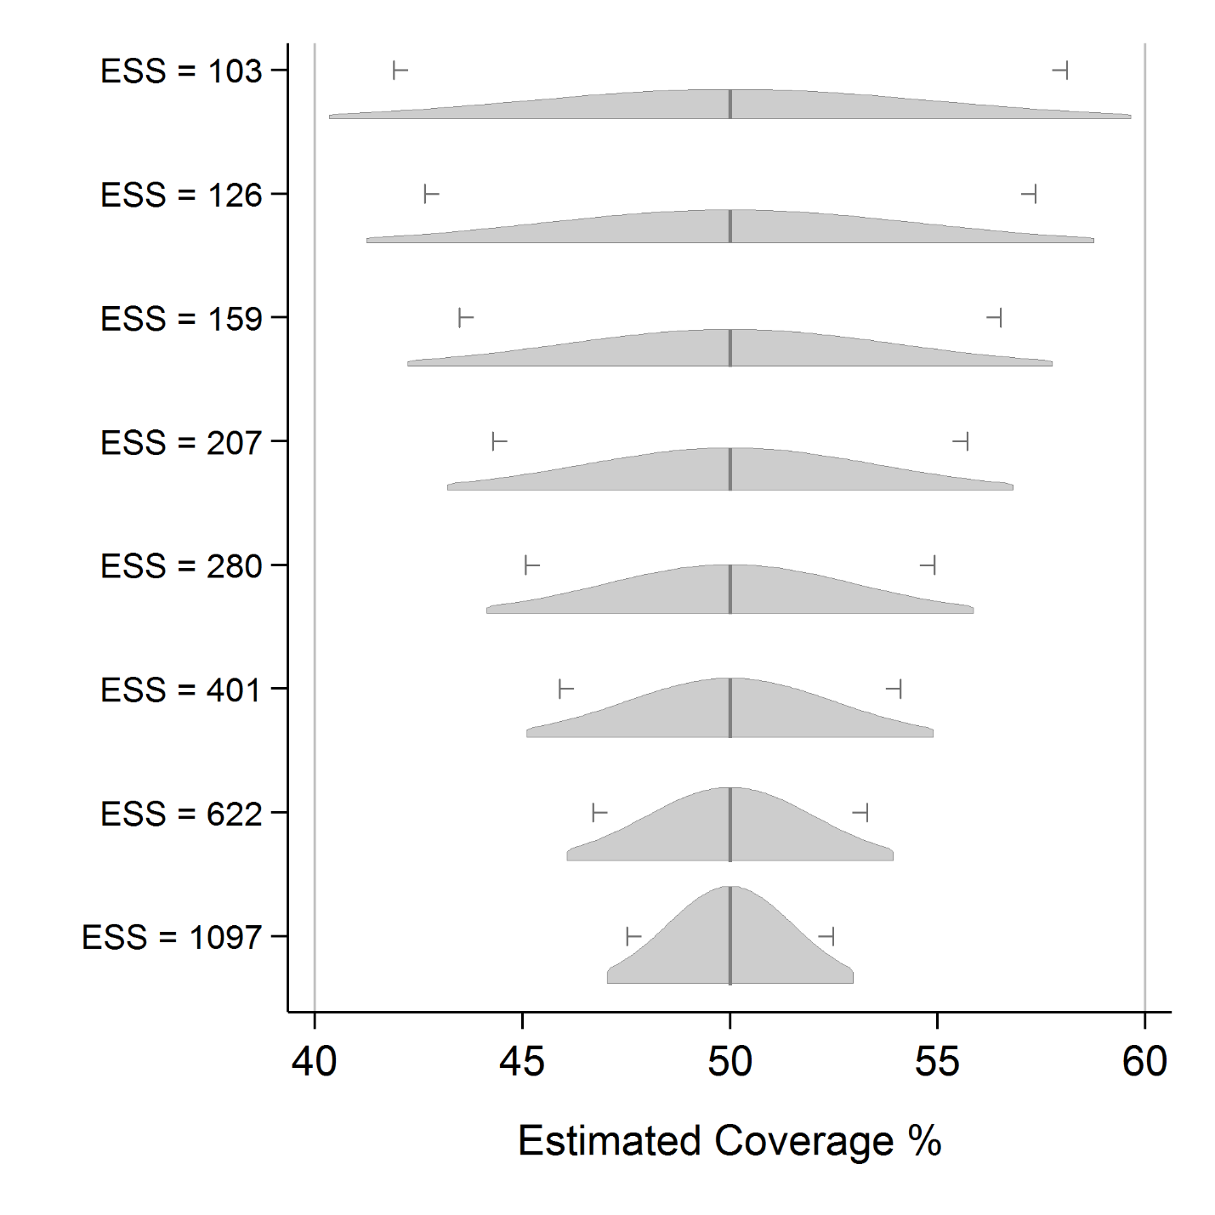Note: ESS = Effective Sample Size; distributions are plotted using equal areas, so those with narrow confidence intervals are taller than those that are wide. For each distribution, the standardized area represents 95% confidence.

#### Figure B1-2. 95% confidence intervals for eight samples where coverage = 80%

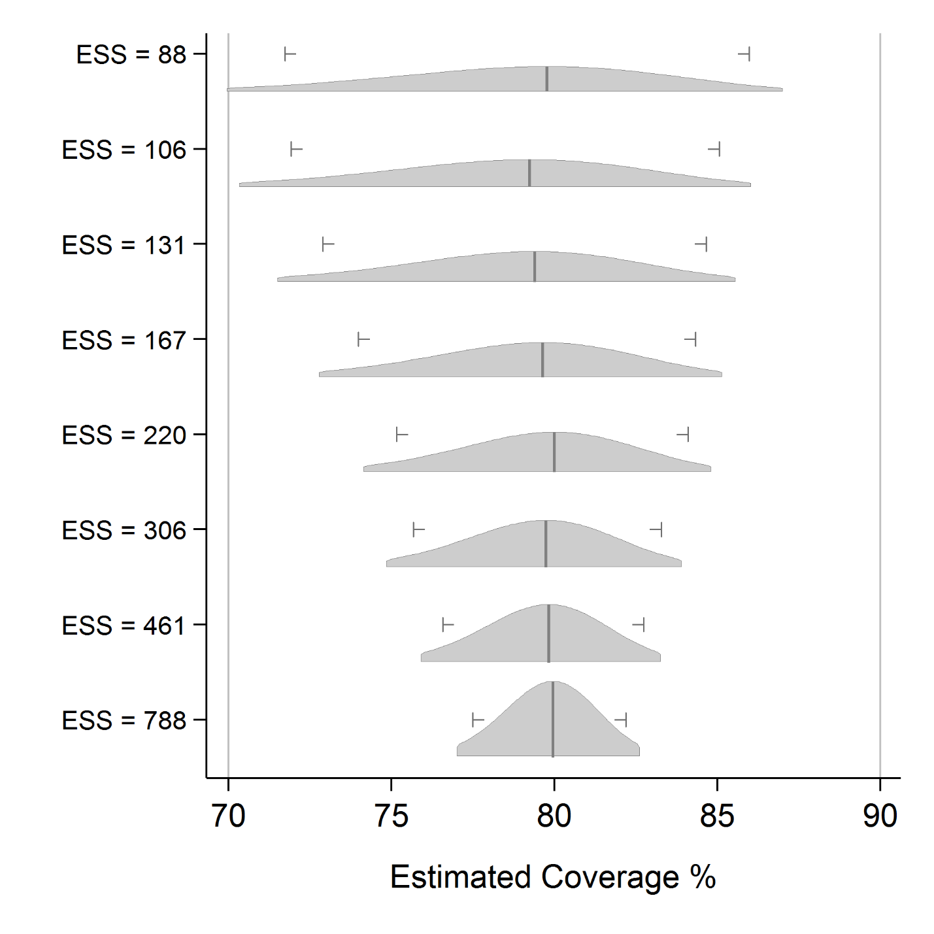

#### Note: ESS = Effective Sample Size; distributions are plotted using equal areas, so those with narrow confidence intervals are taller than those that are wide. For each distribution, the standardized area represents 95% confidence.Figure B1-3. 95% confidence Intervals for eight samples where coverage = 95%

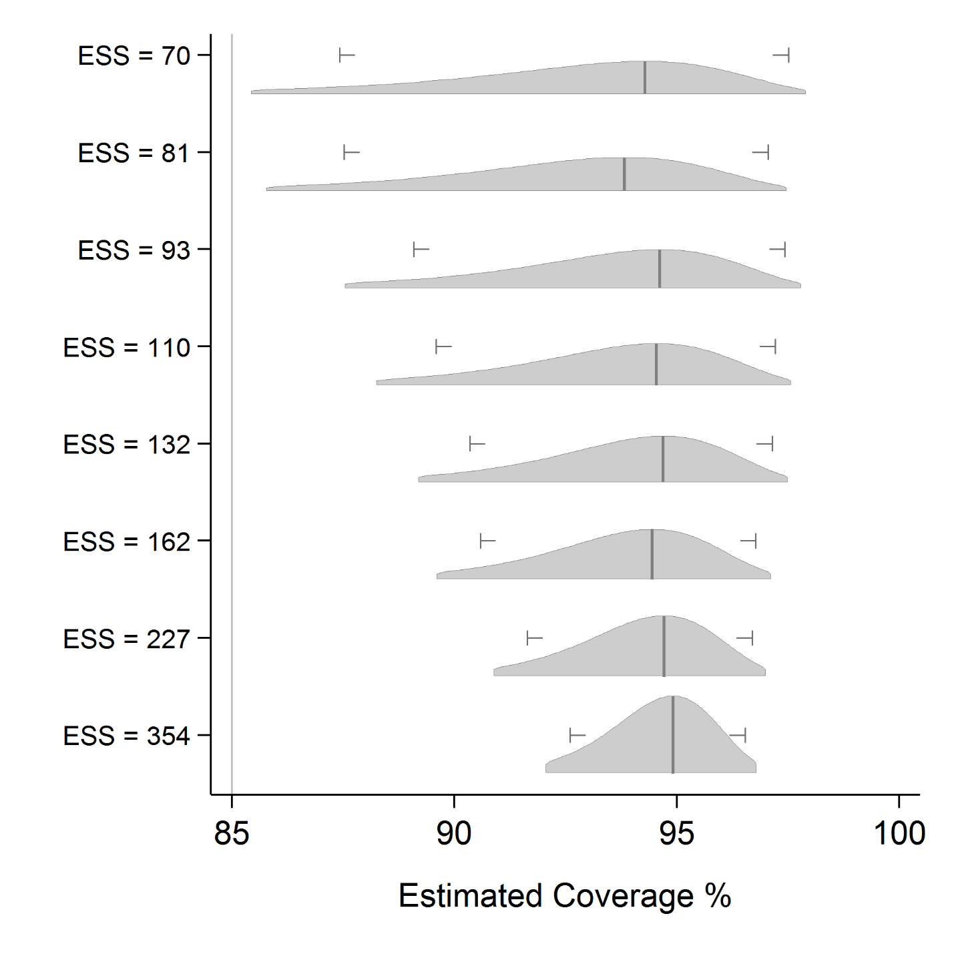 Note: ESS = Effective Sample Size; distributions are plotted using equal areas, so those with narrow confidence intervals are taller than those that are wide. For each distribution, the standardized area represents 95% confidence.

#### Table B-2. Effective ample sizes (ESS) to classify coverage as being very likely b*elow* a programmatic threshold

|  |  | **alpha = 10%; power = 80%** | **alpha = 5%; power = 80%** | **alpha = 10%; power = 90%** | **alpha = 5%; power = 90%** |
| --- | --- | --- | --- | --- | --- |
| **Programmatic Threshold (%)** | **Delta (%)** | **ESS** | **ESS** | **ESS** | **ESS** |
| 50 | 1 | 11,368 | 15,555 | 16,521 | 21,506 |
| 55 | 11,273 | 15,421 | 16,389 | 21,330 |
| 60 | 10,953 | 14,978 | 15,929 | 20,725 |
| 65 | 10,407 | 14,226 | 15,141 | 19,692 |
| 70 | 9,636 | 13,165 | 14,024 | 18,230 |
| 75 | 8,640 | 11,795 | 12,579 | 16,341 |
| 80 | 7,418 | 10,115 | 10,804 | 14,023 |
| 85 | 5,970 | 8,126 | 8,701 | 11,276 |
| 90 | 4,296 | 5,827 | 6,269 | 8,100 |
| 95 | 2,396 | 3,217 | 3,506 | 4,494 |
| 50 | 5 | 469 | 637 | 674 | 873 |
| 55 | 468 | 635 | 674 | 872 |
| 60 | 458 | 620 | 661 | 854 |
| 65 | 439 | 593 | 634 | 818 |
| 70 | 411 | 554 | 595 | 766 |
| 75 | 374 | 502 | 542 | 696 |
| 80 | 328 | 438 | 476 | 609 |
| 85 | 272 | 362 | 397 | 504 |
| 90 | 208 | 272 | 304 | 382 |
| 95 | 133 | 169 | 196 | 241 |
| 50 | 10 | 121 | 163 | 171 | 221 |
| 55 | 122 | 163 | 173 | 222 |
| 60 | 120 | 161 | 171 | 220 |
| 65 | 116 | 155 | 166 | 213 |
| 70 | 110 | 146 | 158 | 201 |
| 75 | 102 | 134 | 146 | 186 |
| 80 | 91 | 119 | 131 | 165 |
| 85 | 78 | 101 | 113 | 141 |
| 90 | 62 | 79 | 91 | 111 |
| 95 | 44 | 53 | 64 | 77 |
| 50 | 15 | 55 | 74 | 77 | 98 |
| 55 | 56 | 74 | 78 | 100 |
| 60 | 56 | 74 | 78 | 100 |
| 65 | 54 | 72 | 77 | 97 |
| 70 | 52 | 68 | 74 | 93 |
| 75 | 49 | 63 | 69 | 87 |
| 80 | 44 | 57 | 63 | 79 |
| 85 | 38 | 49 | 55 | 68 |
| 90 | 32 | 40 | 46 | 56 |
| 95 | 24 | 28 | 35 | 41 |

Note 1. Programmatic threshold is the expected coverage level.

Note 2. Delta is the difference (+ or –) from the programmatic threshold, from which you want to be well powered to reject the null hypothesis. For example, when *ESS* = 11,368, a classification based on an upper confidence limit will misclassify strata with true coverage of 50% only 5% of the time, and will have 80% power to correctly classify strata with true coverage of 49% or lower as having low coverage.

Note 3. This table conservatively provides ESS based on testing whether coverage is below a programmatic threshold (subtract delta from the programmatic threshold). In some cases, the ESS would be slightly smaller if testing whether coverage is above a programmatic threshold (adding delta to the programmatic threshold), as in Table B-3.

Note 4. For example, if the effective sample size is 146, from the column where alpha = 5%, and power = 80%, and programmatic threshold = 70%, and delta = 5%, then we might say the following: If true vaccination coverage is at least as low as (threshold – delta) = (70% – 10% = 60%) and we conduct numerous repeated surveys, each with an effective sample size of 146, when we calculate 100% –alpha% = (100% – 5% = 95%) upper confidence bound for all those surveys, we expect 80% of them to fall somewhere below 70%, leading to the correct and strong conclusion in at least 80% of those surveys, that we have 95% confidence that the population coverage is below 70%.  
  
Of course, in practice we do not conduct many repeated surveys in a single stratum, and we do not know the true underlying population coverage figure, so we cannot know whether our classification is correct. Therefore, we power the survey to make it likely that the classifications will be correct, and we accept the risk that some classification outcomes will be incorrect due to sampling variability.

#### Table B-3. Effective sample sizes (ESS) to classify coverage as being very likely *above* a programmatic threshold

|  |  |  |  |  |  |
| --- | --- | --- | --- | --- | --- |
|  |  | **alpha=10%; power=80%** | **alpha=5%; power=80%** | **alpha=10%; power=90%** | **alpha=5%; power=90%** |
| **Programmatic Threshold (%)** | **Delta (%)** | **ESS** | **ESS** | **ESS** | **ESS** |
| 50 | 1 | 11,368 | 15,555 | 16,521 | 21,506 |
| 55 | 11,238 | 15,379 | 16,324 | 21,255 |
| 60 | 10,882 | 14,894 | 15,798 | 20,575 |
| 65 | 10,300 | 14,101 | 14,944 | 19,467 |
| 70 | 9,493 | 12,998 | 13,761 | 17,930 |
| 75 | 8,461 | 11,585 | 12,250 | 15,966 |
| 80 | 7,203 | 9,864 | 10,410 | 13,572 |
| 85 | 5,720 | 7,833 | 8,241 | 10,751 |
| 90 | 4,010 | 5,492 | 5,743 | 7,500 |
| 95 | 2,073 | 2,839 | 2,913 | 3,816 |
| 50 | 5 | 469 | 637 | 674 | 873 |
| 55 | 461 | 626 | 661 | 857 |
| 60 | 444 | 603 | 634 | 824 |
| 65 | 418 | 568 | 595 | 773 |
| 70 | 383 | 520 | 542 | 705 |
| 75 | 338 | 460 | 476 | 620 |
| 80 | 285 | 388 | 397 | 518 |
| 85 | 222 | 302 | 304 | 398 |
| 90 | 149 | 203 | 196 | 259 |
| 95 | 50 | 70 | 50 | 70 |
| 50 | 10 | 121 | 163 | 171 | 221 |
| 55 | 118 | 159 | 166 | 215 |
| 60 | 113 | 152 | 158 | 204 |
| 65 | 105 | 142 | 146 | 190 |
| 70 | 96 | 129 | 131 | 171 |
| 75 | 83 | 113 | 113 | 147 |
| 80 | 69 | 93 | 91 | 119 |
| 85 | 51 | 70 | 64 | 85 |
| 90 | 24 | 34 | 24 | 34 |
| 50 | 15 | 55 | 74 | 77 | 98 |
| 55 | 53 | 71 | 74 | 95 |
| 60 | 51 | 68 | 69 | 89 |
| 65 | 47 | 63 | 63 | 82 |
| 70 | 42 | 56 | 55 | 72 |
| 75 | 36 | 48 | 46 | 60 |
| 80 | 28 | 38 | 35 | 46 |
| 85 | 16 | 22 | 16 | 22 |

Note 1. Programmatic threshold is the expected coverage level.

Note 2. Delta is the difference above the programmatic threshold (PT) from which you want to be well powered to reject the null hypothesis. For example, when *ESS* = 11,368, a classification based on an upper confidence limit will misclassify strata with true coverage of 50% only 5% of the time, and will have 80% power to correctly classify strata with true coverage of 51% or higher as having high coverage. In other words, if the true coverage is *PT* + Delta, then a survey of ESS will have at most *alpha* misclassification errors and at least 1 – *beta* power.

Note 3. This table provides ESS based on testing whether coverage is above a programmatic threshold (add delta to the programmatic threshold). In some cases, the ESS would be slightly larger if testing whether coverage is below a programmatic threshold (subtract delta from the programmatic threshold), as in Table B-2.

Note 4. For example, if the effective sample size is 129, from the column where alpha = 5%, and power = 80%, and the programmatic threshold = 70%, and delta = 5%, then we might say the following: If true vaccination coverage is at least threshold + delta (70% + 10% = 80%), and we conduct numerous repeated surveys that each have an effective sample size of 129, when we calculate the 100% – alpha% (100% – 5% = 95%) lower confidence bound for all those surveys, we expect 80% of them to fall somewhere above 70%. This leads to the correct and strong conclusion that in at least 80% of those surveys, population coverage is 95% likely to be higher than 70%.

#### Table C. Example design effects (DEFF) for coverage surveys

|  |  |  |  |  |  |  |  |
| --- | --- | --- | --- | --- | --- | --- | --- |
| **ICC** | **Average Respondents per Cluster *(m)*** | | | | | |  |
| **1** | **5** | **7** | **10** | **15** | **20** | **Description** |
| 0 | 1 | 1 | 1 | 1 | 1 | 1 | Uniform coverage |
| 0.042 | 1 | 1.17 | 1.25 | 1.38 | 1.58 | 1.79 | *ICC* = 1/24 very little variation in coverage |
| 0.167 | 1 | 1.67 | 2 | 2.50 | 3.33 | 4.17 | *ICC* = 1/6 conservative choice for SIA surveys |
| 0.333 | 1 | 2.33 | 3 | 4 | 5.67 | 7.33 | *ICC* = 1/3 conservative choice for RI surveys |
| 1 | 1 | 5 | 7 | 10 | 15 | 20 | Some clusters 100% covered; all others 0% |

SIA: Supplementary Immunization Activity. RI: Routine immunization

Note 1. The Design Effect is calculated here as *DEFF* = 1 + (*m* – 1) * ICC

Note 2. *ICC* = the Intracluster Correlation Coefficient (sometimes called the Intraclass Correlation Coefficient)

Note 3. *ICC* = 0.042 refers to a plausible ICC value that may result after an excellent campaign.

Note 4. *ICC* = 0.167 refers to a value that is implicit but not stated in the 2005 *EPI Cluster Survey Guidelines*: a design effect of 2 with 7 respondents per cluster implies that the *ICC* = 1/6 = 0.167. This is a direct result from the equation in Note 1. This would reflect more variability in coverage than 0.042. We recommend this conservative choice for planning a post-campaign survey if you do not have a strong reason to select another value.

Note 5. *ICC* = 0.333 refers to a more conservative value that will be listed in the 2015 update to the *EPI Cluster Survey Guidelines*. In routine immunization surveys we sometimes observe ICCs higher than the 0.167 value that was implicit in the 2005 document, so we recommend a conservative value of 0.333, or a design effect of 4.0 when *m* = 10.

#### Table E. Inflation factor to account for nonresponse

|  |  |
| --- | --- |
| **Anticipated % of households with an eligible child where no one will be at home or the caregiver will refuse to respond** | **Inflation factor for non-response (INonresponse)** |
| 0% | 1 |
| 5% | 1.05 |
| 10% | 1.11 |
| 15% | 1.18 |
| 20% | 1.25 |

If the anticipated non-response is higher than 20%, it is likely not worth doing the survey. Remember the formula for the inflation factor for non-response is INonresponse = 100/(100 – PHH eligible and not respond).

# 

# Annex B2: Sample size equations for estimation or classification

Tables B-1 through B-3 provide effective sample sizes (ESS) for common combinations of input parameters. Annex B2 provides the underlying equations used to calculate the effective sample sizes in those tables. These equations can be used to calculate the ESS using different input parameter values than those provided in the tables.

## B2.1 Supporting calculations for Table B-1

The ESS necessary to meet the inferential goals of the survey is given by Equation B2-1 (Fleiss et al., 2003, p.35). Table B1-4 provides the ESS for a 95% confidence interval for several expected coverage and desired precision combinations. Equation B2-1 can be used to calculate the ESS for other combinations of expected coverage, desired precision and confidence level.

Equation B2-1:

$$n≥\frac{k{ z}_{1-α/2}^{2}}{{4d}^{2}}+ \frac{1}{d}-2{ z}_{1-α/2}^{2}+ \frac{z_{1-α/2} +2}{k}$$

where $z_{1-x}$ is the standard normal distribution evaluated at 1 – $x$ and $d$ is the desired half-width of the confidence interval (for example, if you want the confidence interval to be no wider than ± 10%, then *d* = 0.1). If $d$ ≤ 0.3, then $k$ is calculated according to Table K, where *p* refers to the expected coverage proportion. If $d$ > 0.3 or if *p* is unknown, then use the conservative $k$ = 1. (Note: Fleiss defines $d$ to be the full interval width while Equation B2-1 and Table B2-1 define $d$ as the half interval width[2]. This distinction accounts for the $2d$ factor in the equations in this manual compared to Fleiss’s. Also note that Fleiss uses the notation $z_{x}$ for the critical value in his equations, which he defines as the critical value of the normal distribution cutting off probability $x$ in the upper tail. The critical value resulting from the definition used in this manual and the value from the definition used by Fleiss are equivalent.)

#### Table K. Sample size determination for a confidence interval of pre-specified width

|  |  |
| --- | --- |
| **If p satisfies** | **Then use** |
| 0 ≤ p < d | k = 8d(1 – 2d) |
| d ≤ p < 0.3 | k = 4(p + d)(1 – p – d) |
| 0.3 ≤ p ≤ 0.7 | k = 1 |
| 0.7 < p ≤ 1 – d | k = 4(p – d)(1 – p + d) |
| 1 – d < p ≤ 1 | k = 8d(1 – 2d) |

Note that the ESS does not change for coverage levels between 30% and 70%. When the coverage level is assumed to lie outside the interval [30%, 70%], then a value of $k$ < 1 could be used to reduce the required effective sample size (see Table B-1 for examples).

For example, suppose a 2-sided 95% confidence interval is desired with ±6% precision (d = 0.06). Also suppose that the coverage probability is expected to be around 75%. Using the value

$k=4\left(0.75-0.06\right)\left(1-0.75+0.06\right)=0.8556$ (from Table K), then:

$$n≥\frac{\left(0.8556\right){1.96}^{2}}{{\left(4\right)0.06}^{2}}+ \frac{1}{0.06}-\left(2\right){1.96}^{2}+ \frac{1.96+2}{0.8556}=241.9$$

Round up to the nearest child whole number, so that the ESS is $n$ ≥ 242. With this ESS, if a simple random sample were taken, then a 95% confidence interval will be at most ±6% for any observed coverage value of coverage 75% or higher.

## B2.2 Supporting calculations for Tables B-2 and B-3

If sufficient resources are not available to obtain very precise results in every stratum, it can be helpful to select a sample size based on the power to use a 1-sided hypothesis test to classify coverage in those strata as being higher or lower than a fixed programmatic threshold. Coverage will either be:

* very likely lower than the programmatic threshold
* very likely higher than the threshold, or
* not distinguishable from the threshold with high confidence, using the sample size in this survey.

This design requires five input parameters to be specified in order to calculate the corresponding ESS. They are defined as follows:

1. The programmatic threshold (PT or $P_{0}$) is a coverage level of interest, such as might be the coverage target or the expected coverage level.
2. Delta is a coverage percent defining a distance from the programmatic threshold. If the true coverage is at least delta points away from the programmatic threshold, then we pick a sample size likely to classify those districts as having coverage likely different than delta. For example, if the programmatic threshold is 80% and delta is 5%, then when coverage is 80 – 5 = 75% (or lower) or 80 + 5 = 85% (or higher), you want the survey results to be very likely to show that coverage is very likely lower or higher than 80%, respectively.
3. Direction indicates whether you are specifying statistical power for correctly classifying strata with coverage delta percent above the programmatic threshold, or delta percent below the programmatic threshold. If the threshold of interest is 80% and you want to be very sure to correctly classify strata with 90% or greater coverage, then the direction is *above* and you should use Table B-3 to look up the ESS. If the direction is *below* then use Table B-2. Note that the effective sample sizes in B-2 are larger than those in B1-6, so the conservative choice is to use Table B-2 unless you are very focused on detecting differences above the programmatic threshold.
4. Alpha (α) is the probability that a stratum with coverage at the programmatic threshold will be mistakenly classified as very likely to be above or below that threshold.
5. Beta (β) is the probability that a stratum with coverage delta points away from the threshold will be mistakenly classified as not different than the threshold. We call the quantity 100% – β the *statistical power* of the classifier.

Tables B-2 and B-3 provide the ESS for several combinations of these five input parameters. The steps below can be used to calculate the ESS for other combinations of inputs (Fleiss et al., 2003, p. 32).

* Step 1: Write down the values of the five input parameters defined above (programmatic threshold, delta, direction, alpha, and beta).
* Step 2: If testing whether coverage is *below* some threshold, calculate $P_{1}=P_{0}-delta$. If testing whether coverage is *above* some threshold, calculate $P_{1}=P_{0}+delta$.
* Step 3: Use Equation B2-2 below to calculate $n^{'}$; the ESS not corrected for continuity.
* Step 4: Use Equation B2-3 below to calculate $n$; the ESS corrected for continuity.

Equation B2-2:

$$n^{'}≥{\left[\frac{z_{1-α}\sqrt{P_{0}(1-P_{0})}+z_{1-β}\sqrt{P_{1}(1-P_{1})}}{P_{1}-P_{0}}\right]}^{2}$$

where $z_{1-x}$ is the standard normal distribution evaluated at 1 – x.

Equation B2-3:

$$n≥\frac{n^{'}}{4}{\left(1+\sqrt{1+\frac{2}{n^{'}\left|P_{1}-P_{0}\right|}}\right)}^{2}$$

For example, suppose the coverage target level is 85% (that is, PT = 0.85), delta =10%, α = 5%, and β = 20% (power = 100% – 20% = 80%). If it is desired to classify coverage as being very likely below the programmatic threshold, (direction is *below*), then we calculate $P_{1}$ = 0.85–0.10 = 0.75 and find

$$n^{'}≥{\left[\frac{1.645\sqrt{0.85\left(1-0.85\right)}+0.842\sqrt{0.75\left(1-0.75\right)}}{0.75-0.85}\right]}^{2}=90.6$$

Round $n^{'}$ up to the nearest child whole number and substitute it into Equation B2-3 to get

$$n≥\frac{91}{4}{\left(1+\sqrt{1+\frac{2}{91\left|0.75-0.85\right|}}\right)}^{2}=100.8$$

Round up again to the nearest child whole number so that the ESS is $n$ ≥ 101. With this ESS, if repeated simple random samples were taken from a population with true coverage 75% or lower, then the 100*(1 – α) = 95% UCB would fall below 85% in at least 100*(1 – β) = 80% of the surveys. That is, the 1-sided hypothesis test would have at least 80% power to detect a difference of at least 10%, and the probability of a Type I error (mistakenly concluding that coverage is < 85% when coverage is truly ≥ 85%) would be ≤ α = 5%.

If you wanted to classify coverage as being very likely above the programmatic threshold (direction is *above*), then we calculate $P_{1}$ = 0.85 + 0.10 = 0.95 and find

$$n^{'}≥{\left[\frac{1.645\sqrt{0.85\left(1-0.85\right)}+0.842\sqrt{0.95\left(1-0.95\right)}}{0.95-0.85}\right]}^{2}=59.4$$

Round $n^{'}$ up to the nearest child whole number and substitute it into Equation B2-3 to get

$$n≥\frac{60}{4}{\left(1+\sqrt{1+\frac{2}{60\left|0.95-0.85\right|}}\right)}^{2}=69.6$$

Round up again to the nearest child whole number so that the ESS is $n$ ≥ 70. With this ESS, if repeated simple random samples were taken from a population with true coverage 95% or higher, then the 100*(1 – α) = 95% LCB would fall above 85% in at least 100*(1 – β) = 80% of the surveys. That is to say, the 1-sided hypothesis test would have at least 80% power to detect a difference of at least 10% in the upward direction, and the probability of a Type I error (mistakenly concluding that coverage is > 85% when coverage is truly ≤ 85%) would be ≤ α = 5%.

# 

# Annex B3: Sample size equations for comparisons between places or subgroups and comparisons over time

Annexes B1 and B2 were concerned with designing a single survey to meet an inferential goal. Annex B3 explains how to calculate the sample size for a survey that will conduct comparisons, either (1) between subgroups in a single survey (such as urban and rural), (2) between two simultaneous surveys (one survey in each place, Province A and Province B), or (3) between results of two surveys conducted at different time points (that is, changes over time). Comparing results over time could either mean two future surveys (to be conducted at different time points) or a past survey and a future survey. Of the three types of comparison, the first two are the most straightforward.

Regardless of the type of comparison, in order to make a meaningful comparison between surveys, many things about the two surveys should be the same:

* Both surveys should use probability samples selected in the same manner, using the same eligibility criteria.
* Both should use similar methods of fieldwork and similar questionnaires and training. Both should have roughly similar proportions of respondents who give evidence of vaccination by card and by caretaker recall.

In other words, the sources of non-sampling bias or error must be very nearly similar in order to attribute observed differences to actual improvements in vaccination coverage. We do not recommend conducting a new, large, and expensive survey for which the primary inferential goal is to measure change comparing with an earlier survey, if there are questions about the older survey’s details of the implementation or the quality of the work.

If you are planning two surveys simultaneously among different subgroups, and can control the quality and implementation of both, then sources of non-sampling bias or error are likely to be very similar in both surveys. There may be differences in ICC between the two subgroups, and there may be differences in sample sizes; both are accounted for in the guidelines presented here.

Looking for differences in coverage over time works best when you are planning two future surveys, one now and another in several years, so you can control the quality and implementation of both surveys. In that context, it may be possible to make meaningful comparisons between surveys over time. The guidelines presented here can help plan for those situations. The comparison is trickier when the earlier survey occurred in the past and you wish to do a new survey to show that coverage has improved. Some aspects that affect the quality of the earlier survey may be undocumented and difficult to learn. **Many aspects of the two surveys may differ, so it will be challenging to draw a strong conclusion that observed differences in coverage are due to underlying differences in population coverage, and not due to other differences in survey design and implementation.**

The methods for calculating the sample sizes necessary to conduct comparisons between two future surveys (to be conducted at different time points) are similar to the methods for calculating the sample sizes necessary to compare results between subgroups in a single survey or in two simultaneous surveys (one survey in each place). The next section of this annex discusses these methods. The methods for calculating sample sizes required to compare a past survey and a future survey are discussed near the end of this annex.

## B3.1 Testing for differences in vaccination coverage between places or subgroups, or between two future surveys

In this section, we use the term *between places*, which may be interpreted to mean between groups or between two surveys in the future.

Table B-4 lists effective sample sizes for conducting two surveys of identical size for the purpose of detecting a statistically significant difference in estimated coverage between the two places. The effective sample sizes listed in the table are for *each* survey. The sample sizes are for a 2-sided test, where the null hypothesis is that coverage is the same in the two places, and the alternative hypothesis is that coverage differs. As with earlier comparisons, *alpha* is the probability of making a Type I error, or mistakenly concluding that there is a significant difference in coverage. *Beta* is the probability of making a Type II error, or mistakenly concluding there is no difference when in fact the population coverage difference between the two places is at least delta. *Delta* is the amount of difference for which you hope to power the comparison, and P1 is the value of coverage that is lower, if there is any difference.

For example, if you conducted surveys in Provinces A and B, each of which had effective sample sizes of 1,291 respondents, and expected coverage in one province was 70%, then you would have 80% power to detect a statistically significant difference using a 2-sided test, if the true prevalence was 75% or higher in the other province. The probability of making a Type I error, and mistakenly detecting a difference would be no more than alpha, or 5%.

The equations described in the text after Table B-4 give guidance on calculating sample sizes for parameters not covered in the table, or for unequal sample sizes in the two places. Those equations help calculate the effective sample size (ESS) needed to power the hypothesis test adequately. Use the equations listed in this section to calculate an ESS that will do the job, and then refer back to Annex B1 of the annex to calculate items C (the design effect), D (the number of households needed to find an eligible candidate), and E (the inflation factor for non-response). At that point you can substitute the ESS from this section in for factor B, and proceed with the calculations listed under Step 6 in Annex B1.

Note that these equations are for conducting a 2-sided test. If two future surveys are to be conducted at different points in time, and the goal is to estimate if coverage increased over time (a 1-sided test), use a critical value of $z_{1-α}$ in Equation B2-1. This will potentially result in smaller effective sample sizes.

#### Table B-4. Effective sample sizes (ESS) for identically sized surveys using a 2-sided test for coverage difference between two places or subgroups, or two future surveys

|  |  |  |  |  |  |
| --- | --- | --- | --- | --- | --- |
|  |  | **alpha =10%; power=80%** | **alpha=5%; power=80%** | **alpha=10%; power=90%** | **alpha=5%; power=90%** |
| **P1 (%)** | **Delta (% above P1)** | **ESS** | **ESS** | **ESS** | **ESS** |
| 50 | 1 | 31,109 | 39,440 | 43,013 | 52,730 |
| 55 | 30,738 | 38,969 | 42,500 | 52,100 |
| 60 | 29,749 | 37,713 | 41,129 | 50,418 |
| 65 | 28,141 | 35,672 | 38,903 | 47,687 |
| 70 | 25,915 | 32,846 | 35,820 | 43,904 |
| 75 | 23,071 | 29,236 | 31,880 | 39,070 |
| 80 | 19,609 | 24,840 | 27,084 | 33,186 |
| 85 | 15,528 | 19,660 | 21,432 | 26,251 |
| 90 | 10,829 | 13,695 | 14,923 | 18,265 |
| 95 | 5,512 | 6,944 | 7,558 | 9,228 |
| 50 | 5 | 1,273 | 1,605 | 1,747 | 2,134 |
| 55 | 1,248 | 1,574 | 1,713 | 2,092 |
| 60 | 1,198 | 1,511 | 1,644 | 2,008 |
| 65 | 1,124 | 1,417 | 1,541 | 1,882 |
| 70 | 1,025 | 1,291 | 1,404 | 1,714 |
| 75 | 901 | 1,134 | 1,233 | 1,504 |
| 80 | 753 | 945 | 1,027 | 1,252 |
| 85 | 580 | 726 | 787 | 957 |
| 90 | 382 | 474 | 513 | 621 |
| 95 | 157 | 190 | 204 | 242 |
| 50 | 10 | 325 | 408 | 442 | 538 |
| 55 | 316 | 396 | 429 | 523 |
| 60 | 300 | 376 | 408 | 496 |
| 65 | 279 | 349 | 378 | 460 |
| 70 | 251 | 313 | 339 | 412 |
| 75 | 217 | 270 | 292 | 354 |
| 80 | 177 | 219 | 237 | 286 |
| 85 | 130 | 160 | 172 | 207 |
| 90 | 77 | 93 | 99 | 117 |
| 50 | 15 | 147 | 183 | 198 | 240 |
| 55 | 141 | 176 | 190 | 230 |
| 60 | 133 | 165 | 179 | 216 |
| 65 | 122 | 151 | 163 | 198 |
| 70 | 108 | 134 | 144 | 174 |
| 75 | 92 | 113 | 121 | 146 |
| 80 | 72 | 88 | 95 | 114 |
| 85 | 50 | 60 | 64 | 76 |

Note 1. P1 is the estimated coverage level from one of the two surveys.

Note 2. Delta is the difference above P1 from which the survey should be well powered to reject the null hypothesis. If the true coverage is P1 + delta in one place, then a survey of ESS will have at most alpha probability of Type I error and at least 1 ­– beta power.

Note 3. This table provides the ESS required for both surveys when the ratio *(r)* of the sample sizes is 1:1 (that is, equal sample sizes). If one place is slated to have a larger or smaller sample size than the other (that is, *r* ≠ 1), then ESS from this table should not be used, and the additional calculations described below are necessary.

### Supporting Calculations for Table B-

To calculate the sample size necessary to test for a difference in vaccination coverage between two places or subgroups, or between two future surveys, use the following multi-step process (Fleiss et al., 2003, p. 76):

1. First, let the effective sample size for the first population be denoted by $n_{1}$ and the effective sample size for the second population be denoted by ${rn}_{1} (0<r<∞)$ where $r$ is specified in advance.

Let $P_{1}$ be the sampled proportion of coverage from population 1, $P_{2}$ be the sampled proportion of coverage from population 2, and $\overline{P}={(P}_{1}+rP_{2})/(r+1)$. If the underlying proportions of the two populations are not different, then the chance of falsely concluding that there is a difference is approximately α (the probability of a Type 1 error).

Also, if the underlying proportions of population 1 and population 2 are in fact P1 and P2 ≠ P1, then the chance of correctly concluding that the two proportions are different is 1 – β (the power of the test). Thus, the required effective sample size for the first population (without the use of the continuity correction) is computed using Equation B3-1.

Equation B3-1.

$${n_{1}}^{'}≥\frac{{\left\{z_{1-α/2}\sqrt{(r+1)\overline{P}(1-\overline{P})}+z_{1-β}\sqrt{{rP}_{1}\left(1-P_{1}\right)+P_{2}\left(1-P_{2}\right)}\right\}}^{2}}{r{(P_{2}-P_{1})}^{2}}$$

The required effective sample size for the second population (without the use of the continuity correction) is then computed using Equation B3-2.

Equation B3-2.

$${n_{2}}^{'}=r{n_{1}}^{'}$$

1. Next, a continuity correction is applied to ${n_{1}}^{'}$ to provide the desired significance level and power. Thus, the required effective sample size for the first population is computed using Equation B3-3. Note that this value corresponds to the value that is written in Box B from Step 2 in Annex B1.

Equation B3-3.

$$n_{1}≥\frac{{n_{1}}^{'}}{4}{\left\{1+\sqrt{1+\frac{2(r+1)}{{n_{1}}^{'}r|P_{2}-P_{1}|}}\right\}}^{2}$$

The required ESS for the second population is then computed using Equation B3-4, and added to Box B as well. Again, note that this value corresponds to the value that gets written in Box B from Step 2 in Annex B1.

Equation B3-4.

$$n_{2}≥rn_{1}$$

1. Finally, the required cluster survey sample size for the two populations will be scaled to account for the cluster sampling design. After estimating the ICC for each population, the DEFF for each population can be computed for a given $m$ (the number of children sampled per cluster) using Equation B3-5. Note that these values correspond to what would be written in Box C from Step 3 in Annex B1.

Equation B3-5.

$${DEFF}_{1}=1+\left(m_{1}-1\right){ICC}_{1}$$

$${DEFF}_{2}=1+\left(m_{2}-1\right){ICC}_{2}$$

The required cluster survey sample sizes for the two populations, taking into account the cluster design, are computed using Equation B3-6. Note that this calculation is the result from multiplying the values from Box B and Box C in Annex B1. Also consider multiplying the factors that account for the number of households that need to be visited in order to find an eligible respondent (Box D from Step 4 in Annex B1), and an inflation factor for nonresponse (Box E from Step 5 in Annex B1), by the results from Equation B3-6 to get a more accurate idea of the cluster survey sample size required.

Equation B3-6.

$$n_{1Cluster}≥{DEFF}_{1}*n_{1}$$

$$n_{2Cluster}≥{DEFF}_{2}*n_{2}$$

For example, suppose two strata within a country are to be compared to each other to test whether coverage in one stratum is 10% higher than coverage in the other. Suppose that one stratum is likely to have estimated coverage of 70%, and that you want to set alpha as (α = 0.05), meaning that there is no more than a 5% probability of the test incorrectly concluding that the two strata have a coverage difference when in fact they do not. You also want at least 80% probability (β = 0.2) that the test will correctly conclude that there is a coverage difference when the true difference is at least 10%.

Suppose the sample in the second stratum should be 1.5 times the size of the first strata (*r* = 1.5). First calculate $\overline{P}$ = ${(P}_{1}+rP_{2})/(r+1)$ =(0.7 + 1.5*0.8)/(1.5 + 1) = 0.76. Using Equations B3-1 and B3-2, calculate

$${n_{1}}^{'}≥\frac{{\left\{1.96\sqrt{\left(1.5+1\right)0.76\left(1-0.76\right)}+0.842\sqrt{\left(1.5\right)0.7\left(1-0.7\right)+0.8\left(1-0.8\right)}\right\}}^{2}}{1.5{\left(0.8-0.7\right)}^{2}}=241.6$$

$${n_{2}}^{'}=\left(1.5\right)242=363$$

Round up and substitute $n_{1}^{'}$ into Equation B3-3 and B3-4 to get

$$n_{1}≥\frac{242}{4}{\left[1+\sqrt{1+\frac{2\left(1.5+1\right)}{294\left(1.5\right)\left|0.8-0.7\right|}}\right]}^{2}=258.4$$

$$n_{2}≥\left(1.5\right)259=388.5$$

Thus, after rounding up to the nearest whole number, the ESS for the first stratum with estimated coverage of 70% is $n_{1}$ ≥ 259 and the ESS for the second stratum is $n_{2}$ ≥ 389. (Note that these values correspond to values that could be written in Box B in Step 2 in Annex B1. In order to obtain the required cluster survey sample size, the ESS would need to be multiplied by values corresponding to Boxes C through E in Annex B1.)

## B3.2 Testing for an increase in coverage over time, when the earlier survey was conducted in the past

Subject to the warnings described above about the difficulty of comparing coverage between two surveys conducted at different times by different teams and methods, this section of the annex gives guidance for sizing a survey for a 1-sided comparison between two surveys with coverage measured at an earlier time for one of the surveys.

In contrast to the previously described comparisons, this task offers far less flexibility. When two surveys are to be compared and one of them has already been conducted, then there is no flexibility in the effective sample size needed to meet the inferential goals of the comparison study, as the effective sample size from the first study is already locked in and not negotiable. If the effective sample size required of the second survey to meet the inferential goals is too large and therefore too expensive or time consuming, the inferential goals will need to be modified.

For example, if a country is planning to conduct two future surveys at different time points such that the results can be compared, the survey planners could decide to (1) conduct two equally sized surveys, (2) conduct a large survey first and then a smaller survey to follow or (3) conduct a smaller survey at first and a larger survey later. Depending on the budget and the timeline, there is great flexibility planning these two surveys such that the inferential goals are met. When one survey has already been conducted, there is no flexibility in the effective sample size needed to meet the inferential goals of the comparison study because the effective sample size has already been set.

The equations below help calculate the effective sample size (ESS) needed to power the hypothesis test adequately. Use the equations listed in this section to calculate an ESS that will do the job, and then refer back to Annex B1 to calculate items C (the design effect), D (the number of households to find an eligible candidate), and E (the inflation factor for non-response). At that point you can substitute the ESS from this section in for factor B, and proceed with the calculations listed under Step 6 in Annex B1.

To calculate the cluster survey sample size necessary to test for an increase in coverage over time since an earlier survey, use the following multi-step process (Fleiss et al., 2003, pp. 72, 78). (Note that the equation in Fleiss tests for a *difference* over time, and so a critical value associated with a 2-sided test is used. This manual is testing for an *increase* in coverage over time, so a 1-sided critical value is used.)

1. First, assume that the effective sample sizes from the two surveys *n1* and *n2* are equal to a common *n*. (Corrections to account for unequal effective sample sizes will be made in a later step.) Let $P_{1}$ be the sample coverage proportion from sample 1 (the earlier survey), $P_{2}$ be the sample coverage proportion from sample 2 (the survey being planned), and $\overline{P}=(P_{1}+P_{2})/2$. If the underlying proportion from sample 2 is not greater than the underlying proportion from sample 1, and coverage did not increase over time, then the chance of falsely concluding that proportion 2 is greater than proportion 1 is approximately α (the probability of a Type 1 error). Also, if the underlying proportions of sample 1 and sample 2 are in fact P1 and P2 > P1, then the chance of correctly concluding that proportion 1 is less than proportion 2 is 1 – β (the power of the test). So, the required effective sample size from each of the two compared populations (without the use of the continuity correction) is calculated using Equation B3-7.

Equation B3-7.

$$n^{'}≥\frac{{\left\{z_{1-α}\sqrt{2\overline{P}(1-\overline{P})}+z_{1-β}\sqrt{P_{1}\left(1-P_{1}\right)+P_{2}\left(1-P_{2}\right)}\right\}}^{2}}{{(P_{2}-P_{1})}^{2}}$$

1. Next, a continuity correction is applied to $n^{'}$ to provide the desired significance level and power. Thus, the required effective sample size from each of the two populations being compared is calculated using Equation B3-8.

Equation B3-8.

$$n≥\frac{n^{'}}{4}{\left[1+\frac{4}{n^{'}|P_{2}-P_{1}|}\right]}^{2}$$

1. Now use the effective sample size from the first survey, which has already taken place and is presumably known. (If the effective sample size is not listed in the survey report, see the notes at the end of this section for methods of calculating the ESS from the earlier survey.) This adjusts $n$ in Step 2 to allow the effective sample sizes in the two surveys to be different. Let the effective sample size from the first survey (old survey) be denoted by $n_{1known}$. First, determine whether $n_{1known}$ is the effective sample size (that is, the sample size necessary to obtain results if a simple random sample were taken) or the actual sample size of the cluster survey. If it is the effective sample size, then let $n_{1}=n_{1known}$. If it is the actual cluster survey sample size, then the effective sample size is calculated as $n_{1}=n_{1known}/DEFF$. (See the section “Calculating the ESS from an old survey report” in this annex for more details on calculating this important quantity.) After you determine the effective sample size, $n_{1}$, use $n$ as calculated in Step 2, to calculate $r$ in Equation B3-9.

Equation B3-9.

$$r=\frac{n}{2n_{1}-n}$$

If $n_{1}≤n/2$, no positive value for $r$ exists and the study as planned should be abandoned. Consider making adjustments to some of the assumptions to get a positive value of for $r$. For example, the power could be reduced or the values of $P_{1}$ and $P_{2}$ could be moved farther apart.

If a positive value for $r$ exists, then the resulting effective sample size for the second survey (the new survey) is calculated using Equation B3-10. Note that this value corresponds to the value that gets written in Box B from Step 2 in Annex B1.

Equation B3-10.

$n_{2}≥r*n_{1}$

1. Finally, the required cluster survey sample size for the second survey will be scaled to account for the cluster sampling design. After estimating the ICC, calculate the DEFF for a given $m$ (the number of children sampled per cluster) using Equation B3-11. These values correspond to what would get written in Box C from Step 3 in Annex B1.

Equation B3-11.

$$DEFF=1+\left(m-1\right)ICC$$

The resulting cluster survey sample size for the second (new) survey, taking into account the cluster design, is computed using Equation B3-12. Note that this calculation is the result of multiplying the values from Box B and Box C in Annex B1. Also consider multiplying factors that account for the number of households needed to that need to be visited in order to find an eligible respondent (Box D from Step 4 in Annex B1) and an inflation factor for nonresponse (Box E from Step 5 in Annex B1) by the result from Equation B3-12, to get a more accurate cluster survey sample size figure.

Equation B3-12.

$$n_{2Cluster}≥DEFF*n_{2}$$

For example, suppose a country conducted a survey a few years ago and the estimated coverage was 70%. Suppose it was desired to conduct another survey and test if the coverage had increased over time to 80%, with no more than a 5% probability of incorrectly concluding that it had increased when in fact it had not (α = 0.05), and at least 80% probability of correctly concluding that it had increased (β = 0.2). First calculate $\overline{P}$ = (0.7+0.8)/2 = 0.75. Using the equation in Step 1, we calculate

$$n^{'}≥ {\left[\frac{1.645\sqrt{2x0.75\left(1-0.75\right)}+0.842\sqrt{0.7\left(1-.07\right)+0.8\left(1-0.8\right)}}{\left(0.8-0.7\right)}\right]}^{2}=230.9.$$

Round $n^{'}$ up to the nearest child whole number and substitute it into the equation in Step 2 to get

$n≥\left(\frac{231}{4}\right){\left[1+\sqrt{1+\frac{4}{(231\left|0.8-0.7\right|)}}\right]}^{2}=250.6$

Round up again to the nearest whole number, so that the total ESS for the two surveys is $n$ ≥251. Further suppose that the ESS of the first survey is not known, but the cluster survey size was 400 with a *DEFF* = 2.3. Proceeding to Step 3, the ESS for the first survey is calculated as

$n_{1}=\frac{400}{2.3}=174$ and $r=\frac{251}{(\left(2x174\right)-251)}=2.6$

Thus the ESS for the new survey, rounding up to the nearest whole number, is $n_{2}$ ≥2.6 x 174 = 453.

This is the ESS needed for the upcoming survey to meet the inferential goals of the survey (that is, the value from Box B in Step 2 in Annex B1). In order to obtain the required cluster survey sample size, the ESS would need to be multiplied by the values corresponding to Boxes C through E in Annex B1.

### Calculating the ESS from an old survey report

Because the earlier survey’s effective sample size is required for the calculations described above, one potential challenge is calculating it. Use the following equations to do so, depending on the information available.

* **Calculate ESS given Nand DEFF**: If the total cluster survey sample size is listed, along with the design effect (DEFF), then the effective sample size is the total sample size divided by DEFF.
* **Calculate ESS given Nand DEFT**: Sometimes rather than reporting DEFF, DHS and other surveys report DEFT, which is the square root of DEFF. In that case the effective sample size is the total sample size divided by DEFT-squared.
* **Calculate ESS given N, p1, and the 95% CI**: If the DEFF is not listed, but a 95% confidence interval for vaccination coverage is listed, along with the total survey sample size, then:
* Let *N* be the total cluster survey sample size from which coverage was calculated in the earlier survey.
* Let *p1* be the survey coverage estimate from the earlier survey, divided by 100: 80% / 100% = 0.8.
* Let *FCW* (full confidence width) equal the full width of the 95% confidence interval, expressed in proportions, so a CI of 63% to 73% would be a *FCW* of (73% – 63%) / 100% = 0.1.

Then the ESS for the earlier survey is:

$$ESS=\frac{3.92 \sqrt{p1(1-p1)N}}{FCW}$$

# Annex C: Survey budget template

Simple template to estimate the required budget

|  |  |  |  |
| --- | --- | --- | --- |
| **Template Coverage Survey Budget** |  |  |  |
|  | **UNIT COST** | **QUANTITY** | **TOTAL** |
|  | **(USD)** |  | **(USD)** |
| **Consultant** |  |  |  |
|  |  | x per x months at x salary level |  |
|  |  | Per diem per x days |  |
|  |  | Travel (x trips) |  |
| **Field Coordinator** |  | x per x months at x salary level |  |
|  |  | Per diem per x days |  |
|  |  | Travel (x trips) |  |
| **Accident insurance (for field work)** |  | x person x month |  |
| **Technical Planning Committee** |  |  |  |
| Development of Standard Operating Procedures (SOPs) |  |  |  |
| Production of SOPs |  |  |  |
| **Training** |  |  |  |
| Training venue |  |  |  |
| Refreshments/lunch |  |  |  |
| Equipment rental |  |  |  |
| Travel (air fares) |  |  |  |
| Per diem |  |  |  |
| Videos of interviews for training |  |  |  |
| **Supplies** |  |  |  |
| Field materials (pens, pencils, plastic bags to keep forms, folders, envelopes for forms, etc) |  |  |  |
| Numbering Stamp |  |  |  |
| Internet access |  |  |  |
| Printer and Photocopies |  |  |  |
| Stationery |  |  |  |
| Development of maps |  |  |  |
| Phone cards |  |  |  |
| Mobile devices |  |  |  |
| Cameras |  |  |  |
| GPS devices |  |  |  |
| **Field Staff (Interviewers and supervisors)** |  |  |  |
| Salaries |  |  |  |
| Per diem |  |  |  |
| Transportation |  |  |  |
| **Data Entry Clerks** |  |  |  |
| Questionnaire double entry |  | entries |  |
| Computers for Data Entry Clerks (laptops) |  |  |  |
| Per diem |  | x days x persons |  |
| **Data Entry** |  |  |  |
| Data Entry clerks |  |  |  |
| Flash drives |  |  |  |
| **Data Analysis** |  |  |  |
| Contracting of Statistician |  |  |  |
| **Report Writing and Dissemination** |  |  |  |
| Printing final report |  |  |  |
| Meeting logistics |  |  |  |
| Social Mobilization |  |  |  |
| Media Release |  |  |  |
| **Dissemination meeting** |  |  |  |
| Meeting Venue |  |  |  |
| CDs or USBs |  |  |  |
| **SUB-TOTAL** |  |  |  |
| **Coordination Visits** |  | Per diem x days x persons x trips |  |
|  |  | X trips x airfares |  |
| **SUB-TOTAL** |  |  |  |
| **TOTAL** |  |  |  |

For more comprehensive and detailed budget templates see examples from:

DHS: <https://www.k4health.org/toolkits/dhs>

MICS: <http://mics.unicef.org/tools>

# Annex D: An example of systematic random cluster selection without replacement and probability proportional to estimated size (PPES)

## D.1 Introduction

This annex provides a worked example of how to randomly and systematically select, *without replacement*, 15 clusters for a survey in a given stratum, using probability proportional to the estimated number of households per cluster. The sampling frame consists of a list of census enumeration areas (EAs). In this example, they are numbered 1–45 by the census bureau.

If the sample had been done *with* replacement, it would mean that, theoretically, any EA could be selected into the sample two or more times. Because the sampling described here is systematic, and because we recommend segmenting large EAs so that none are sampled with certainty, the sampling here is *without replacement*. This annex discusses the benefits and disadvantages of sampling large clusters with certainty, and also gives tips for auditing the cluster selection process.

## D.2 Example of cluster selection

The example described in this section demonstrates cluster selection using systematic selection without replacement and demonstrates probability proportional to estimated size (PPES), with implicit urban/rural stratification and pre-segmentation of large clusters to avoid selection of any EA with certainty.

### Implicitly stratify the sample

In this example, the survey designers have decided to stratify the sample implicitly by urban/rural status. That is, they want the ratio of urban to rural respondents in the survey to match the ratio of urban to rural population in each stratum. Implicit urban/rural stratification is usually a good idea; it makes the sample proportions representative of the population proportions, even if the survey is not examining urban vs. rural distinctions as a primary goal.

Table D-1 lists the 45 EAs in the stratum, along with the estimated number of households in each and an indicator for urban/rural status. Suppose that there will be 15 clusters in this survey, and that to yield an adequate number of completed questionnaires, the survey design calls for visiting 35 households in each cluster.

When using systematic sampling, first list the EAs in a pre-specified order to facilitate auditing later on. For this example, we will sort the list with all the urban EAs listed at the top and the rural EAs afterward. This creates an implicit urban/rural stratification. Within the urban and rural categories we will sort the list by EA number. Table D-2 shows the re-sorted table, with an additional column for cumulative number of households (HH).

#### Table D-1. List of the 45 enumeration areas in the stratum, including urban/rural status

| **EA#** | **# of HH in the EA** | **Urban/Rural Status** |
| --- | --- | --- |
| 1 | 78 | R |
| 2 | 27 | R |
| 3 | 118 | R |
| 4 | 101 | R |
| 5 | 103 | R |
| 6 | 150 | U |
| 7 | 95 | R |
| 8 | 101 | R |
| 9 | 34 | U |
| 10 | 87 | R |
| 11 | 28 | R |
| 12 | 309 | U |
| 13 | 45 | R |
| 14 | 38 | R |
| 15 | 179 | U |
| 16 | 51 | R |
| 17 | 23 | R |
| 18 | 64 | R |
| 19 | 91 | R |
| 20 | 30 | R |
| 21 | 40 | R |
| 22 | 53 | R |

|  |  |  |
| --- | --- | --- |
| **EA#** | **# of HH in the EA** | **Urban/Rural Status** |
| 23 | 41 | U |
| 24 | 125 | R |
| 25 | 73 | R |
| 26 | 147 | R |
| 27 | 183 | U |
| 28 | 38 | R |
| 29 | 87 | R |
| 30 | 300 | U |
| 31 | 186 | U |
| 32 | 30 | R |
| 33 | 44 | R |
| 34 | 165 | U |
| 35 | 96 | R |
| 36 | 112 | R |
| 37 | 17 | U |
| 38 | 34 | R |
| 39 | 135 | R |
| 40 | 73 | R |
| 41 | 123 | R |
| 42 | 37 | R |
| 43 | 89 | R |
| 44 | 112 | R |
| 45 | 61 | U |

#### Table D-2. Enumeration areas sorted by urban/rural status and by EA Number

|  |  |  |  |
| --- | --- | --- | --- |
| **EA#** | **HH** | **Urban/Rural** | **Cumulative HH** |
| 6 | 150 | Urban | 150 |
| 9 | 34 | 184 |
| 12 | 309 | 493 |
| 15 | 179 | 672 |
| 23 | 41 | 713 |
| 27 | 183 | 896 |
| 30 | 300 | 1,196 |
| 31 | 186 | 1,382 |
| 34 | 165 | 1,547 |
| 37 | 17 | 1,564 |
| 45 | 61 | 1,625 |
| 1 | 78 | Rural | 1,703 |
| 2 | 27 | 1,730 |
| 3 | 118 | 1,848 |
| 4 | 101 | 1,949 |
| 5 | 103 | 2,052 |
| 7 | 95 | 2,147 |
| 8 | 101 | 2,248 |
| 10 | 87 | 2,335 |
| 11 | 28 | 2,363 |
| 13 | 45 | 2,408 |
| 14 | 38 | 2,446 |

|  |  |  |  |
| --- | --- | --- | --- |
| **EA#** | **HH** | **Urban/Rural** | **Cumulative HH** |
| 16 | 51 | Rural | 2,497 |
| 17 | 23 | 2,520 |
| 18 | 64 | 2,584 |
| 19 | 91 | 2,675 |
| 20 | 30 | 2,705 |
| 21 | 40 | 2,745 |
| 22 | 53 | 2,798 |
| 24 | 125 | 2,923 |
| 25 | 73 | 2,996 |
| 26 | 147 | 3,143 |
| 28 | 38 | 3,181 |
| 29 | 87 | 3,268 |
| 32 | 30 | 3,298 |
| 33 | 44 | 3,342 |
| 35 | 96 | 3,438 |
| 36 | 112 | 3,550 |
| 38 | 34 | 3,584 |
| 39 | 135 | 3,719 |
| 40 | 73 | 3,792 |
| 41 | 123 | 3,915 |
| 42 | 37 | 3,952 |
| 43 | 89 | 4,041 |
| 44 | 112 | 4,153 |

### Combine small EAs and divide large EAs

The next step is to consider combining small EAs and splitting very large EAs. Table D-2 indicates that there are an estimated 4,153 households altogether in this sample. We wish to select 15, so the sampling interval will be 4153/15 = 276.86, rounded down to 276 households.

In Table D-3 below, we combine any EAs with fewer than 35 households with another EA that is a geographic neighbour (selected with assistance from someone familiar with the local geography), and make a single combined entry in the table. This will help ensure that field staff will find at least 35 households in the cluster if it is selected, and therefore will not compromise the desired sample size.

In addition, before sampling we split any EAs in the list with more than 276 households, to keep any EA from entering the sample “with certainty.” EAs that are sampled with certainty need special handling during analysis, and their results do not contribute to estimates of the sampling variability in the study. It is good to avoid this complication, so we will split those EAs into smaller units with fewer than 276 households, and make a separate entry in the sampling frame for each portion of the split EA. To split an EA, look at a map and divide it logically, maybe into northern and southern portions, or into quadrants. It may be possible to use satellite maps or census maps to estimate the number of households in each portion after the split.[3] Note that if one of these portions listed in the sampling frame is selected, it may need to be segmented yet again at a later stage, to get the size down near 35 households (as described in section 3.6.3). The split at this stage does not need to be down into portions as small as 35 households – we do not want to go to all the work of segmenting EAs down to 35 households if they are not selected into our sample. At this stage, simply partition the large entries in the frame into entries with fewer than 276 households.

Table D-3 lists the same clusters as in Table D-2, this time with some grouped together and some (EAs 12 and 30) split into two parts. You may wish to separate the portions of large EAs in the list so they are not adjacent. If they are adjacent, one or the other will be selected with certainty because the sum of their households is larger than 276. If you wish to introduce a chance that those large EAs are not selected into the sample, separate their entries in the frame by giving one of them a number that puts it at the bottom of the list. For example, instead of using the numbers 12B and 30B, those EAs might be given the numbers 15B and 34B for purpose of sorting the frame.

#### Table D-3. List of clusters to select from, with cumulative number of households

|  |  |  |  |
| --- | --- | --- | --- |
| **EA#** | **HH** | **Urban/ Rural** | **Cumulative HH** |
| 6 & 9 | 184 | Urban | 184 |
| 12A | 155 | 339 |
| 12B | 154 | 493 |
| 15 | 179 | 672 |
| 23 | 41 | 713 |
| 27 | 183 | 896 |
| 30A | 170 | 1,066 |
| 30B | 130 | 1,196 |
| 31 | 186 | 1,382 |
| 34 | 165 | 1,547 |
| 37 & 45 | 78 | 1,625 |
| 1 & 2 | 105 | Rural | 1,730 |
| 3 | 118 | 1,848 |
| 4 | 101 | 1,949 |
| 5 | 103 | 2,052 |
| 7 | 95 | 2,147 |
| 8 | 101 | 2,248 |
| 10 & 11 | 115 | 2,363 |
| 13 | 45 | 2,408 |
| 14 | 38 | 2,446 |

|  |  |  |  |  |  |  |  |
| --- | --- | --- | --- | --- | --- | --- | --- |
| **EA#** | | **HH** | | **Urban/ Rural** | | **Cumulative HH** | |
| 16 & 17 | | 74 | | Rural | | 2,520 | |
| 18 | | 64 | | 2,584 | |
| 19 | | 91 | | 2,675 | |
| 20 & 21 | | 70 | | 2,745 | |
| 22 | | 53 | | 2,798 | |
| 24 | | 125 | | 2,923 | |
| 25 | | 73 | | 2,996 | |
| 26 | | 147 | | 3,143 | |
| 28 | | 38 | | 3,181 | |
| 29 | | 87 | | 3,268 | |
| 32 & 33 | | 74 | | 3,342 | |
| 35 | | 96 | | 3,438 | |
| 36 | | 112 | | 3,550 | |
| 38 & 40 | | 107 | | 3,657 | |
| 39 | | 135 | | 3,792 | |
| 41 | | 123 | | 3,915 | |
| 42 | | 37 | | 3,952 | |
| 43 | | 89 | | 4,041 | |
| 44 | | 112 | | 4,153 | |

### Select clusters

We are ready to begin selecting clusters. The next step is to select a random number between 1 and 276 and identify which cluster it falls in. To select the random number, you can use Microsoft Excel with the formula =RANDBETWEEN(1,276). Be sure to record the result somewhere for the permanent record, as the random number will change every time you refresh.

In this example, assume the equation yielded a random starting number of 107. The household with cumulative number 107 falls in EA 6 & 9. This is the first cluster selected for our sample. The second is identified by adding 276 (the sampling interval) to 107, which yields 383. Household 383 falls in EA #12B. We go on adding 276 to the running total time after time, until we have selected a total of 15 numbers systematically. Table D-4 shows which 15 clusters were selected.

#### Table D-4. List of clusters to select from, and those selected

| **EA#** | **HH** | **Urban/Rural** | **Cumulative HH** | **Selected HH#**  **After adding the sampling interval (Running Sum)** | **Cluster ID** |
| --- | --- | --- | --- | --- | --- |
| 6 & 9 | 184 | Urban | 184 | 107 | 1 |
| 12A | 155 | 339 |  |  |
| 12B | 154 | 493 | 383 | 2 |
| 15 | 179 | 672 | 659 | 3 |
| 23 | 41 | 713 |  |  |
| 27 | 183 | 896 |  |  |
| 30A | 170 | 1,066 | 935 | 4 |
| 30B | 130 | 1,196 |  |  |
| 31 | 186 | 1,382 | 1,211 | 5 |
| 34 | 165 | 1,547 | 1,487 | 6 |
| 37 & 45 | 78 | 1,625 |  |  |
| 1 & 2 | 105 | Rural | 1,730 |  |  |
| 3 | 118 | 1,848 | 1,763 | 7 |
| 4 | 101 | 1,949 |  |  |
| 5 | 103 | 2,052 | 2,039 | 8 |
| 7 | 95 | 2,147 |  |  |
| 8 | 101 | 2,248 |  |  |
| 10 & 11 | 115 | 2,363 | 2,315 | 9 |
| 13 | 45 | 2,408 |  |  |
| 14 | 38 | 2,446 |  |  |
| 16 & 17 | 74 | 2,520 |  |  |
| 18 | 64 | 2,584 |  |  |
| 19 | 91 | 2,675 | 2,591 | 10 |
| 20 & 21 | 70 | 2,745 |  |  |
| 22 | 53 | 2,798 |  |  |
| 24 | 125 | 2,923 | 2,867 | 11 |
| 25 | 73 | 2,996 |  |  |
| 26 | 147 | 3,143 | 3,143 | 12 |
| 28 | 38 | 3,181 |  |  |
| 29 | 87 | 3,268 |  |  |
| 32 & 33 | 74 | 3,342 |  |  |
| 35 | 96 | 3,438 | 3,432 | 13 |
| 36 | 112 | 3,550 |  |  |
| 38 & 40 | 107 | 3,657 |  |  |
| 39 | 135 | 3,792 | 3,708 | 14 |
| 41 | 123 | 3,915 |  |  |
| 42 | 37 | 3,952 |  |  |
| 43 | 89 | 4,041 | 3,984 | 15 |
| 44 | 112 | 4,153 |  |  |

Note that 1,625/4,153 or 39.1% of households are urban in this stratum. In the sample, 6/15 or 40% of clusters come from urban EAs. The implicit stratification is successful because the proportion of urban clusters selected mirrors the proportion of urban households in the stratum. The final proportion of urban respondents with completed survey responses in the analysis dataset will not be known until the survey is complete, but this selection process makes it likely that it will be somewhere near 39%.

## D.3 Auditing considerations

Discuss the sampling options with a statistician to determine the features you would like to include in the survey. Whatever decisions you make, be sure to document carefully so your process is clear in case the process is audited.

It is not strictly necessary to combine small EAs before sampling, but failing to do so may yield a sample that is smaller than the target that was calculated to reach the inferential goal, as the maximum number of respondents cannot be achieved. This might lead to results less precise than planned.

It is also not strictly necessary to split large clusters that would be selected with certainty, but doing so makes the analysis simpler and allows those clusters to contribute to estimates of sampling variability, which they would otherwise not do, so it is probably worthwhile.

Finally, it is not strictly necessary to use systematic random sampling. Any other system of probability sampling would be acceptable, but systematic sampling has the advantage that the method is easy to audit. Anyone can re-open the spreadsheet and examine the random number, sampling interval, and selected clusters. Sort clusters in alphabetic order by EA name or numeric order by EA identifier, so there is no possibility whatsoever that anyone could tamper with the cluster selection list and hand pick the clusters in the sampling plan.[4] An audit of tampered cluster selection would show that the sample frame was not sorted properly from the start, or that the sampling interval was not respected. Therefore, systematic sampling is advisable if the survey steering committee wishes to audit the cluster selection process and ensure that clusters are selected in a random fashion.

## D.4 Weighting considerations

Regardless of the method used for random cluster sampling, the materials used to select clusters should be made available to the project statistician to use when calculating sampling weights. The probability of selection for each cluster must be calculable, as they are used to calculate weights. If EAs were combined or split, that information must be available, too.

If applicable, the materials used to further segment the clusters must be made available as well. If a cluster with 70 households was split into two segments and one was randomly selected, the sampling weights need to account for that. The cluster selection process should be well documented, and all the materials used to conduct it should be carefully preserved and made available.

## D.5 Analysis considerations

Because the statistical software needs to account for the sampling design, it is important to specify whether cluster selection was done without replacement, as in the example described, or with replacement. The appropriate syntax should be used to accurately reflect whether sampling was with or without replacement, and whether any clusters were selected with certainty.

# 

# Annex E: How to map and segment a primary sampling unit

This is adapted from the guidance provided in the DHS Sampling and Household Listing Manual at <http://dhsprogram.com/pubs/pdf/DHSM4/DHS6_Sampling_Manual_Sept2012_DHSM4.pdf>. According to WHO recommendations, primary sampling units (PSUs) will usually be census enumeration areas (EAs).

Maps of the clusters selected for the sample are needed first of all to enable field teams to ensure that they remain within the cluster boundaries. Further use of maps, which requires more detailed maps, is indicated in two circumstances:

1. In a *single-stage* sample, more detailed maps are needed ONLY FOR PSUs OF LARGE POPULATION SIZE in order to segment them.
2. In a *two-stage* cluster sample, in which there is a stage of household listing followed by selection of a random or systematic random sample of households within the cluster, more detailed maps are needed for ALL SELECTED CLUSTERS, in order for field teams to be able to locate the households that have been selected and to complete questionnaires for those where a person in the target age group resides or slept there the previous night. Household listing may be preceded by segmentation of large PSUs.

There is no standard threshold for the size of an EA that needs to be segmented, or for segment size. The final decision to segment an EA, and the number of segments to be created, must be made by the survey coordinator, and will depend in part on the target number of questionnaires to complete, the target age group, the birth rate and the average household size.

For example, if the sample size calls for questionnaires to be completed for 10 children aged 12–23 months in each cluster, in a setting where the birth rate is 40/1000 population and average household size is five, and where infant mortality is 100/1000 live births, then on average 60 households are needed to complete 10 questionnaires on children aged 12–23 months, and segmentation may be considered in EAs of more than 120 households.

In a setting with a lower birth rate of 20/1000 population, average household size of 4 and infant mortality of 30/1000 live births, allowing for a non-response rate of 10%, on average a total of 143 households needs to be visited to complete 10 questionnaires (see Annex B1, steps 4 and 5 for how this is calculated). In this case, if an EA has 150–200 households, it is not worth segmenting the EA because the time needed to construct adequate maps would likely be more than the time needed to visit the entire EA and enrol all eligible persons. If the EA has more than 200 households then it is likely to be worth considering segmenting the EA, the number of segments depending on the estimated number of households in the EA. If there are approximately 200 households, then the EA can be divided into 4 segments and one of the segments selected randomly for exclusion from the cluster (although the smaller the segment, the more difficult it may be to create segments on the map that have clear and easily identifiable boundaries and it may not always be feasible to create appropriate segments). If there are approximately 300 households in the EA, then the EA can be divided into two segments and one of the two selected at random for exclusion from the cluster.

To segment an EA, you will need maps showing the EA boundaries, the approximate location, number and type of structures, and identifying features such as roads, rivers, railway tracks, electricity or telephone lines that can be used to create logical segments whose boundaries will be identifiable in the field.

As described in Chapter 3, the survey coordinator will obtain maps of the selected EAs from the census office. These maps will vary from country to country in completeness and quality. In some cases, they may be sufficiently detailed to allow segmentation directly on the map. If the maps have GPS coordinates and there are good Google Earth or other images available for that country, you can superimpose the GPS coordinates on Google Earth to do the segmentation, for example, in the office of the central coordinator or statistician.

In other cases, only a *base* map will be available that describes the geographical location and boundaries of an EA, and a field team will need to visit the EA to draw a sketch map prior to segmentation.

To create a sketch map, a mapping team needs to take the following steps. Each step is elaborated further below.

1. Locate the EA.
2. Draw a *location map* (see below) that indicates the EA boundaries, the main access to the EA (including main roads), and the main landmarks in the EA.

* Sometimes it may be useful to include some important landmarks in the neighbouring EA(s) to help distinguish the boundaries of the EA from its neighbours.

1. Draw a *sketch map* (see below)of the E*A* showing the location and indicating the type of all structures in EA.

* This helps the coordinator to assess how many households are in different areas of the EA and thus draw segments appropriately.
* In two-stage sampling, sketch maps also help the interviewer to relocate the selected households.
* A sketch map also contains the EA identification information, location information, access information, principal physical features and landmarks such as mountains, rivers, roads and electric poles.

1. For EAs that are going to be segmented, the field coordinator draws suitable segments on the sketch map and selects one segment randomly (using, for example, a random number table or computer program).

* This differs from practice in DHS and MICS where PPES sampling is used to select EAs.
* It is not necessary to know how many households are in the other segments that are not selected into the sample – the probability of selection of the segment is known (for example, if two segments were drawn on the map and one is selected, then the probability of selection is 0.5; if four segments are drawn and one is randomly excluded, the probability of selection of the remaining segments into the survey is 0.75). It is that probability that is used for weighting.

## E.1 Locate the EA and draw the location map

The survey coordinator will obtain maps of the selected EAs from the census office. At a minimum, these will allow the team to locate the EA and to verify the EA boundaries. Upon arrival the team should first contact the local authorities for help in identifying the boundaries. In most cases, the boundaries follow easily recognizable natural features such as streams or rivers, and construction features such as roads or railroads. In some cases, the boundaries may not be marked with visible features, especially in rural areas. Attention should be paid to locate the cluster boundaries as precisely as possible according to the detailed description of the EA and its base map. The team will make a location map (Figure 1) indicating the boundaries, the main access roads or tracks, and the relative location of landmarks. GPS coordinates should be taken of the boundaries and main landmarks.

The mapping of the cluster should be done in a systematic manner so that there are no omissions or duplications. If an urban cluster consists of a number of blocks, the team should finish each block before going to the next adjacent block. Within each block, start at one corner of the block and move clockwise around it. In rural areas where structures are frequently found in small groups, the team should work in one group of structures at a time and in each group they can start at the centre (choosing any landmark, such as a school, to be the centre) and move around it clockwise.

In the first tour of the EA, the mapper will prepare a location map on the map information form. First, fill in the identification box for the EA on the first page. The survey coordinator will provide all information needed for filling in the identification box. In the space provided on the second page, draw a map showing the location of the EA and include instructions on how to get to the EA. Include all useful information to find the EA and its boundaries directly on the map and in the space reserved for observations if necessary.

#### Figure E-1. Example of a location map of an urban EA (from DHS sampling manual, 2012). Curvy red line shows EA boundaries.



## E.2 Draw the sketch map of the EA

In the second tour of the EA, using the third page of the Map Information Form, the mapper will draw a sketch map of all structures found in the cluster, including vacant structures and structures under construction. An example of a sketch map in an urban area is shown in Figure 2 and in a rural area in Figure 3.

On the sketch map, mark the starting point with a large X. Place a small square at the spot where each structure is located; note if the structure is a dwelling (even if you are not sure if that dwelling is occupied) or if it is a non-residential structure. For any non-residential structure, identify its use (for example, a store or factory).

In some countries, dwellings are organized in compounds, which are premises usually enclosed by a wall, and having one or more structural units with a common entrance. For the purposes of the sketch map, note the location of compounds; the coordinator will obtain data on the average number of households per compound from the census office. In some urban areas, many people and families live in informal dwellings such as tents or improvised shelters that may not have a complete physical structure. Even though they are not strictly permanent dwellings, often families live in these areas for substantial periods of time. Every effort should be made to include them in the sample. Note the location of these informal shelters on the sketch map and include them on the household listing form.

Add to the sketch map all landmarks (such as a park), public structures (such as a school or church), and streets or roads. Sometimes it is useful to add to the sketch map landmarks that are found outside the cluster boundaries, if they are helpful in identifying other structures inside the cluster. After segmentation and selection of one segment at random is completed, this map will help teams to identify the correct segment and its boundaries.

Number all structures, including informal shelters, in sequential order beginning with 1. Whenever there is a break in the numbering of structures (for example, when moving from one block to another), use an arrow to indicate how the numbers proceed from one set of structures to another. Although it may be difficult to pinpoint the exact location of the structures on the map, even an approximate location will be useful for finding them in the future.

For surveys with a two-stage cluster sample, the numbers of the structures on the sketch map should also be written on the structures themselves so that field teams can locate the ones selected for the survey. Where appropriate, use the marker or chalk provided to write on the entrance to the structure the number that has been assigned to the structure (the serial number of the structure as assigned on the household listing form, which is the same as the number indicated on the sketch map). In order to distinguish the number from other numbers that may exist already on the door of the structure, write “EPI” in front of the number, for example, for the structure 5, write “EPI/5” and for structure number 44, write “EPI/44” on the door.

#### Figure E-2. Sketch map of the urban EA shown in Figure 1



## E.3 Draw segments on the sketch map

In dividing an EA into segments, it is important to adopt segment boundaries that are easily identifiable. Segmenting urban areas can be easier than segmenting rural areas because cities and towns are usually organized into blocks or some similar units, and census enumeration maps are usually available showing streets and blocks.

The survey coordinator should use the process described below to segment the maps:

* Using identifiable boundaries such as roads, streams, and electric power lines, divide the EA into the designated number of segments (see Figure 3). When drawing segments on the sketch map, ensure that after exclusion of a randomly selected segment, the cluster will still have at least the estimated number of residential dwellings required to find the desired sample size in the target age group. It is best to be somewhat conservative here and err towards more dwellings than are needed to account for uncertainty about how many dwellings are currently occupied and the actual number of individuals in the target population. Sometimes it may not be feasible to draw appropriate segments; in that case, it is preferable to keep the entire EA as the cluster, even if this means more fieldwork for household listing and/or interviewing eligible persons.
* Number the segments sequentially.
* Select one segment at random using a random number table or computer program.

Figure E-3. Example of segmentation of a rural area



Field workers draw the sketch map of the EA. The coordinator divides it into two segments, using the North-South Highway as a convenient divider. One segment is then selected at random.

**Figure E-4. Symbols for mapping and listing**

key1.tif

Orientation to the North

Boundaries of the cluster

Paved road

Railway track

Unpaved (dirt) road

Footpath

River, Creek, Stream etc.

Bridge

Lake, pond, etc.

Mountains, hills

key2.tif

Water point (wells, tap, fountain etc.)

Market

School

Administrative structure (write type of structure inside, e.g. town hall)

Church, temple

Mosque

Cemetery

Residential structure e.g. house, hut

Apartment block

key3.tif

Non-residential structure

Vacant structure

Informal shelter

Compound

Hospital, clinic, health post etc.

Electric pole

Tree or bush

# Annex F: How to enumerate and select households in a two-stage cluster sample

For surveys of routine vaccination coverage of children aged 12–23 months, it will often be efficient to do a single-stage cluster sample and enrol all eligible children in the selected clusters or segments.

For surveys of wider target age groups, or for those with very long questionnaires, a two-stage sample is a good option. In a two-stage sample, household listing is done first, followed by random selection of households for the completion of individual questionnaires.

The household listing operation consists of visiting each of the selected clusters, collecting geographic coordinates of the cluster, drawing a location map and sketch map as shown in annex E, and recording on listing forms a description of every dwelling together with the names of the heads of the households in the dwellings. Mapping and listing of households represents a substantial field cost, but it is essential to guarantee the exactness of sample implementation.

## F.1 Definitions

A *structure* is a free-standing building or other construction that can have one or more dwelling units for residential or commercial use. Residential structures can have one or more dwelling units (for example, single house, apartment structure, compound, etc). A structure is called a *multi-unit structure* if it contains more than one household in the structure. Otherwise it is called a single-unit structure.

A *dwelling unit* is a room or a group of rooms normally intended as a residence for one household (for example: a single house, an apartment, a group of rooms in a house); a dwelling unit can also have more than one household.

An *informal shelter* is a non-permanent structure such as a tent, or semi-covered living area, where persons sleep regularly. It is most commonly found in urban areas having large homeless populations. It is usually not possible to capture all homeless populations in a survey, but when there are areas known to be used regularly and to have informal shelters, efforts should be made to include them in the household listing operation.

A *household* consists of a person or a group of related or unrelated persons, who live together in the same dwelling unit or informal shelter, who acknowledge one adult male or female 15 years old or older as the head of the household, who share the same housekeeping arrangements, and are considered as one unit. In some cases one may find a group of people living together in the same house, but each person has separate eating arrangements; they should be counted as separate one-person households. Collective living arrangements such as army camps, boarding schools, or prisons should not be considered as households. Examples of households are:

* a man with his wife or his wives, with or without children
* a man with his wife or his wives, his children and his parents
* a man with his wife or his wives, his married children living together for social or economic reasons (the group recognize one person as household head)
* a widowed, divorced or separated man or woman with or without children
* a single mother and her children.

The *head of household* is the person who is acknowledged as such by members of the household and who is usually responsible for the upkeep and maintenance of the household.

A *location map* is a map produced in the household listing operation that indicates the main access to a cluster, including main roads and main landmarks in the cluster, and sometimes includes important landmarks in the neighbouring cluster.

A *sketch map* is a map showing the location or marks of all structures found in the listing operation that helps the interviewer to locate the selected households. A sketch map also contains the cluster identification information, location information, access information, principal physical features and landmarks such as mountains, rivers, roads and electric poles.

## F.2 Responsibilities of the listing staff

Persons recruited to participate in the household listing operation will work in teams consisting of two enumerators. A coordinator will monitor the entire operation.

The responsibilities of the coordinator are to:

* obtain base maps for all the clusters included in the survey;
* arrange for the reproduction of all listing materials (listing manuals, mapping and listing forms) –the map information forms and the household listing forms must be prepared in sufficient numbers to cover all of the clusters to be visited
* assign teams to clusters
* monitor the reception of the completed listing forms at the central office
* verify that the quality of work is acceptable.

If GPS coordinates are being collected during the listing operation, the coordinator must also:

* obtain one GPS receiver per listing team, plus two backup receivers, and tag each GPS receiver with a number
* ensure that all GPS receivers have the correct settings and distribute a receiver to each field team
* obtain and copy all GPS training materials for listing staff
* train all listing staff to record GPS waypoints in the GPS units and record them on the paper form.

The responsibilities of the enumerators are to:

* identify the boundaries of the cluster
* draw a location map showing the location of the cluster
* draw a detailed sketch map of the cluster showing the locations of all structures residing in the cluster
* list all the households in the cluster in a systematic manner
* communicate to the coordinator problems encountered in the field and follow his/her instructions
* transfer the completed listing forms to the coordinator or to the central office.

If GPS coordinates are being collected during the listing operation, enumerators must also capture and record the GPS waypoint of the centre of the cluster, the cluster boundaries and each structure in the cluster.

The materials needed for the household listing operation are:

1. manual for household listing
2. base map of the area containing the cluster
3. Map Information Form
4. Household Listing Form

If GPS coordinates are to be recorded during the listing operation and are not recorded automatically by the equipment used for data capture, the following additional materials are needed:

1. GPS receivers, batteries and cables
2. GPS training manuals and handouts

## F.3 Locating the cluster and drawing maps

This is done as described in Annex E.

## F.4 Listing of households

The lister will use the Household Listing Form to record all households found in the cluster. Annex H lists data elements to include when designing a household listing form. The text in this section describes some work using the form DHS/2 which is depicted on the last page of this Annex. Your form may vary slightly from this one, but should include the important data elements listed here and in Annex H.

A structure is called a *multi-unit structure* if it contains more than one household in the structure; otherwise it is called a single-unit structure. All households found in a structure or multi-unit structure must be numbered from 1 to *m*, within the structure[5]. The structure number plus the household number form a unique identification number for each household in the cluster. For example, household number 3 in structure number 44 would be uniquely identified with ID number 44-3.

It is useful to write the household ID number at the entrance of the household to later assist the interviewer to identify the household for interview in two-stage samples, and for repeat visits and quality control in both single- or two-stage samples.

Begin by entering the identification information for the cluster. The first two columns are reserved for office use only—leave them blank.

Complete the rest of the form as follows:

1. **Column (1)** [*Serial Number of Structure*]: For each structure, record the same structure serial number that the mapper enters on the sketch map. All the structures recorded on the sketch map (except the landmarks) must be recorded on the listing form and numbered.
2. **Column (2)** [*Address/Description of Structure*]: Record the street address of the structure. Where structures do not have visible street addresses (especially in rural areas), give a description of the structure and any details that help in locating it (for example, in front of the school, next to the store, etc.). Note that this is not essential in single-stage cluster surveys because interviews are completed concurrently, however it is recommended because it will be helpful if revisits are needed to complete any interviews, and for revisits done by supervisors or coordinators for quality control.
3. **Column (3)** [*Residence Y/N*]: Indicate whether the structure is used for residential purposes (eating and sleeping) by writing Y for “Yes”. In cases where a structure is used for commercial or other purposes, write N for “No”. Structures used both for residential and commercial purposes (for example, a combination of store and home) should be classified as residential, and marked Y in column 3). Make sure to list any household unit found in a non-residential structure (for example, a guard living inside a factory or in a church). List any informal shelters identified. Also, do not forget to list vacant structures and structures under construction, and in Column (6) give some explanation (for example, vacant, under construction). All structures seen in the cluster should be recorded on the sketch map of the cluster and in the listing.
4. **Column (4)** [*Serial Number of Household in Structure*]: This is the serial number assigned to each household found in the structure; there can be more than one household in a structure. The first household in the structure will always have number 1. If there is a second household in the structure, this household should be recorded on the next line with a 2 recorded in Column (4); Columns (1) to (3) repeat the structure number and address or are left blank.
5. **Column (5)** [*Name of Head of Household*]: Write the name of the head of the household. There can only be one head per household. If no one is home or the household refuses to cooperate, ask neighbours for the name of the head of the household. If a name cannot be determined, leave this column blank. It is not the name of the landlord or owner of the structure that is needed, but the name of the head of the household who lives there.
6. **Column (6)** [*Observations/Occupied or not*]: This space is provided for any special remarks that might help the coordinator decide whether to include a household in the household selection, and might also help the interviewing team locate the structure or identify the household during the main survey fieldwork.

If the structure is an apartment block or block of flats or apartments, assign one serial number to the entire structure (only one square with one number appears on the sketch map), but complete Columns (2) through (6) for each apartment in the structure individually. Each apartment should have its own address, which is the apartment number within the structure. The same process is done for compounds in rural areas.

The listing team should be careful to locate hidden structures. In some areas, structures may have been built so haphazardly that they are easily missed. In rural areas, structures may be hidden by tall grasses and trees. If there is a pathway leading from the listed structure, check to see if the pathway goes to another structure. Talking with people living in the area may help with identifying hidden structures.

## F.5 Quality control

Quality checks should be performed to ensure that the work done by each listing team is acceptable. The coordinator should tour the regions during the household listing operation, and assess the quality of the finished clusters. The coordinator should select a finished cluster and do an independent listing of 10% of the cluster. If important errors are found, the whole cluster should be relisted. If the problem is related to systematic errors and it is not possible to do corrections on the listing forms, then all of the listed clusters should be relisted.

## F.6 Prepare the household listing forms for household selection

Household selection might be done by staff in a Central Office, after the household listing forms are turned in, or in some cases the selection might be accomplished in the field, possibly on the same data that interviews are scheduled to begin.

Once the central office receives the completed listing materials for a cluster, they first assign a serial number to all of the households in the cluster in the second column of the form DHS/2. An example is provided on the last page of this Annex.

Only occupied residential households (including households that refused to cooperate at the time of listing and households where the occupants were absent at the time of listing but would return shortly and would be at home during the period of household interview) will be numbered.

* This is a new continuous serial number from 1 to the total number of occupied residential households listed in the cluster.
* Leave the cell in the second column blank if the household is not occupied, or if the structure is not a residential structure.
* Fill in the second column only if the structure on that row is an occupied household.
* Make sure that the numbering of all occupied households follows sequentially from the previous occupied household on the list, with no gaps or repetitions in the numbering.

## F.7 Instructions for having staff in a central office select the households

After assigning the serial numbers to all households listed in the cluster, the central office staff will use a protocol for randomly selecting the right number of households. This process will likely involve a table of random numbers or a computer spreadsheet or program to identify a random subset of household serial numbers. The process should be specified in the survey protocol and documented carefully.

The Internet has numerous web pages with instructions for using a spreadsheet to identify a random sample. One simple process using Microsoft Excel is as follows:

1. Enter the serial numbers of eligible households in column A of a new spreadsheet. (1 in the first row, 2 in the second row, etc.)
2. Enter the formula =RAND() in column B of the spreadsheet beside each household’s serial number. This will yield a random number between 0 and 1 in column B.
3. Click at the top of the column to select Column B. Click ‘copy’ and click ‘Paste->Values’ to replace the formula with the random numbers (so the formula does not change the numbers later.)
4. Sort the entire spreadsheet (columns A and B together) based on the numbers in column B (lowest-to-highest). This will re-order the household serial numbers in a random fashion.
5. The households listed at the top of the spreadsheet are those selected for the survey. If the protocol indicates that staff should visit 12 households in each cluster, then record the serial numbers of the top 12 cells of column A. Save the spreadsheet to document the selection.

When the central office produces the list of selected households, they can be marked carefully on the household listing form. Copy the numbers of the selected households to the first column of the form DHS/2, corresponding to the serial number of the households in the listing form. These are the households that must be interviewed. It is recommended to use a different coloured pen on the listing forms to indicate the households selected for interviewing. It is also very helpful to use colour on the cluster’s sketch map to mark the structures where the selected households are located.

## F.8 Instructions for Household Selection by Staff in the Field

When the household listing occurs on the same day that interviews are scheduled to start, it may not be possible to have the household selection accomplished at a central office, though this is the preferred approach. Make every effort to have a central office do the selection to be sure to avoid any temptation that can bias the work in the field. If the selection must be accomplished by field staff, then have the central office prepare a list of randomly-ordered numbers between 1 and something high like 500. Print the numbers in randomly selected order and seal the pages in an envelope that can be sent to the field. After households are listed and serial numbers are assigned, open the envelope and read the numbers down the list. The first number from the envelope is the serial number of the first household selected in to the sample. The second number from the envelope is the serial number of the second household selected in to the sample. And so on. It is important that the sheets in the envelope have numbers that go up at least as high as the number of eligible homes in the cluster, so it may be necessary for the central office staff to always print lists that include numbers up to 250 or 500 or whatever figure will be sure to be high enough. Staff can identify the randomly selected households using the lists from the envelope. The sheets from the envelope should be saved and turned in with the other forms from the cluster, to document how households were identified.

Another alternative for selecting a random list of households while in the field is to use a handheld computer or smartphone application. There are programs that allow a team to walk around the cluster, listing households in one step, noting whether respondents are eligible or not, and recording a serial number for each household along with its GPS coordinates. Then in a later step the application can select a random subset from the list and provide the team with a list of serial numbers of selected households, along with GPS coordinates to help field staff go back and conduct interviews in those households.

Figure F-1. Example of a household listing form (from DHS sampling manual, 2012)

# Annex G: Tips for high-quality training of survey staff

For any vaccination coverage survey, it is essential that the staff be qualified and well trained. Interviewers must be able follow the protocol for identifying the appropriate households, establishing who in the household is eligible, conducting the interview, and completely and correctly recording the information on the survey forms.

## G.1 Training topics

In some cases, the purpose of the training is to improve the team members’ understanding of the objectives and methods of the survey. In other instances, the purpose is to ensure that team members correctly perform a task. Where performance of a task is required it is important that the staff not only *understand* what to do but that they have an opportunity to *practice* the task with both common and easily understood examples as well as more difficult ones.

During training it is important to ensure that participants have appropriate information on the objectives of the survey and what their roles will be. They should be aware of the different vaccine-preventable diseases for which the vaccine programme provides vaccines, what the different vaccine names are, how many does are required and how they are administered. They should also know what the target populations (for example, women of childbearing age, girls 9–14 years of age, infants less than one year of age, all children under five years of age).

Information from the interview must be clearly and completely records on the survey data collection tools. The tools should be designed such that there is adequate space for the interviewer to easily record the replies. It is usually useful that half an hour or so be spent on practicing recording letters and digits on the form in a standardized way. Handwriting exercises often done by young children are useful and should be used during the training. Such exercises and worksheets are readily available on the Internet and can be adapted as necessary.

Several topics in immunization vaccination surveys are important to learn but difficult to convey. Two of the most important are the issue of eligibility and how to interpret evidence of vaccination.

### Survey eligibility

In most immunization coverage surveys whether questions are asked about an individual's vaccination history will depend on the individual's age. The eligibility criteria might also include residential status, sex, or other factors. Training on how to ascertain whether the individual should be included in the survey is essential. It may be helpful to build survey aids such as calendars of local events, age estimation charts or pre-calculated eligible dates of birth.

### Evidence of vaccination

To complete the survey forms, staff should be familiar with the kinds of evidence used to establish vaccination status. This includes both home-based vaccination or child health cards as well as records kept in health facilities. It might also include records given during supplemental immunization activities (SIAs) and physical marks for vaccinated individuals such as fingernail colouring. The evidence of vaccination from these sources may require interpretation before being recorded on the survey data collection forms and it is essential that interviewers and supervisors can accurately record the vaccination status documented by the different sources of data.

The naming of vaccines may not be consistent over time, from place to place and source of vaccination. For example, a common name for the diphtheria-pertussis-tetanus-HepB-Hib pentavalent vaccine is “penta”. In some instances the pentavalent vaccine may have recently been introduced and the cards used may still use the name DPT or DTP. The training should include a detailed presentation with examples of the different types of cards that might be seen in the survey and how this information should be recorded.

In some instances children have been vaccinated and no record or physical evidence of that vaccination is available, and the only evidence of the child's vaccination status is that of the child's caretaker's memory. Eliciting as much detail as possible regarding the child's vaccination history from the caretaker is likely to improve the accuracy of their report. It is essential that the training include the appropriate way to gather data based on both documented records and caretaker recall.

## G.2 Training methods

One of the most valuable methods for learning a new task is *role playing.* Short scenarios should be developed and presented (with team members participating) to the group. It is useful if scenarios not only present correct examples but also include errors for the group to find. The scenarios are useful to identify any lack of complete and common understanding, and surface these issues for group discussion. Such scenarios could include household identification, introduction to the household, eligibility issues and other tasks. Recording and showing short videos of field practice is also useful.

Presentations, examples, practice sessions and role playing scenarios should be prepared prior to the training session. If time permits, training session participants can also practice tasks (for example, conducting an interview) and role playing (determining how may in the house are eligible for the survey) with other participants. Many surveys prepare a manual or standard operating procedures (SOP) for the interviewers and supervisors. The manual should be reviewed during the training. In addition, participants should be encouraged to refer to the manual during exercises, practice sessions and role playing.

## G.3 Training schedule

Training for interviewers and supervisors requires approximately five days, including at least one day in the community practicing the protocol and instruction on the following topics: identifying the appropriate households, obtaining permission to conduct the interview, selecting eligible individuals in the household, using the survey tools to conduct the interview, obtaining the appropriate responses and clearly and accurately recording the responses.

Below is a sample agenda for a five-day training session for interviewers and field supervisors. The training may take more time if GPS systems, digital recording or cameras are used. It is important that the interviewers and supervisors understand the equipment, how it is to be used and to have time to practice its use.

|  |  |  |
| --- | --- | --- |
| Table G-1: Sample Agenda: Training for Interviewers and Supervisors | | |
|  |  |  |
| Day 1 | AM | Welcome, introductions, administrative issues |
| Objectives of the survey, how the survey results will be used |
| Survey timeline: previous steps, training, field work, data cleaning, analysis, report writing and dissemination, use of the data |
| Questions / discussions |
| PM | Overview of survey methods: selecting areas, selecting households, eligibility criteria, interviewing and recording, revisits, daily checks by supervisors, consolidation of data, data entry, analysis, reporting writing and use of results |
| Detailed review of data collection forms – household listing: eligibility, respondent, questions, responses and skip patterns |
| Review of other control forms: cluster summary forms, etc. |
| Day 2 | AM | Review of previous day’s activities/questions/discussions |
| Overview of immunization services: vaccine-preventable diseases, vaccines, target populations, number of doses, method of administration, age, adverse events. |
| Vaccination records: review of immunization cards and health facility registers |
| Caretaker recall of vaccination history |
| PM | Detailed review of data collection forms – vaccination status: eligibility, respondent, questions, responses and skip patterns; using the vaccination cards; interview techniques |
| Practice session: handwriting practice using models for letters and digits |
| Practice session: recording card information on survey vaccination forms |
| Day 3 | AM | Review of previous days’ activities/questions/discussions |
| Review of protocol for finding clusters to visit |
| Detailed review of how households are to be found and the information recorded for each household |
| PM | Detailed review of household interaction: introduction, purpose of the survey/how long the interview will take, agreement to participate, interview and recording, exit from household; sharing information for children requiring vaccination; revisits |
| Role play of common and unusual situations |
| Day 4 | AM | Practice fieldwork |
| PM | Practice fieldwork continues; analysis of practice fieldwork data |
| Day 5 | AM | Discussion of fieldwork problems and questions. |
| PM | Recap of survey objectives and methods |
| Logistics for beginning field work |
| * If geographical coordinates are used/collected an overview, plan a presentation on methods, practice session and discussion. Explain the use of instruments; interviewers and supervisors should have an opportunity for supervised practice. | | |
|  |  |  |
| * If photographs are to be taken, explain the equipment and methods to be used; interviewers and supervisors should have the opportunity for supervised practice. | | |

# Annex H: Sample survey forms

This annex provides lists of questions and guidance on what type of responses and skip patterns might be appropriate. Each form is divided into three sections: a suggested header with information for field staff to fill in before they begin the data collection, the main body of the form, and a footer with information for staff to fill in when they finish the work.

The header always includes several fields to identify which stratum and cluster the data is being collected from. If possible, these fields should either be pre-printed on the forms, or pre-printed on weather-proof stickers to be applied to the forms, so that stratum ID and cluster ID will be correct, easy to for data entry clerks to read, and recorded in a uniform fashion across the entire survey.

The main body of the form includes items that will be repeated many times with one entry per household or one entry per respondent. Paper forms should be laid out in a manner that provides enough room to fill in each entry, so it may work best to use two or three rows per entry on the form, instead of one small cramped row. In some cases it may be appropriate to use a separate paper form for each respondent. In other cases you may design forms that will accommodate responses from several respondents on one sheet of paper.

The footer includes fields to document when the work in the household or cluster is finished and spaces for comments so field staff can note information that may be helpful later in interpreting the survey data. On paper forms, be sure to leave large spaces for clearly-written comments, including text on how the interview went, and be sure to have data entry clerks enter those comments into the database so they are available to analysts later.

## Form HH – Sample Items for a Household Listing Form

| **Item** | **Question** | **Responses** |
| --- | --- | --- |
| Header, to be printed at the top of the form | | |
| HH01 | Stratum ID number* | Number |
| HH02 | Stratum name* | Free text |
| HH03 | Cluster ID number* | Number |
| HH04 | Cluster name* | Free text |
| HH05 | Enumerator Number | Number |
| HH06 | Enumerator Name | Free text |
| HH07 | Supervisor number | Number |
| HH08 | Supervisor name | Free text |
| HH09 | Start date of enumeration | Date |
| HH10 | Start time of enumeration | Time |
| * Pre-print on the form, if possible | | |
|  | | |
| Main body of the form, one entry per household | | |
| HH11 | Structure ID |  |
| HH12 | Occupied: Does this structure contain any households? | Yes/No |
| HH13 | Household (HH) Serial Number in the structure | Number |
| HH14 | Household ID | Structure Number - HH Serial Number (e.g., 44-3) |
| HH15 | Address or Description | Free text |
| HH16 | Latitude | ##.#### |
| HH17 | Longitude | ##.#### |
| HH18 | Is the data from a resident, or a neighbour? | 1=resident; 2=neighbour |
| HH19 | Name of Head of Household | Free text |
| HH20 | Phone number to coordinate visit time | Free text |
| HH21 | Second phone number | Free text |
| HH22 | Total number of HH residents | Number |
| HH23 | # of Eligible Respondents: 12-23 Months | Number |
| HH24 | # of Eligible Respondents: Gave Live Birth in Last 12 Months | Number |
| HH25 | # of Eligible Respondents: Post-Campaign Survey | Number |
| HH26 | Comment | Free text |
| HH27 | OFFICE USE ONLY: Serial # of Occupied HH in Cluster | Leave Blank |
| HH28 | OFFICE USE ONLY: Household is selected to participate in the survey | Yes/No |
|  | | |
| Footer, to be printed at the bottom of the form | | |
| HH29 | End date of enumeration | Date |
| HH30 | End time of enumeration | Time |
| HH31 | Where there households you couldn’t enumerate? | Yes/No |
| HH32 | If yes, how many? | Free text |
| HH33 | What prevented you from doing it? | Free text |
| HH34 | Other comments: | Free text |
| HH35 | Supervisor’s comments: | Free text |

## Form HM – Sample Items for a Household Members Listing Form

| **Item** | **Question** | **Responses** |
| --- | --- | --- |
| Header, to be printed at the top of the form | | |
| HM01 | Stratum ID number* | Number |
| HM02 | Stratum name* | Free text |
| HM03 | Cluster ID number* | Number |
| HM04 | Cluster name* | Free text |
| HM05 | Interviewer number | Number |
| HM06 | Interviewer name | Free text |
| HM07 | Supervisor number | Number |
| HM08 | Supervisor name | Free text |
| HM09 | Household ID | Copy number from HH list form |
| HM10 | Name of head of household | Free text (may be copied from HH list form) |
| HM11 | Latitude | ##.#### |
| HM12 | Longitude | ##.#### |
| HM13 | Visit Number | Number |
| HM14 | Start Date of Interview at Visit 1 | Date |
| HM15 | Start Time of Interview at Visit 1 | Time |
| HM16 | Start Date of Interview at Visit 2 | Date |
| HM17 | Start time of Interview at Visit 2 | Time |
| HM18 | Start Date of Interview at Visit 3 | Date |
| HM19 | Start time of Interview at Visit 3 | Time |
| HM20 | Disposition Code | O- Return later; no one home (fill in # of eligible respondents if you learn if from a neighbour) C- Come back later; interview started but could not complete  R- Refused…someone is home but refused to participate F- Complete… collected all necessary information |
| * Pre-print on the form, if possible | | |
|  | | |
| Main body of the form, one entry per household member | | |
| HM21 | Individual Number | Number |
| HM22 | Name | Free text |
| HM23 | Did the individual sleep here last night? | Yes/No |
| HM24 | How long has the individual lived in this household? | Time (years) |
| HM25 | How long has the individual lived in this household? | Time (months) |
| HM26 | Sex | 1=M; 2=F |
| HM27 | Age | Birthday (DD/MM/YYYY) |
| HM28 | Age | Number: Age (years) |
| HM29 | Age | Number: Age (months) |
| HM30 | Eligible for RI Coverage Survey | Yes/No |
| HM31 | Selected for RI Coverage Survey | Yes or blank |
| HM32 | Disposition code for RI Survey: Visit 1 | C-Come back later; caregiver not available;  R-Refused interview for this respondent;  F-Completed interview |
| HM33 | Disposition code for RI Survey: Visit 2 | C-Come back later; caregiver not available;  R-Refused interview for this respondent;  F-Completed interview |
| HM34 | Disposition code for RI Survey: Visit 3 | C-Come back later; caregiver not available;  R-Refused interview for this respondent;  F-Completed interview |
| HM35 | Eligible for TT Survey | Yes/No |
| HM36 | Selected for TT Survey | Yes or blank |
| HM37 | Disposition code for TT Survey: Visit 1 | C-Come back later; caregiver not available;  R-Refused interview for this respondent;  F-Completed interview |
| HM38 | Disposition code for TT Survey: Visit 2 | C-Come back later; caregiver not available;  R-Refused interview for this respondent;  F-Completed interview |
| HM39 | Disposition code for TT Survey: Visit 3 | C-Come back later; caregiver not available;  R-Refused interview for this respondent;  F-Completed interview |
| HM40 | Eligible for Post-SIA Survey | Yes/No |
| HM41 | Selected for Post-SIA Survey | Yes or blank |
| HM42 | Disposition code for Post-SIA Survey: Visit 1 | C-Come back later; caregiver not available;  R-Refused interview for this respondent;  F-Completed interview |
| HM43 | Disposition code for Post-SIA Survey: Visit 2 | C-Come back later; caregiver not available;  R-Refused interview for this respondent;  F-Completed interview |
| HM44 | Disposition code for Post-SIA Survey: Visit 3 | C-Come back later; caregiver not available;  R-Refused interview for this respondent;  F-Completed interview |
|  | | |
| Footer, to be printed at the bottom of the form | | |
| HM45 | End date of interview | Date |
| HM46 | End time of interview | Time |
| HM47 | Finished with household (check box): | Yes/No |
| HM48 | Interviewer’s comments | Free text |
| HM49 | Supervisor’s comments | Free text |

## Form RI – Sample Items for a Routine Immunization Form (12-23 months)

| **Item** | **Question** | **SubQuestion** | **Responses** | **Skip** |
| --- | --- | --- | --- | --- |
| Header, to be printed at the top of the form | | | | |
| RI01 | Stratum ID number* |  | Number |  |
| RI02 | Stratum name* |  | Free text |  |
| RI03 | Cluster ID number* |  | Number |  |
| RI04 | Cluster name* |  | Free text |  |
| RI05 | Interviewer number |  | Number |  |
| RI06 | Interviewer name |  | Free text |  |
| RI07 | Supervisor number |  | Number |  |
| RI08 | Supervisor name |  | Free text |  |
| RI09 | Start date of interview |  | Date |  |
| RI10 | Start time of interview |  | Time |  |
| * Pre-print on the form, if possible | | | | |
|  |  |  |  |  |
| Main body of the form, one entry per child | | | | |
| RI11 | Household ID |  | Copy number from Form HM |  |
| RI12 | Individual number of child (from form HM) |  | Copy number from Form HM |  |
| RI13 | Individual number being surveyed (from form HM) |  | Copy number from Form HM |  |
| RI14 | Individual number of primary caregiver (from form HM) |  | Copy number from Form HM |  |
| RI15 | Latitude |  | ##.#### |  |
| RI16 | Longitude |  | ##.#### |  |
| RI17 | Name of child (full name) |  | Free text |  |
| RI18 | Name of child's father |  | Free text |  |
| RI19 | Name of child's mother |  | Free text |  |
| RI20 | Sex of child |  | 1=M; 2=F |  |
| RI21 | Birth date of child | Day | Number Don't know = 99 |  |
| RI22 | Birth date of child | Month | Number Don't know = 99 |  |
| RI23 | Birth date of child | Year | Number Don't know = 99 |  |
| RI24 | Age of child (if birthdate not known) | Years | Number |  |
| RI25 | Age of child (if birthdate not known) | Months | Number |  |
| Home Based Record or Vaccination Card | | | | |
| RI26 | Did you ever receive or were given a vaccination card or a family folder for (name)? |  | 1: Yes 2: No 99: Do Not Know | 2 or 99 -> RI70 |
| RI27 | May I see it please? |  | 1: Yes, Card Seen 2: Yes, Card Not Seen 3: No Card | 1 or 2 -> RI30 |
| RI28 | Why do you no longer have the vaccination card? |  | 1. Lost card 2. Destroyed 3. Other (Specify below) | Anything but 3-> Skip next |
| RI29 | Other, please specify |  | Free text |  |
| RI30 | Is the card the original that you received or a replacement/copy? |  | 1: Original 2: Replacement/Copy 99: Do Not Know | Anything but 2 -> Skip next |
| RI31 | Did you have to pay for the replacement card? |  | 1: Yes 2: No 99: Do Not Know |  |
| RI32 | Date of birth (as recorded on card) |  | Date |  |
| *Note: The following vaccines and doses are listed as an example. You will update this list to reflect the information (and order) on the vaccination cards in the country where you are doing the survey.* | | | | |
| RI33 | BCG |  | Date | If date recorded on card-- Skip next |
| RI34 | BCG - Tick mark on card |  | 1=Yes; 2=No |  |
| RI35 | Hepatitis B (birth dose) |  | Date | If date recorded on card-- Skip next |
| RI36 | Hepatitis B (birth dose) - Tick mark on card |  | 1=Yes; 2=No |  |
| RI37 | Polio at birth (OPV0) |  | Date | If date recorded on card-- Skip next |
| RI38 | Polio at birth (OPV0) - Tick mark on card |  | 1=Yes; 2=No |  |
| RI39 | Penta/DPT-Hib-Hep 1 |  | Date | If date recorded on card-- Skip next |
| RI40 | Penta/DPT-Hib-Hep 1- Tick mark on card |  | 1=Yes; 2=No |  |
| RI41 | Pneumococcal 1 (PCV-1) |  | Date | If date recorded on card-- Skip next |
| RI42 | Pneumococcal 1 (PCV-1)- Tick mark on card |  | 1=Yes; 2=No |  |
| RI43 | Polio 1 (OPV1) |  | Date | If date recorded on card-- Skip next |
| RI44 | Polio 1 (OPV1) - Tick mark on card |  | 1=Yes; 2=No |  |
| RI45 | Rotavirus 1 |  | Date | If date recorded on card-- Skip next |
| RI46 | Rotavirus 1 - Tick mark on card |  | 1=Yes; 2=No |  |
| RI47 | Penta/DPT-Hib-Hep 2 |  | Date | If date recorded on card-- Skip next |
| RI48 | Penta/DPT-Hib-Hep 2 - Tick mark on card |  | 1=Yes; 2=No |  |
| RI49 | Pneumococcal 2 (PCV-2) |  | Date | If date recorded on card-- Skip next |
| RI50 | Pneumococcal 2 (PCV-2)- Tick mark on card |  | 1=Yes; 2=No |  |
| RI51 | Polio 2 (OPV2) |  | Date | If date recorded on card-- Skip next |
| RI52 | Polio 2 (OPV2) - Tick mark on card |  | 1=Yes; 2=No |  |
| RI53 | Rotavirus 2 |  | Date | If date recorded on card-- Skip next |
| RI54 | Rotavirus 2- Tick mark on card |  | 1=Yes; 2=No |  |
| RI55 | Penta/DPT-Hib-Hep 3 |  | Date | If date recorded on card-- Skip next |
| RI56 | Penta/DPT-Hib-Hep 3 - Tick mark on card |  | 1=Yes; 2=No |  |
| RI57 | Pneumococcal 3 (PCV-3) |  | Date | If date recorded on card-- Skip next |
| RI58 | Pneumococcal 3 (PCV-3)- Tick mark on card |  | 1=Yes; 2=No |  |
| RI59 | Polio 3 (OPV3) |  | Date | If date recorded on card-- Skip next |
| RI60 | Polio 3 (OPV3) - Tick mark on card |  | 1=Yes; 2=No |  |
| RI61 | Rotavirus 3 |  | Date | If date recorded on card-- Skip next |
| RI62 | Rotavirus 3 - Tick mark on card |  | 1=Yes; 2=No |  |
| RI63 | Polio (IPV) |  | Date | If date recorded on card-- Skip next |
| RI64 | Polio (IPV) - Tick mark on card |  | 1=Yes; 2=No |  |
| RI65 | Measles (1st) |  | Date | If date recorded on card-- Skip next |
| RI66 | Measles (1st) - Tick mark on card |  | 1=Yes; 2=No |  |
| RI67 | Yellow Fever |  | Date | If date recorded on card-- Skip next |
| RI68 | Yellow Fever - Tick mark on card |  | 1=Yes; 2=No |  |
| Caretaker Recall or History  *Again, the vaccines and doses listed here are an example that will likely need to be updated when you design your questionnaire so the list corresponds to the vaccines delivered in your country.* | | | | |
| RI69 | *Has the child received every vaccine in this survey?* |  | 1=Yes; 2=No | 1-> RI107 |
| RI70 | Has *the child* ever received any vaccinations, drops or injectionsin the past*?* |  | 1: Yes  2: No 99: Do Not Know | 2 or 99 -> RI107 |
| RI71 | Has the child ever received an injection in the right upper arm or shoulder that usually causes a scar?  – that is, BCG vaccination (against tuberculosis) |  | 1: Yes  2: No 99: Do Not Know | 2 or 99 -> Skip next |
| RI72 | If the child is present, check for evidence of a scar and record |  | 1: Scar Present 2: No Scar Present 3: Child not available to check |  |
| RI73 | Has the child ever received any “vaccination drops in the mouth” – that is, polio? |  | 1: Yes  2: No 99: Do Not Know | 2 or 99 -> RI76 |
| RI74 | How many times was the polio vaccine received at a health facility? |  | Number (99: Do Not Know) |  |
| RI75 | How many times was Polio vaccine given during a large campaign, usually involving a large group of children (up to five years of age), and perhaps vaccinating at your house? |  | Number (99: Do Not Know) |  |
| RI76 | Has the child ever received an injection on the upper outer thigh?  – that is a penta (DTP-Hep b- Hib) vaccination to prevent him/her from getting tetanus, whooping cough, or diphtheria, influenza & hepatitis |  | 1: Yes  2: No 99: Do Not Know | 2 or 99 -> RI78 |
| RI77 | How many times? |  | Number (99: Do Not Know) |  |
| RI78 | Has the child ever received Pneumococcal Conjugate (PCV) vaccine? |  | 1: Yes  2: No 99: Do Not Know | 2 or 99 -> RI80 |
| RI79 | How many times? |  | Number (99: Do Not Know) |  |
| RI80 | Has the child ever received an injection on the left upper arm?  that is measles injection at the age of 9 months or older - to prevent him/her from getting measles |  | 1: Yes  2: No 99: Do Not Know | 2 or 99 -> RI83 |
| RI81 | How many times was measles vaccine given at a health facility? |  | Number (99: Do Not Know) |  |
| RI82 | How many times was measles vaccine given during a large campaign, normally involving a large group of children? (The campaign can be up to five or up to fifteen years of age) |  | Number (99: Do Not Know) |  |
| RI83 | Has the child ever received Yellow Fever vaccine? |  | 1: Yes  2: No 99: Do Not Know | 2 or 99 -> RI86 |
| RI84 | How many times did the child receive it at a health facility? |  | Number (99: Do Not Know) |  |
| RI85 | How many times did the child receive it during a large campaign, usually involving a large group of children (up to five years of age), and perhaps vaccinating at your house? |  | Number (99: Do Not Know) |  |
| RI86 | Has the child ever received Rotavirus vaccine? |  | 1: Yes  2: No 99: Do Not Know | 2 or 99 -> Skip next |
| RI87 | How many times? |  | Number (99: Do Not Know) |  |
| RI88 | Where does your child usually receive vaccinations? |  | 1. Local Government Health Clinic 2. Local Private Doctor's Office 3. Local Other  4. Outside Government Health Clinic 5. Outside Private Doctor's Office 6. Outside Other |  |
| RI89 | Write the name of the clinic or facility. |  | Free text |  |
| RI90 | Does the child usually receive vaccinations at one of the facilities on your list? (where the team will go to search for records) |  | 1=Yes; 2=No |  |
| RI91 | Where did your child receive his/her most recent vaccination? |  | 1. Local Government Health Clinic 2. Local Private Doctor's Office 3. Local Other  4. Outside Government Health Clinic 5. Outside Private Doctor's Office 6. Outside Other |  |
| RI92 | Do you think your child has received all the vaccines that are recommended? |  | 1: Yes  2: No 99: Do Not Know | 1-> RI107 |
| RI93 | Why hasn't the child had all recommended vaccines?  *(Without probing, record all reasons mentioned)* | A. Place Of Immunization Too Far | 1=Mentioned; 2=Not Mentioned |  |
| RI94 | Why hasn't the child had all recommended vaccines?  *(Without probing, record all reasons mentioned)* | B. Time Of Immunization Inconvenient | 1=Mentioned; 2=Not Mentioned |  |
| RI95 | Why hasn't the child had all recommended vaccines?  *(Without probing, record all reasons mentioned)* | C. Mother Too Busy | 1=Mentioned; 2=Not Mentioned |  |
| RI96 | Why hasn't the child had all recommended vaccines?  *(Without probing, record all reasons mentioned)* | D. Family Problem, Including Illness Of Mother | 1=Mentioned; 2=Not Mentioned |  |
| RI97 | Why hasn't the child had all recommended vaccines?  *(Without probing, record all reasons mentioned)* | E. Child Ill- Not Brought | 1=Mentioned; 2=Not Mentioned |  |
| RI98 | Why hasn't the child had all recommended vaccines?  *(Without probing, record all reasons mentioned)* | F. Child Ill- Brought But Not Given Immunization | 1=Mentioned; 2=Not Mentioned |  |
| RI99 | Why hasn't the child had all recommended vaccines?  *(Without probing, record all reasons mentioned)* | G. Long Wait | 1=Mentioned; 2=Not Mentioned |  |
| RI100 | Why hasn't the child had all recommended vaccines?  *(Without probing, record all reasons mentioned)* | H. Rumours | 1=Mentioned; 2=Not Mentioned |  |
| RI101 | Why hasn't the child had all recommended vaccines?  *(Without probing, record all reasons mentioned)* | I. No Faith In Immunization | 1=Mentioned; 2=Not Mentioned |  |
| RI102 | Why hasn't the child had all recommended vaccines?  *(Without probing, record all reasons mentioned)* | J. Fear Of Side Reactions | 1=Mentioned; 2=Not Mentioned |  |
| RI103 | Why hasn't the child had all recommended vaccines?  *(Without probing, record all reasons mentioned)* | K. Place And/Or Time Of Immunization Unknown | 1=Mentioned; 2=Not Mentioned |  |
| RI104 | Why hasn't the child had all recommended vaccines?  *(Without probing, record all reasons mentioned)* | L. Other (Specify Below) | 1=Mentioned; 2=Not Mentioned |  |
| RI105 | Why hasn't the child had all recommended vaccines?  *(Without probing, record all reasons mentioned)* | Other, please specify | Free text |  |
| RI106 | Which reason above is the MOST IMPORTANT reason? |  | A-L |  |
| RI107 | Have you taken a child to a health facility for vaccination and the child was not vaccinated? |  | 1: Yes  2: No 99: Do Not Remember | 2 or 99 -> Skip next |
| RI108 | Why was the child not vaccinated? (W*ithout probing record all reasons mentioned)* | A. No Vaccine | 1: Mentioned; 2: Did Not Mention |  |
| RI109 | Why was the child not vaccinated? (W*ithout probing record all reasons mentioned)* | B. No Vaccinator (Not Closed) | 1: Mentioned; 2: Did Not Mention |  |
| RI110 | Why was the child not vaccinated? (W*ithout probing record all reasons mentioned)* | C. Health Facility Closed When I Went | 1: Mentioned; 2: Did Not Mention |  |
| RI111 | Why was the child not vaccinated? (W*ithout probing record all reasons mentioned)* | D. Child Was Sick | 1: Mentioned; 2: Did Not Mention |  |
| RI112 | Why was the child not vaccinated? (W*ithout probing record all reasons mentioned)* | E. Not Enough Children Present To Open A Vial of Vaccine | 1: Mentioned; 2: Did Not Mention |  |
| RI113 | Why was the child not vaccinated? (W*ithout probing record all reasons mentioned)* | F. The Visit Was Not In The Vaccination Day | 1: Mentioned; 2: Did Not Mention |  |
| RI114 | Why was the child not vaccinated? (W*ithout probing record all reasons mentioned)* | G. Wait was too long | 1: Mentioned; 2: Did Not Mention |  |
| RI115 | Why was the child not vaccinated? (W*ithout probing record all reasons mentioned)* | I. Others (Specify Below) | 1: Mentioned; 2: Did Not Mention |  |
| RI116 | Why was the child not vaccinated? (W*ithout probing record all reasons mentioned)* | J. Do Not Know | 1: Mentioned; 2: Did Not Mention |  |
| RI117 | Other, please specify |  | Free text |  |
| RI118 | Do you know of any child (own or neighbour, etc.) who had an abscess after a vaccination? |  | 1. Yes 2. No 99. Do Not Know | 2 or 99 -> RI123 |
| RI119 | Who was the child? |  | 1. Own Child 2. Neighbour Child 3. Friend's Child 4. Family Member's Child 5. Classmate/Friend of Own Child 6. Other (Specify Below) | Anything but 6 -> Skip next |
| RI120 | Other, please specify |  | Free text |  |
| RI121 | Where was the abscess located? |  | 1. Arm 2. Thigh 3. Other (Specify Below) | Anything but 3-> Skip next |
| RI122 | Other, please specify |  | Free text |  |
| RI123 | If your child was due for a vaccination and was showing symptoms of a fever, would you take them to be vaccinated? |  | 1. Yes 2. No 99. Unsure |  |
| RI124 | If they had a cough? |  | 1. Yes 2. No 99. Unsure |  |
| RI125 | If they had a rash? |  | 1. Yes 2. No 99. Unsure |  |
| RI126 | If they had diarrhoea? |  | 1. Yes 2. No 99. Unsure |  |
| RI127 | What messages have you heard about immunizations? | 1. About Campaigns (E.G. Dates, Target Group) | 1: Mentioned; 2: Did Not Mention |  |
| RI128 | What messages have you heard about immunizations? | 2. Importance Of Routine Vaccination | 1: Mentioned; 2: Did Not Mention |  |
| RI129 | What messages have you heard about immunizations? | 3. Where To Get Routine Vaccination | 1: Mentioned; 2: Did Not Mention |  |
| RI130 | What messages have you heard about immunizations? | 4. Age To Get Routine Vaccination | 1: Mentioned; 2: Did Not Mention |  |
| RI131 | What messages have you heard about immunizations? | 5. Return For The Next Doses Of The Routine Vaccination | 1: Mentioned; 2: Did Not Mention |  |
| RI132 | What messages have you heard about immunizations? | 6. About New Vaccines (Pneumococcal/Rotavirus Vaccine) | 1: Mentioned; 2: Did Not Mention |  |
| RI133 | What messages have you heard about immunizations? | 7. Other (Specify Below) | 1: Mentioned; 2: Did Not Mention |  |
| RI134 | What messages have you heard about immunizations? | 99. Do Not Know | 1: Mentioned; 2: Did Not Mention |  |
| RI135 | Other, please specify |  | Free text |  |
| Mobility Questions  *The following questions may help identify families that are mobile or where caretakers travel for part of the year. If a substantial portion of families are somewhat mobile for cultural or economic reasons, it may be worthwhile to include these questions and to perform a hypothesis test to see if coverage levels differ between mobile and immobile households.* | | | | |
| RI136 | In the last year, have any members of this household gone to live or work somewhere else for part of the year? (Sleeping away from home for more than one month) |  | 1. Yes 2. No 99. Do Not Know | 2-> Skip to RI142 |
| RI137 | If yes, how many times? |  | 1. Once 2. 2-3 Times 3. 4 or More Times 99. Do Not Know |  |
| RI138 | If yes, what was the duration of the longest trip? |  | 1. 1-2 Months 2. 3-6 Months 3. More Than 6 Months 99. Do Not Know |  |
| RI139 | Who went? |  | 1. Everyone in the Household 2. One Adult Only 3. Two or more Adults 4. Children Only 5. A Mix of Adults and Children 99. Do Not Know |  |
| RI140 | What was the purpose of the trip? |  | 1. To Work 2. To Visit Family 3. For Leisure Or Holiday Or Vacation 4. Other, Specify Below 99. Do Not Know | Anything but 4 -> Skip next |
| RI141 | Other, please specify |  | Free text |  |
|  |  |  |  |  |
| Footer, to be printed at the bottom of the form | | | | |
| RI142 | End date of interview |  | Date |  |
| RI143 | End time of interview |  | Time |  |
| RI144 | Finished with household (check box): |  | Yes/No |  |
| RI145 | Interviewer’s comments |  | Free text |  |
| RI146 | Supervisor’s comments |  | Free text |  |

## Form TT – Sample Items for a Maternal Tetanus Immunization Form (Women who gave birth to a live baby in the last 12 months)

| **Item** | **Question** | **Responses** | **Skip** |
| --- | --- | --- | --- |
| *Header, to be printed at the top of the form* | | | |
| TT01 | Stratum ID number* | Number |  |
| TT02 | Stratum name* | Free text |  |
| TT03 | Cluster ID number* | Number |  |
| TT04 | Cluster name* | Free text |  |
| TT05 | Interviewer number | Number |  |
| TT06 | Interviewer name | Free text |  |
| TT07 | Supervisor number | Number |  |
| TT08 | Supervisor name | Free text |  |
| TT09 | Start date of interview | Date |  |
| TT10 | Start time of interview | Time |  |
| *\* Pre-print on the form, if possible* | | | |
|  |  |  |  |
| *Main body of the form; one entry per respondent* | | | |
| TT11 | Household ID | Number |  |
| TT12 | Individual number of mother being surveyed (from form HM) | Copy number from Form HM |  |
| TT13 | Individual number of child (from form HM) | Copy number from Form HM |  |
| TT14 | Latitude | ##.#### |  |
| TT15 | Longitude | ##.#### |  |
| TT16 | Age of the mother (years) | Number |  |
| TT17 | Date of birth of the child aged 0-11 months | Date |  |
| TT18 | Did you see anyone for pregnancy care during your pregnancy with (name) to check your pregnancy? | 1: Yes 2: No 99: Do Not Remember | 2 or 99 -> TT22 |
| TT19 | Whom did you see? | 1. Doctor 2. Health Officer 3. Nurse/Midwife 4. Health Extension Worker 5. Traditional Birth Attendant 6. Community Health Worker 7. Other (Specify Below) 8. Do Not Know | Anything but 7 -> Skip next |
| TT20 | Other, please specify | Free text |  |
| TT21 | How many visits did you have? | Number |  |
| TT22 | Where did you deliver the baby? | 1: Home  2. Relative/Neighbour’s Home 3: Health Post 4: Health Centre/Hospital  5: Private Or Ngo Facility  6: Other (Specify Below) | Anything but 6 -> Skip next |
| TT23 | Other, please specify | Free text |  |
| TT24 | Who attended the delivery of the child? | A. Doctor  B. Health Officer  C. Nurse  D. Midwife  E. Health Extension Worker  F. Traditional Birth Attendant  G. Community Health Worker  H. Relative/Friend  I. Other Person   (Specify Below) J. Do Not Know | Anything but I -> Skip next |
| TT25 | Other, please specify | Free text |  |
| TT26 | Did you ever receive a vaccination card for your own immunizations? | 1: Yes 2: No 99: Do Not Know | 2 or 99 -> TT36 |
| TT27 | Do you have a card or other documents with your own immunizations listed? May I see it? | 1: Yes, Card Seen 2: Yes, Card Not Seen 3: No Card | 3 -> TT36 |
| TT28 | Is the card the original that you received or a replacement/copy? | 1: Original 2: Replacement/ Copy 3: Do Not Know | 1 or 3 -> Skip next |
| TT29 | Did you have to pay for a replacement? | 1: Yes; 2: No |  |
| If card is available, copy dates for TT1-TT6 | | | |
| TT30 | TT1 | Date |  |
| TT31 | TT2 | Date |  |
| TT32 | TT3 | Date |  |
| TT33 | TT4 | Date |  |
| TT34 | TT5 | Date |  |
| TT35 | TT6 | Date |  |
| If no card is available, or if the card does not have a date recorded for  at least five doses, ask the following history questions. | | | |
| TT36 | When you were pregnant with (*name*), did you receive any injection in the arm or shoulder to prevent the baby from getting tetanus after birth? | 1: Yes 2: No  99: Do Not Remember | 2 or 99 -> Skip next |
| TT37 | How many times did you receive this injection in the arm (tetanus vaccine) during your pregnancy with (*name of baby born live in last 12 months*)? | Number of times 3: If >3 99: Do Not Know |  |
| TT38 | During a previous pregnancy (previous to the pregnancy with (name)), did you receive any injection in the arm or shoulder to prevent the baby from getting tetanus after birth? | 1: Yes 2: No  99: Do Not Remember | 2 or 99 -> Skip next |
| TT39 | How many times did you receive this injection in the arm (tetanus vaccination) during your pregnancies previous to the pregnancy with (*name*)? | Number 99: Do Not Know |  |
| TT40 | Did you receive any tetanus vaccination (an injection in the arm) at any time when you were not pregnant, other than injections given for contraception (Depo-Provera)? | 1: Yes 2: No  99: Do Not Know | 2 or 99 -> Skip next |
| TT41 | How many times did you receive a tetanus vaccination when you were not pregnant during routine or outreach immunizations or during large campaign many women attended? | Number of times  7: If >7  99: Do Not Know |  |
| TT42 | When did you receive your last tetanus vaccination (How many years ago)? | 0: If <1 year enter 0 Years ago __________ 99: Do Not Know |  |
| TT43 | If the mother has received 0 or 1 lifetime vaccine doses against tetanus, why?  (Ask the question first, after the person has answered, go through the list of answers to find the main reason) | A. The Mother Did Not Perceive The Importance Of The Second Dose At Least Two Weeks Before Delivery B. The Mother Ignores Need For Immunization C. The Mother Ignores The Place And Time Of The Session D. She Is Afraid Of Side Reactions E. She Made No Antenatal Visits F. She Did Not Have Any Postnatal Consultation G. She Gave Birth In A Health Centre H. The Delivery Was Attended By Skilled Personnel I. She Deferred To A Later Date J. Does Not Trust Vaccination K. Rumours L. Location Of Sitting Too Far Away M. Hours Unsuitable N. Missing Vaccinator O. Vaccine Not Available P. Mother Too Busy Q. Family Problem (Disease)  R. Mother Not Brought Because She Was Sick S. Sick Mother Brought But Was Not Vaccinated T. Price Vaccination Card U. Syringes Too Expensive V. Wait Too Long W. Other (Specify Below) | Anything but W --Skip next |
| TT44 | Other, please specify | Free text |  |
|  | | | |
| *Footer, to be printed at the bottom of the form* | | | |
| TT45 | End date of interview | Date |  |
| TT46 | End time of interview | Time |  |
| TT47 | Interviewer’s comments | Free text |  |
| TT48 | Supervisor’s comments | Free text |  |

## Form SIA – Sample Items for a Post Supplementary Immunization Activity or Campaign Survey Form

| **Item** | **Question** | **Responses** | **Skip** |
| --- | --- | --- | --- |
| *Header, to be printed at the top of the form* | | | |
| SIA01 | Stratum ID number* | Number |  |
| SIA02 | Stratum name* | Free text |  |
| SIA03 | Cluster ID number* | Number |  |
| SIA04 | Cluster name* | Free text |  |
| SIA05 | Interviewer number | Number |  |
| SIA06 | Interviewer name | Free text |  |
| SIA07 | Supervisor number | Number |  |
| SIA08 | Supervisor name | Free text |  |
| SIA09 | Start date of interview | Date |  |
| SIA10 | Start time of interview | Time |  |
| *\*Pre-printed on the forms, if possible* | | | |
|  | | | |
| *Main body of form; one entry per respondent* | | | |
| SIA11 | Household ID | Number |  |
| SIA12 | Individual number of child (from form HM) | Copy number from Form HM |  |
| SIA13 | Individual number being surveyed (from form HM) | Copy number from Form HM |  |
| SIA14 | Individual number (from form HM) of primary caregiver of child in PC12 | Copy number from Form HM |  |
| SIA15 | Latitude | ##.#### |  |
| SIA16 | Longitude | ##.#### |  |
| SIA17 | Was the child living here during the campaign?  (mention the campaign dates) | 1. Yes 2. No |  |
| SIA18 | What was the primary source of information about the occurrence of the campaign?   (Ask the question first, after the person has answered, go through the list of answers to select the primary source.) | A. Not Informed B. Radio C. Television D. Internet E. Criers / Mobilisers F. Community Health Workers G. School H. Family I. Neighbour, Friend J. Village Chief K. Religious Leader L. Other (Specify Below) | Anything but L-> Skip next |
| SIA19 | Other, please specify | Free text |  |
| SIA20 | Did the child receive the measles/rubella vaccine during the recent campaign (name campaign dates here as a reminder)? | 1: Yes, Card Seen 2: Yes, Card Not Seen 3: No  4. Do Not Know |  |
| SIA21 | Did the child receive a vaccination card after receiving the measles/rubella vaccination during the campaign? | 1: Yes, Card Seen 2: Yes, Card Not Seen 3: No Card |  |
| SIA22 | Was the finger of the child marked with a pen after receiving the measles/rubella vaccine during the campaign? | 1. Yes, Saw Mark on Child 2. Yes, Child Not Available to Check 3. No 4. Do Not Know |  |
| SIA23 | Did the child develop a reaction in the months following the vaccination? | 1. Yes 2. No |  |
| SIA24 | If so what is/was the problem? | Free text |  |
| SIA25 | If the child did not receive the measles/rubella vaccine during the campaign, why?   (Ask the question first, after the person has answered, go through the list of answers to find the main reason for non-vaccination.) | A. Didn’t Know About The Campaign B. Confused With Other Vaccines (Believes That The Child Has Already Been Vaccinated. C. Subject Or Parent / Guardian Were Missing D. Injections Fear E. Lack Of Confidence In The Vaccine F. Fear Of Side Effects G. Site Of Vaccination Was Not Known H. Hours Vaccination Unsuitable I. Waited Too Long At The Vaccination Site J. Site Of Vaccination Too Far K. No Vaccine Available To The Vaccination Site L. Missing Vaccinator At The Site M. Not Authorized By Head Of The Household N. Religious Beliefs O. Speaker At The Time Of Vaccination P. Sick At Time Of Vaccination Q. Absent or Travelling During The Period Of The Campaign R. Too Busy To Take Child S. Child Ill T. Mother Ill U. Child Already Received Measles Vaccine  V. Other (Specify Below) | Anything but V -> Skip next |
| SIA26 | Other, please specify | Free text |  |
| SIA27 | Before the campaign, had the child already received the measles/rubella vaccine? | 1. Yes, Date(s) On Card 2. Yes, Recall/History 3. No 4. Do Not Know |  |
| SIA28 | If the vaccination record (routine) is available, record the dates of vaccination: 1st Measles Vaccination | Date |  |
| SIA29 | If the vaccination record (routine) is available, record the dates of vaccination: 2nd Measles Vaccination | Date |  |
| SIA30 | If the vaccination record (previous campaign) is available, record the dates of vaccination: 1st Measles campaign vaccination | Date |  |
| SIA31 | If the vaccination record (previous campaign) is available, record the dates of vaccination: 2nd measles vaccination | Date |  |
|  | | | |
| *Footer, to be printed at the bottom of the form* | | | |
| SIA32 | End date of interview | Date |  |
| SIA33 | End time of interview | Time |  |
| SIA34 | Interviewer’s comments | Free text |  |
| SIA35 | Supervisor’s comments | Free text |  |

## Form RIHC – Sample Items for a Routine Immunization Health Centre Form

| **Item** | **Question** | **Responses** | **Skip** |
| --- | --- | --- | --- |
| *Header, to be printed at the top of the form* | | | |
| RIHC01 | Stratum ID number* | Number |  |
| RIHC02 | Stratum name* | Free text |  |
| RIHC03 | Cluster ID number* | Number |  |
| RIHC04 | Cluster name* | Free text |  |
| RIHC05 | Interviewer number | Number |  |
| RIHC06 | Interviewer name | Free text |  |
| RIHC07 | Supervisor number | Number |  |
| RIHC08 | Supervisor name | Free text |  |
| RIHC09 | Name of health facility | Free text |  |
| RIHC10 | Latitude | ##.#### |  |
| RIHC11 | Longitude | ##.#### |  |
| RIHC12 | Arrival date at health facility | Date |  |
| RIHC13 | Start time of records review | Time |  |
| *\* Pre-printed on the form, if possible* | | | |
|  | | | |
| *Main body of form; one entry per respondent* | | | |
| RIHC14 | Household ID | Number |  |
| RIHC15 | Individual number of child (from form HM) | Number |  |
| RIHC16 | Name of child (full name) | Free text |  |
| RIHC17 | Name of child's father | Free text |  |
| RIHC18 | Name of child's mother | Free text |  |
| RIHC19 | Sex of child | 1=M; 2=F |  |
| RIHC20 | Name of head of household | Free text |  |
| RIHC21 | Date of birth (according to card seen in home (preferred) or caregiver recall on HH listing) | Date |  |
| RIHC22 | Date of birth (according to register) | Date |  |
| *(Note: The specific vaccines and doses, as well as the order in which they appear may vary from survey to survey, so the following section may be adapted to correspond closely to Form RI for your survey.)* | | | |
| RIHC23 | BCG | Date | If date recorded on card -> Skip next |
| RIHC24 | BCG - Tick mark on card | 1=Yes; 2=No |  |
| RIHC25 | Hepatitis B (birth dose) | Date | If date recorded on card -> Skip next |
| RIHC26 | Hepatitis B (birth dose) - Tick mark on card | 1=Yes; 2=No |  |
| RIHC27 | Polio at birth (OPV0) | Date | If date recorded on card -> Skip next |
| RIHC28 | Polio at birth (OPV0) - Tick mark on card | 1=Yes; 2=No |  |
| RIHC29 | Penta/DPT-Hib-Hep 1 | Date | If date recorded on card -> Skip next |
| RIHC30 | Penta/DPT-Hib-Hep 1- Tick mark on card | 1=Yes; 2=No |  |
| RIHC31 | Pneumococcal 1 (PCV-1) | Date | If date recorded on card -> Skip next |
| RIHC32 | Pneumococcal 1 (PCV-1)- Tick mark on card | 1=Yes; 2=No |  |
| RIHC33 | Polio 1 (OPV1) | Date | If date recorded on card -> Skip next |
| RIHC34 | Polio 1 (OPV1) - Tick mark on card | 1=Yes; 2=No |  |
| RIHC35 | Rotavirus 1 | Date | If date recorded on card -> Skip next |
| RIHC36 | Rotavirus 1 - Tick mark on card | 1=Yes; 2=No |  |
| RIHC37 | Penta/DPT-Hib-Hep 2 | Date | If date recorded on card -> Skip next |
| RIHC38 | Penta/DPT-Hib-Hep 2 - Tick mark on card | 1=Yes; 2=No |  |
| RIHC39 | Pneumococcal 2 (PCV-2) | Date | If date recorded on card -> Skip next |
| RIHC40 | Pneumococcal 2 (PCV-2)- Tick mark on card | 1=Yes; 2=No |  |
| RIHC41 | Polio 2 (OPV2) | Date | If date recorded on card -> Skip next |
| RIHC42 | Polio 2 (OPV2) - Tick mark on card | 1=Yes; 2=No |  |
| RIHC43 | Rotavirus 2 | Date | If date recorded on card -> Skip next |
| RIHC44 | Rotavirus 2- Tick mark on card | 1=Yes; 2=No |  |
| RIHC45 | Penta/DPT-Hib-Hep 3 | Date | If date recorded on card -> Skip next |
| RIHC46 | Penta/DPT-Hib-Hep 3 - Tick mark on card | 1=Yes; 2=No |  |
| RIHC47 | Pneumococcal 3 (PCV-3) | Date | If date recorded on card -> Skip next |
| RIHC48 | Pneumococcal 3 (PCV-3)- Tick mark on card | 1=Yes; 2=No |  |
| RIHC49 | Polio 3 (OPV3) | Date | If date recorded on card -> Skip next |
| RIHC50 | Polio 3 (OPV3) - Tick mark on card | 1=Yes; 2=No |  |
| RIHC51 | Rotavirus 3 | Date | If date recorded on card -> Skip next |
| RIHC52 | Rotavirus 3 - Tick mark on card | 1=Yes; 2=No |  |
| RIHC53 | Polio (IPV) | Date | If date recorded on card -> Skip next |
| RIHC54 | Polio (IPV) - Tick mark on card | 1=Yes; 2=No |  |
| RIHC55 | Measles (1st) | Date | If date recorded on card -> Skip next |
| RIHC56 | Measles (1st) - Tick mark on card | 1=Yes; 2=No |  |
| RIHC57 | Yellow Fever | Date | If date recorded on card -> Skip next |
| RIHC58 | Yellow Fever - Tick mark on card | 1=Yes; 2=No |  |
| RIHC59 | Photo file name(s) of digital photo(s) or scan(s) of the EPI register | Free text |  |
|  | | | |
| *Footer, to be printed at the bottom of the form* | | | |
| RIHC60 | End date of interview | Date |  |
| RIHC61 | End time of interview | Time |  |
| RIHC62 | Interviewer’s comments | Free text |  |
| RIHC63 | Supervisor’s comments | Free text |  |

## 

## Form TTHC – Sample Items for a Maternal Tetanus Health Centre Form

|  |  |  |
| --- | --- | --- |
| **Item** | **Question** | **Responses** |
| TTHC01 | Stratum ID number* | Number |
| TTHC02 | Stratum name* | Free text |
| TTHC03 | Cluster ID number* | Number |
| TTHC04 | Cluster name* | Free text |
| TTHC05 | Interviewer number | Number |
| TTHC06 | Interviewer name | Free text |
| TTHC07 | Supervisor number | Number |
| TTHC08 | Supervisor name | Free text |
| TTHC09 | Name of health facility | Free text |
| TTHC10 | Latitude | ##.#### |
| TTHC11 | Longitude | ##.#### |
| TTHC12 | Start date of record check | Date |
| TTHC13 | Start time of record check | Time |
| *\*Pre-printed on the forms, if possible* | | |
|  | | |
| *Main body of the form, one entry per respondent* | | |
| TTHC14 | Household ID | Number |
| TTHC15 | Individual number of mother (from form HM) | Number |
| TTHC16 | Individual number of child (from form HM) | Number |
| TTHC17 | Name of mother (full name) | Free text |
| TTHC18 | Name of head of household | Free text |
| TTHC19 | Mother's date of birth (according to HH listing) | Date |
| TTHC20 | Mother’s date of birth (according to register) | Date |
| TTHC21 | TT1 (according to register) | Date |
| TTHC22 | TT2 (according to register) | Date |
| TTHC23 | TT3 (according to register) | Date |
| TTHC24 | TT4 (according to register) | Date |
| TTHC25 | TT5 (according to register) | Date |
| TTHC26 | TT6 (according to register) |  |
| TTHC27 | Photo file name(s) of digital photos or scans of the register record | Free text |
|  | | |
| *Footer, to be printed at the bottom of the form* | | |
| TTHC28 | End date of interview | Date |
| TTHC29 | End time of interview | Time |
| TTHC30 | Interviewer’s comments | Free text |
| TTHC31 | Supervisor’s comments | Free text |

## Form VH – Sample Vaccine Hesitancy Questions

These questions can be appended to Form RI or Form TT or Form SIA. If this is administered as a separate form, then it would need a header and a footer comparable to those shown for Form RI.

| **Item** | | **Question** | **Responses** | **Skip** |
| --- | --- | --- | --- | --- |
| VH01 | | Do you believe that vaccines can protect children from serious diseases? | 1. Yes 2. No |  |
| VH02 | | Do you think that most parents like you have their children vaccinated with all the recommended vaccines? | 1. Yes 2. No |  |
| VH03 | | Have you ever been reluctant or hesitated to get a vaccination for your child? | 1. Yes 2. No | 2 -> VH31 |
| Please indicate which one(s): | | | | |
| VH04 | | A. Chicken Pox Vaccine | 1. Mentioned 2. Did Not Mention |  |
| VH05 | | B. *Haemophilus influenzae* type b (Hib) Vaccine | 1. Mentioned 2. Did Not Mention |  |
| VH06 | | C. Hepatitis B Vaccine | 1. Mentioned 2. Did Not Mention |  |
| VH07 | | D. Human Papilloma Virus (HPV) Vaccine | 1. Mentioned 2. Did Not Mention |  |
| VH08 | | E. Influenza Vaccine | 1. Mentioned 2. Did Not Mention |  |
| VH09 | | F. Polio Vaccine | 1. Mentioned 2. Did Not Mention |  |
| VH10 | | G. Measles Vaccine | 1. Mentioned 2. Did Not Mention |  |
| VH11 | | H. Meningococcal Vaccine | 1. Mentioned 2. Did Not Mention |  |
| VH12 | | I. Mumps Vaccine | 1. Mentioned 2. Did Not Mention |  |
| VH13 | | J. Rubella Vaccine | 1. Mentioned 2. Did Not Mention |  |
| VH14 | | K. “Pentavalent” Or Other Combination Infant Vaccine | 1. Mentioned 2. Did Not Mention |  |
| VH15 | | L. Pneumococcal Vaccine | 1. Mentioned 2. Did Not Mention |  |
| VH16 | | M. Rotavirus Vaccine | 1. Mentioned 2. Did Not Mention |  |
| VH17 | | N. Tetanus, Diphtheria Pertussis Vaccine | 1. Mentioned 2. Did Not Mention |  |
| What was/were the reason(s)? (Mark all reasons that the respondent mentions.) | | | | |
| VH18 | | A. Did Not Think It Was Needed Heard Or Read Negative Media | 1. Mentioned 2. Did Not Mention |  |
| VH19 | | B. Did Not Know Where To Get Vaccination Had A Bad Experience Or Reaction With Previous Vaccination | 1. Mentioned 2. Did Not Mention |  |
| VH20 | | C. Did Not Know Where To Get Good/Reliable Information | 1. Mentioned 2. Did Not Mention |  |
| VH21 | | D. Had A Bad Experience With Previous Vaccinator/Health Clinic | 1. Mentioned 2. Did Not Mention |  |
| VH22 | | E. Not Possible To Leave Other Work (At Home Or Other) | 1. Mentioned 2. Did Not Mention |  |
| VH23 | | F. Someone Else Told Me They/Their Child Had A Bad Reaction | 1. Mentioned 2. Did Not Mention |  |
| VH24 | | G. Did Not Think The Vaccine Was Effective Someone Else Told Me That The Vaccine Was Not Safe | 1. Mentioned 2. Did Not Mention |  |
| VH25 | | H. Did Not Think The Vaccine Was Safe or Concerned About Side Effects | 1. Mentioned 2. Did Not Mention |  |
| VH26 | | I. Fear Of Needles | 1. Mentioned 2. Did Not Mention |  |
| VH27 | | J. Religious Reasons Other (Explain) | 1. Mentioned 2. Did Not Mention |  |
| VH28 | | K. Other Beliefs/Traditional Medicine | 1. Mentioned 2. Did Not Mention |  |
| VH29 | | L. Other (Specify Below) | 1. Mentioned 2. Did Not Mention | 2 -> Skip next |
| VH30 | | Other, please specify | Free text |  |
| VH31 | | Have you ever refused a vaccination for your child? | 1. Yes 2. No | 2 -> VH59 |
| Please indicate which one(s): | | | | |
| VH32 | | A. Chicken Pox Vaccine | 1. Mentioned 2. Did Not Mention |  |
| VH33 | | B. *Haemophilus influenzae type b* (Hib) Vaccine | 1. Mentioned 2. Did Not Mention |  |
| VH34 | | C. Hepatitis B Vaccine | 1. Mentioned 2. Did Not Mention |  |
| VH35 | | D. Human Papilloma Virus (HPV) Vaccine | 1. Mentioned 2. Did Not Mention |  |
| VH36 | | E. Influenza Vaccine | 1. Mentioned 2. Did Not Mention |  |
| VH37 | | F. Polio Vaccine | 1. Mentioned 2. Did Not Mention |  |
| VH38 | | G. Measles Vaccine | 1. Mentioned 2. Did Not Mention |  |
| VH39 | | H. Meningococcal Vaccine | 1. Mentioned 2. Did Not Mention |  |
| VH40 | | I. Mumps Vaccine | 1. Mentioned 2. Did Not Mention |  |
| VH41 | | J. Rubella Vaccine | 1. Mentioned 2. Did Not Mention |  |
| VH42 | | K. “Pentavalent” Or Other Combination Infant Vaccine | 1. Mentioned 2. Did Not Mention |  |
| VH43 | | L. Pneumococcal Vaccine | 1. Mentioned 2. Did Not Mention |  |
| VH44 | | M. Rotavirus Vaccine | 1. Mentioned 2. Did Not Mention |  |
| VH45 | | N. Tetanus, Diphtheria Pertussis Vaccine | 1. Mentioned 2. Did Not Mention |  |
| What was/were the reason(s)? (Mark all reasons that the respondent mentions.) | | | | |
| VH46 | | A. Did Not Think It Was Needed Heard Or Read Negative Media | 1. Mentioned 2. Did Not Mention |  |
| VH47 | | B. Did Not Know Where To Get Vaccination Had A Bad Experience Or Reaction With Previous Vaccination | 1. Mentioned 2. Did Not Mention |  |
| VH48 | | C. Did Not Know Where To Get Good/Reliable Information | 1. Mentioned 2. Did Not Mention |  |
| VH49 | | D. Had A Bad Experience With Previous Vaccinator/Health Clinic | 1. Mentioned 2. Did Not Mention |  |
| VH50 | | E. Not Possible To Leave Other Work (At Home Or Other) | 1. Mentioned 2. Did Not Mention |  |
| VH51 | | F. Someone Else Told Me They/Their Child Had A Bad Reaction | 1. Mentioned 2. Did Not Mention |  |
| VH52 | | G. Did Not Think The Vaccine Was Effective Someone Else Told Me That The Vaccine Was Not Safe | 1. Mentioned 2. Did Not Mention |  |
| VH53 | | H. Did Not Think The Vaccine Was Safe or Concerned About Side Effects | 1. Mentioned 2. Did Not Mention |  |
| VH54 | | I. Fear Of Needles | 1. Mentioned 2. Did Not Mention |  |
| VH55 | | J. Religious Reasons Other (Explain) | 1. Mentioned 2. Did Not Mention |  |
| VH56 | | K. Other Beliefs/Traditional Medicine | 1. Mentioned 2. Did Not Mention |  |
| VH57 | | L. Other (Specify Below) | 1. Mentioned 2. Did Not Mention |  |
| VH58 | | Other, please specify | Free text |  |
| VH59 | | Has distance, timing of clinic, time needed to get to clinic or wait at clinic and/or costs in getting to clinic prevented you from getting your child immunized? | 1. Yes 2. No | 2-> Skip next |
| VH60 | | Please explain | Free text |  |
| VH61 | | Are there other pressures in your life that prevent you from getting your child immunized on time? | 1. Yes 2. No | 2-> Skip next |
| VH62 | | Please specify | Free text |  |
| VH63 | | Are there any reasons you think children should not be vaccinated? | 1. Yes 2. No | 2-> Skip next |
| VH64 | | Please specify | Free text |  |
| VH65 | | Do you think that it is difficult for some ethnic or religious groups in your community / region to get vaccination for their children? | 1. Yes 2. No | 2-> VH69 |
| Was it due to: (Mark all reasons that the respondent mentions.) | | | |
| VH66 | | A. They Choose Not To Vaccinate? | 1. Mentioned 2. Did Not Mention |  |
| VH67 | | B. They Do Not Feel Welcome At The Health Service? | 1. Mentioned 2. Did Not Mention |  |
| VH68 | | C. Health Services Don't Reach Them? | 1. Mentioned 2. Did Not Mention |  |
| VH69 | | Have you ever received or heard negative information about vaccination? | 1. Yes 2. No | 2-> VH72 |
| VH70 | | Please provide an example | Free text |  |
| VH71 | | If yes, did you still take your child to get vaccinated after you heard the negative information? | 1. Yes 2. No |  |
| VH72 | | Do religious leaders in your community support vaccines for infants and children? | 1. Yes 2. No 99. Do Not Know |  |
| VH73 | | Do political leaders in your community support vaccines for infants and children? | 1. Yes 2. No 99. Do Not Know |  |
| VH74 | | Do teachers in your community support vaccines for infants and children? | 1. Yes 2. No 99. Do Not Know |  |
| VH75 | | Do health care workers leaders in your community support vaccines for infants and children? | 1. Yes 2. No 99. Do Not Know |  |

# Annex I: Using information and communication technology (ICT) for digital data capture

It is beyond the scope of this document to include detail on digital data capture here, and specific details would be out of date rather quickly. However, the following guiding principles apply:

* **Test, test, test the implementation**. Enter full responses for every form from pilot testing the survey and have the data manager and statistician look at the resulting database records to detect and correct any sort of problem early.
* **Provide methods for supervisors to view data after it has been collected** so they can review for mistakes and check the quality. This might be a report from the back-end database or a view into data stored locally on devices before upload. Make such reports and views accessible to supervisors at the end of each day so they can go over it the way they would if the data were collected on paper forms.
* **Include logic to detect date errors.** If the system is recording timestamps, like the date and time an interview begins and ends, include some logic to detect when the ICT system date is clearly wrong (for example, year is not 2015) and prompt the user to reset the date on the device. Consider asking the user to review and approve the system date and time at the start of entering data from a new respondent.
* **Include a field to write comments about the conduction of the survey**
* **Use double-entry system for vaccination dates.** Users should be prompted to enter vaccination dates twice to cut down on otherwise high rates of data entry errors.
* **Include logic to detect GPS precision.** The system should detect when the GPS precision is very poor and prompt for a better reading.
* **Build in standards and processes for data changes.** Be intentional about who can change which data in which records; maintain an electronic log of changes when someone edits a survey data record.
* **Include logic to flag illogical values.** Include some checks for illogical values (for example DTPCV2 date is before the date for DTPCV1). Have the system pop up a message that asks, “Are you sure?” or a similar message when values seem improbable. Do not, however, prevent the user from entering illogical values (at least for dates) because the data as recorded on the vaccination card may be illogical, and the user **must** be able to enter the data as it appears on the vaccination card, even if it is illogical.
* **Train staff on taking digital photos.** During training, include some tips and practice for taking good digital photos of paper documents (for example, position the document so lighting is even and position the camera to avoid glare.)
* **Design a person to troubleshoot any problem that may arise.**

# Annex J: Calculating survey weights

This annex provides guidance on the data the project statistician will use to calculate the survey weights to include in vaccination coverage analyses. The purpose of this section is not to equip the reader to do all manner of weight calculations, but to introduce the ideas and to emphasize the importance of keeping track of the following information: sample selection probabilities at each stage of selection; the information used to segment each cluster; and the results of each household visit, including which houses had eligible inhabitants, which had only ineligible inhabitants, and which, if any, did not yield any data regarding eligibility. Finally, this annex describes the process of incorporating additional demographic information, usually from the census agency, to adjust the survey weights so they offer the best possible approximation of the total population from which the survey drew its probability sample.

## J.1 Sampling weights

The first step in calculating weights is to calculate the probability with which each respondent was selected into the survey sample. The first level weight, also called a sampling weight or base weight, is the inverse of the probability of selection.

$$Sampling Weight for Respondent i= \frac{1}{Probability Respondent i was Selected into the Sample}$$

In a one-stage cluster survey, this figure is related solely to the probability that the cluster has been selected. If the cluster needs to be segmented, or if it is a multi-stage cluster sampling design, then the probability will equal the product of the probability of selection at each stage.

$$Probability Respondent i was Selected=\left(Stage 1 Probability\right)\left(Stage 2 Probability\right)(…)$$

**Example**. The enumeration area (EA) Panski is selected into the sample for the province Bennich. The measure of EA size (number of households) is 220 for Panski, the sampling interval is 410, and there are 15,500 total households in Bennich. Therefore, the first stage probability of selection is 220/15,500 = 0.0141935.

The sample size calculation calls for data collectors to visit 40 households in each cluster to find the appropriate number of respondents, on average. So during the micro-planning stage, Bennich is divided into five segments, each of which is contiguous and has about 220/4 = 44 households within it. Each segment is assigned a number, and a random number table is consulted to select a segment. The probability, then, that Panski would be selected is 220/15,500 x 1/5 = 0.0028387. The weight assigned to each respondent in this segment is 1/0.0028387 = 352.2739.

Important information to inform sampling weight calculations:

* Use the original probability of EA selection from PPES sampling or whatever alternative method was used.
* If using systematic sampling, keep track of the size of the sampling interval to identify clusters that are selected with certainty.
* If the cluster is segmented to focus on a limited number of households, track the probability that the specific segment is selected.

## J.2 Interviewing respondents within a household

This manual recommends interviewing every eligible respondent in every selected household, so the probability of selection for an individual is equal to the probability of selection for his or her household. If the survey protocol includes selecting a single respondent in each eligible household, keep track of the probability of selection at that stage as well. For example, if there are four eligible respondents and one is selected randomly, then multiply the probability of selection by 1/4.

## J.3 Adjusting for non-response

A full treatment of methods for accounting for missing data is beyond the scope of this manual, but we do provide guidance that empowers survey designers to collect a dataset that will be compatible with modern methods.

The micro-planning for each cluster identifies a fixed set of households to visit. Field data collectors visit every household in the sample. If the respondents are at home and cooperative in every home, there will be no missing data, and no extra uncertainty in the survey results due to missing data. In most circumstances, though, there will be missing data of some kind:

* There may be entire clusters missing due to natural disaster, war, or other safety concerns.
* Entire households may be missing because no one was at home, despite repeated visits. It will be helpful to collect some information from neighbours when respondents are not at home.
  + Establish a protocol for asking neighbours whether there are eligible respondents living in the homes where no one is at home.
  + Record this information in a manner that can be coded in the dataset.
    - This will help with adjusting for non-response.
    - It will also be helpful information during survey data collection, as the team can be sure to revisit those households that are most likely to have eligible respondents.
* Data may be missing from individual respondents, because the caregiver was not available or refused to participate.
* The data for single questions may be missing because respondents don’t know or refuse to answer, or data collectors mistakenly skip a question they should have asked.

Missing data can affect survey weights in several ways. All eligible respondents in the selected households should have a survey weight. If there are households for which you do not know whether occupants were eligible, an adjustment may be made to transfer the weight eligible respondents might have had, if you knew about them, to households for which you do know about eligibility. See Valliant, et al. 2013 for a discussion of this adjustment. The statistician can use the information from homes with respondents to estimate the number of eligible respondents that would have likely been in the homes with no information about eligibility, and then allocate the weight from those missing respondents across the households that responded to the survey.

When there are eligible respondents whose responses are missing, the survey analysis plan should specify the method that will be used to account for extra uncertainty due to not knowing what those responses might have been. Some missing data techniques will involve adjusting survey weights, and some will not. If the survey dataset includes information on the outcome of every visit to every household in the sample, the statistician will be able to construct an analysis plan and conduct analyses that adjust for non-response.

Important information to inform adjustment for non-response:

* description in the analysis plan of how missing data will be handled: entire clusters, entire households, entire respondents, and individual questions
* indication of whether the field data team obtained any information on the number of eligible respondents for each household
* number of eligible respondents in each household in the survey sample, as identified by an occupant of the household (preferred) or by a neighbour.

## J.4 Post-stratification to re-scale survey weights

Survey sampling frames are often out of date or include cluster size estimates for total population rather than eligible population (for example, all residents rather than just children 12–23 months), so the sum of the survey weights will most often not equal the size of the total eligible population about whom survey results will be generalized. If the weights are well constructed, the dataset can be used to estimate coverage proportions but should not be used to estimate totals, like the total number of children vaccinated in a campaign. If up-to-date total population figures are available from the census agency, it is possible to re-scale the weights so they sum up to the desired total.

$${Scaled Weight}_{i}= {Unscaled Weight}_{i} \frac{Known Eligible Population Total for Stratum}{\sum{Unscaled Weights in Stratum}}$$

This method would be applicable in a situation where survey designers decide to oversample the population in a stratum of interest, relative to their portion of the overall population, in order to obtain precise coverage estimates for that stratum. Before the data are aggregated across strata, the weights should be post-stratified.

The census agency may provide information on two or more variables, such as projected total eligible population by sex and also by ethnic group. When these figures are provided as marginal population totals (by sex and ethnic group separately, not every combination of sex and ethnic group) then the process known as *raking* can be used to post-stratify the weights. See Lohr 2009 or Valliant, et al. 2013 for more details.

Important information to inform adjustment for non-response:

* likely eligible population totals for each geographic stratum (from census agency)
* likely totals for each demographic subgroup of interest within each geographic stratum (from census agency).

## J.5 Additional comments

This manual strongly encourages conducting weighted statistical analysis of vaccination coverage survey data. The statistician should be involved early in the project to make recommendations about how to select the sample, how questions should be ordered and coded on data collection forms, how to adjust for non-response, how to post-stratify or make other adjustments to weights, and how to incorporate weights into the analysis.

At each stage of selection careful work is required to track and record all the elements that go into calculating the weights. During fieldwork careful work is required to record the outcome of every visit to every home. The result of the additional work required to conduct a weighted analysis will be a set of results that are more representative and generalizable than they have been in the past. EPI surveys with careful attention to random selection, appropriate use of survey weights and excellent quality control in data collection will be more comparable to other modern surveys (such as the USAID Demographic and Health Surveys- DHS or UNICEF Multi-Indicator Cluster Surveys-MICS) compared to surveys collected and analysed with earlier EPI cluster survey protocols.

# Annex K: Using software to calculate weighted coverage estimates

The calculation of the weighted coverage estimate from respondents with completed interviews is straightforward and may be accomplished using any statistical software package. Some techniques for accounting for survey nonresponse may be sophisticated and require special software. Calculation of coverage confidence intervals is more complicated than calculation of point estimates, and definitely requires software that accounts properly for the complex sample design as well as the survey weights.

The appropriate calculations can all be made using modern survey data analysis software like Stata, R, SAS, SUDAAN, SPSS, Epi Info, and others. Consult the user documentation for your software package to be sure to use commands appropriate for weighted analysis of stratified cluster survey data. Exploratory analyses might be conducted using interactive drop-down menus, but the final calculations to be included in the survey report should use commands that are saved in a program or script or syntax file, so important results are reproducible and auditable. In 2016, the WHO intends to provide helpful programs and user guides to conduct the calculations described in this manual.

The following are best practices for including information about the software in the survey report:

1. Name the software package used and make the programs available for review.
2. Specify analysis choices and assumptions clearly. Describe how the data were weighted and how non-response is handled in the calculations.
3. When estimated coverage is below 20% or higher than 80%, it may be advisable to calculate confidence intervals and bounds using modified Clopper-Pearson or modified Wilson formulas (available in SAS and programmable in most of the other packages listed above). The software that WHO provides will include this capability.
4. When comparing coverage between subgroups or strata or over time, use a technique like the Rao-Scott chi-squared to account for survey sampling and weights.
5. When classifying coverage, describe the classification rules and results clearly. Portray results graphically as described in Annex M.
6. Be clear about which tables and output are describing the survey sample and do not need confidence intervals. Also be clear about which tables and output are estimating outcomes for the broader population who were eligible for the survey; these results should be accompanied by confidence intervals.
7. Portray results graphically, and include confidence intervals (or bounds, as appropriate) in the graphics.
8. Report clearly which data sources are considered in each result (cards alone, cards and health facility registries, cards and caregiver recall, etc.).
9. Facilitate the planning of future surveys by including an annex in the survey report that lists the calculated design effect and intracluster correlation coefficients from your survey for each important outcome in each stratum and overall.

# Annex L: Estimation of coverage by age 12 months using documented records and caretaker history

When estimating vaccination coverage by the age of 12 months, the calculations are quite straightforward for children with documented records, but less so for those whose records are obtained by caretaker recall only. Recall responses do not include any information regarding whether the vaccination occurred before or after the child’s first birthday. Human memory of the timing of past events is notoriously unreliable, so coverage questionnaires do not ask caretakers **when** the child was vaccinated, only **if** the child was vaccinated.

One way to proceed with the estimation is to assume that the age distribution for a specific vaccination dose is the same, regardless of whether a child’s vaccination status is available from a vaccination card or only available from the caretaker’s recall. To carry out the calculation, the number of children with the specific vaccination dose from caretakers’ reports is multiplied by the proportion of children who received that dose before 12 months of age, as determined by information taken from the vaccination card or register. Table L-1 below shows an example of this calculation. The coverage survey evaluates measles vaccination, and represents a population of 2 million children. The survey weights have been post-stratified so their sum adds up to the known target population in the country.[6] Three-fourths of the children (1.5 million) are represented in the sample by respondents with documented dates of birth and vaccination. One-fourth of the children (0.5 million) are represented by respondents for whom the survey team did not find documented data, so their vaccination status is based on verbal history alone. Among children with documented dates, 1.1 million are represented by respondents who were vaccinated by the time of the survey, and 0.8 million are represented by respondents who were vaccinated by their first birthday. Among children with verbal history alone, 0.4 million are represented by respondents who were vaccinated by the time of the survey, and it is not possible to estimate directly the number who were vaccinated by their first birthday.   
  
Considering children with documented dates, we see that 0.8 million/1.1 million or 72.7% of those vaccinated for measles were vaccinated by their first birthday. Multiply this proportion by the number of children with only verbal vaccination histories to estimate that 0.4 million x (0.727) = 0.29 million children are represented by children with verbal history data who were vaccinated for measles by their first birthday. Summing 0.8 million and 0.29 million yields an estimated 1.09 million children in total, or an estimated 54.5% of the country’s children who were vaccinated for measles by the time of their first birthday.

#### Table L-1. Example of calculation for % vaccinated by 12 months

|  |  |  |  |
| --- | --- | --- | --- |
|  | Children with documented dates  (card or register) | Children with only verbal vaccination history | Total |
| Sum of survey weights | 1.5M | 0.5M | 2.0M |
| Sum of survey weights for those who received measles vaccine by the time of the survey | 1.1M | 0.4M | 1.5M |
| Sum of survey weights for those who received measles vaccine by the time of their first birthday | 0.8M | Estimate using the proportion from those with dates: = 0.4M x (0.8/1.1) = 0.29M | = 1.09M |
| Proportion that received measles vaccine by their first birthday | 0.8/1.5 = 53.3% | 0.29 / 0.5 = 58.0%  (estimated) | = 1.09/2 = 54.5% (estimated) |

# Annex M: Graphical display of coverage results

This annex describes confidence intervals, and makes recommendations for how to describe and portray them in survey reports. Sometime in 2015, WHO will issue freely available software to make figures like those shown in this report.

Survey reports should be clear regarding which tables and results are weighted and which are not. Introductory passages and tables that describe the sample or the respondents might not mention weights, for example: “Across the entire survey, 9.6% of the households visited did not have anyone at home during the initial visit, and 7.4% did not have anyone at home during any visit”. There is no uncertainty associated with sample proportions. But when results are generalized to the eligible population, sampling variability should be represented somehow, either with a standard error or, more commonly, with a 95% confidence interval (CI). Whenever a weighted result is reported and interpreted as a population level estimate, we recommend that the point estimate be accompanied by a 95% CI.

In vaccination coverage surveys, readers typically pay most attention to the point estimate; the CI is often omitted or ignored. The reader may misunderstand the confidence interval, so the survey report should carefully explain that the interval describes uncertainty due only to sampling error, and that it does not quantify uncertainty due to any non-sampling errors. It is a good idea to point out once, somewhere in the report, the strict frequentist interpretation of the CI, as described in Annex A. After explaining that, it is fine to use the common interpretation that “we are 95% confident that the true population parameter falls within the CI reported here if the net effect of biases in this survey is 0 (that is, any upward biases balance any downward biases)”.

Confidence intervals are commonly reported in text and tabular formats, or sometimes represented with a thin straight line marking an interval around the parameter point estimate. This manual recommends a graphical representation, where each CI is displayed in two-dimensions instead of with a simple line. Showing the probability distribution, with its peak in the centre and much smaller tails, emphasizes to the reader that the population parameter is much more likely to fall near the point estimate than near the ends of the CI.

#### Figure M-1. Two representations of the 95% confidence interval: a straight line with end caps, and a two-dimensional probability distribution

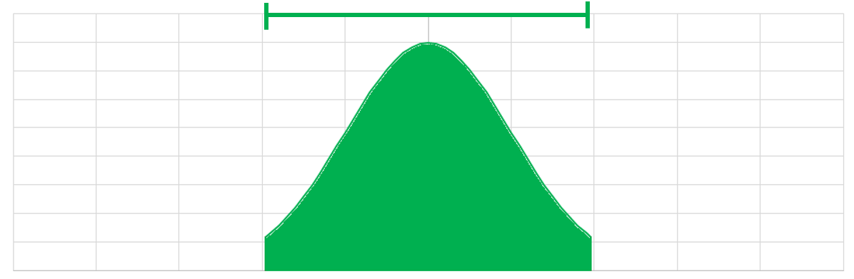

## Three helpful 95% confidence intervals

The manual recommends calculating limits for three helpful 95% CIs. The first interval is illustrated in Figure M-2. Recall that for the traditionally reported CI, we represent the probability distribution of the estimated parameter, and we report the point at which 2.5% of the probability falls to the left and 2.5% of the probability falls to the right. (The distributions in Figures M-1 through M-7 are symmetric for purposes of illustration, but for an estimated binomial proportion, the distribution and the 95% CI will be asymmetric when the estimated probability is not 50%. See Figure M-8.)

#### Figure M-2. The most commonly reported 95% CI is the interval defined by the lowest and highest 2.5% of probability

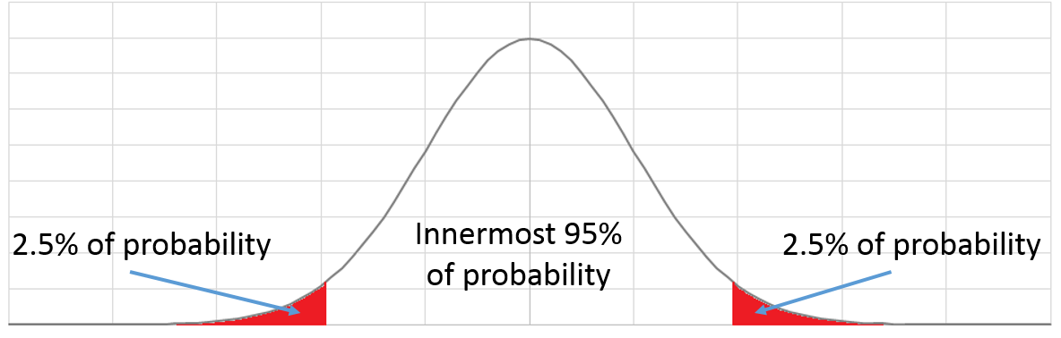

The second helpful interval is represented in Figure M-3. The lower limit of the interval is the point where 5% of the probability falls to the left and 95% falls to the right. We call the left endpoint the 95% lower confidence bound (LCB). For an estimated proportion, it is also valid to call the interval [LCB, 100%) a 95% CI. When specifying an interval, the square bracket “[”or“]” means that the endpoint is included in the interval, and the parenthesis “(“or“)”is **not** included in the interval.

#### Figure M-3. A second useful 95% CI for proportions is defined by the 95% LCB and 1.

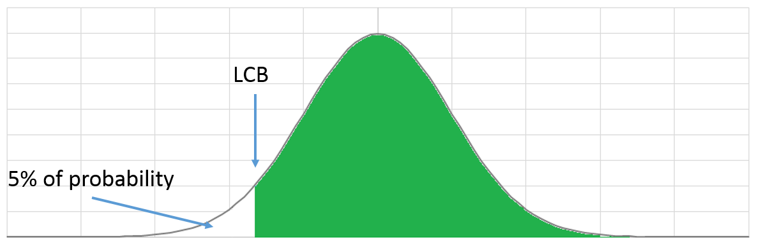

The third helpful interval described here is represented in Figure M-4. The upper limit is the point where 5% of the probability falls to the right and 95% falls to the left. We call the right endpoint the 95% upper confidence bound (UCB). For an estimated proportion, it is also valid to call the interval (0%, UCB] a 95% CI.

#### Figure M-4. A third useful 95% CI for proportions is defined by 0% and the 95% UCB

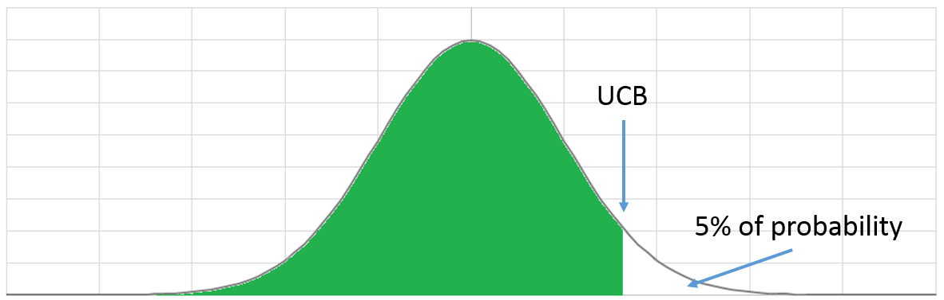

Figure M-5 illustrates the point that the 95% LCB and UCB are located closer to the parameter point estimate than the limits of the traditionally reported, equal-tailed 95% CI.

#### Figure M-5. The 95% LCB and UCB fall inside the traditionally reported 95% CI

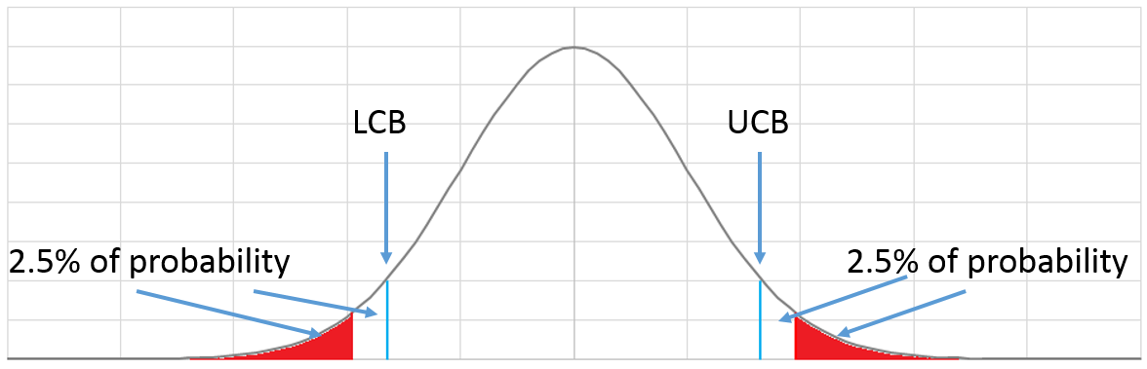

Point Estimate

Subject to the usual caveats about interpreting what a CI means, each of these intervals is equally valid for drawing conclusions with 95% confidence:

* We can be 95% confident that the population parameter (in this case, vaccination coverage) falls within the traditionally reported CI.
* We can be 95% confident that the population parameter is ≥ the LCB.
* We can be 95% confident that the population parameter is ≤ the UCB.

## M.1 Classification using LCB and UCB

If a confidence interval tells where the population parameter is likely to fall, then we can also say that the population parameter is **not** likely to fall in the region outside the interval. This section describes the logic behind the practice of classifying coverage using a 1-sided or 2-sided hypothesis test.

If we want to draw a conclusion about whether coverage is likely to have reached at least a fixed programmatic threshold such as 80%, then we can use a 1-sided hypothesis test where the null hypothesis states that coverage is < 80% and the alternative hypothesis states that coverage is ≥ 80%. If we set α, the probability of a Type I error, to be 5%, then the test statistic is the 95% LCB. If the LCB is ≥ 80%, we reject the null hypothesis and conclude that we can be 95% confident that coverage has reached the threshold. This is a strong conclusion: the sample proportion will need to be high enough that the LCB is ≥ 80% to reach this conclusion. Because we are using the 95% LCB, the probability of mistakenly reaching the conclusion that the LCB will be ≥ 80% if the population coverage is < 80%, will be no more than 5%.

Conversely, if we want to draw a conclusion about whether coverage is likely to be equal to or lower than a threshold – that is, that the stratum very clearly has poor coverage compared with the threshold – then we compute the 95% UCB and compare it with the threshold. If it is less than or equal to the threshold, we might say that we are 95% confident that coverage is less than or equal to the threshold. If the UCB is greater than the threshold, we say that the data do not warrant 95% confidence that coverage is less than or equal to the threshold. The level of confidence can be quantified by the p-value of a test, as reported by statistical software or estimated visually by looking at the where the threshold falls along the graphical distribution.

In some circumstances we might set α to a value other than 5%. If α = 10% then we would calculate a 90% LCB or UCB for purposes of comparison. Annex B gives guidance on selecting sample sizes for classification, and includes power and sample size tables for α = 5% and α = 10%. It also provides equations to calculate sample sizes for other values of α, and provides guidance for setting the other parameters that describe the statistical power of the hypothesis test classifier.

Note that a 1-sided hypothesis test is not the only method of classifying coverage, but it is the one recommended in this manual.

See Annex N for specific examples of classifying coverage.

## M.2 Summarizing the three useful CIs graphically

We recommend portraying the probability distribution associated with the confidence interval graphically, and all three CIs described above are useful for indicating what the survey data have to say about where the population parameter is likely to fall. It is not practical to use three graphical distributions for every estimated parameter. Figure M-6 shows all three for a situation with estimated coverage of 50%, a sample size of 210, and a design effect of 2, as if from a classic EPI 30 x 7 survey with a probability sample. If the traditionally listed CI were presented in the text, we would say the estimated coverage is 50% (95% CI: 40.2%–59.8%). Portrayed graphically, it is the lowest of the three distributions in Figure M-6.

Rather than show three graphical distributions for each estimated coverage figure, we recommend using a graphic like that in Figure M-7, where the traditionally reported 95% CI is shown with a graphical probability distribution, appropriately asymmetric as the estimated coverage approaches 0% or 100%. We recommend that the 95% LCB and UCB be indicated with small black tick marks at the sides of the distribution, to facilitate classification with 95% confidence. The estimated coverage figure can be indicated subtly with a coloured line inside the probability distribution. The colour of the distribution can also be coded to indicate classification results, as described in Annex N. The usefulness of this type of representation becomes more obvious when results are reported for several strata at once, as is true in Annex N, and when the results are plotted along with a relevant programmatic goal.

#### Figure M-6. Three useful CIs for a survey sample with estimated coverage of 50%

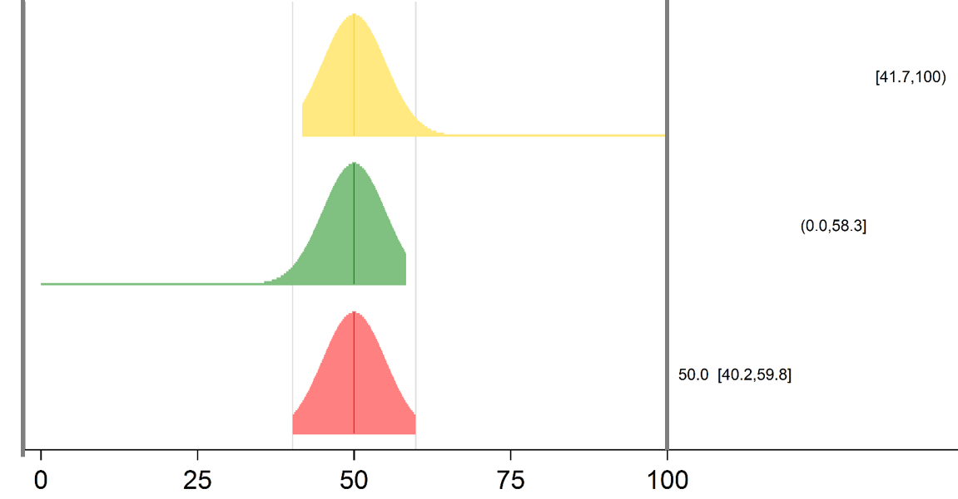

#### Figure M-7. Recommended graphical representation of 95% CI, LCB and UCB

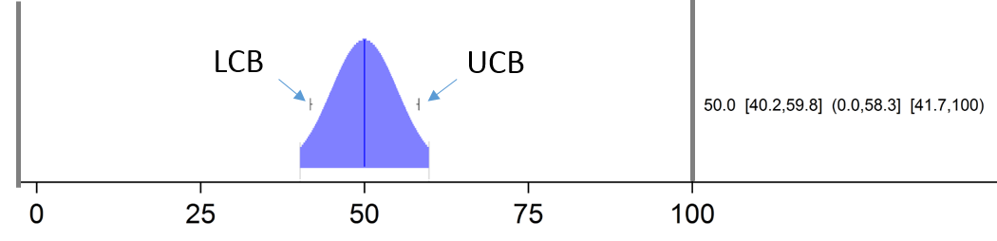

Figure M-8 is the same as Figure 9 found in section 6.5.2 of this manual. Coverage results are portrayed for 24 districts, and there is a red line to indicate the programmatic goal of 95% coverage. The LCB and UCB tick marks allow easy classification with respect to the coverage target: it is possible to tell at a glance which districts have coverage very likely greater than or equal to 95%, which have coverage very likely below 95%, and which districts are near 95%, but we can’t be 95% confident whether their coverage is above or below the threshold. Most of what the survey says about estimated coverage in this province is intuitively understandable from the figure. This Figure lists all three CIs to the right of the graph. It is also possible to remove the CIs from the figure and use an accompanying table instead, devoting the full width of the figure to graphical representation.

Note that the distributions in Figure M-8 use equal area representations of confidence. Within the limits of the figure size, the same number of grey pixels makes up each distribution; each distribution represents 95% confidence. When a district’s confidence is spread over a wide region, the distribution is not tall, because those pixels have to cover a wide expanse. When the confidence is confined to a narrow region, as for the province-level distribution or for districts H, L, and C, then the distributions are much taller in the centre, hopefully attracting the reader’s eye and making it clear that the survey inference about coverage is quite precise.

As mentioned above, WHO will provide software to create these figures in commonly used statistical packages. The final version of this document will also include some graphical representations of survey results from pilot surveys. It is our hope that this representation will shift attention away from a single-minded focus on coverage point estimates, and intuitively communicate what the survey does and does not tell us about likely coverage levels.

Of course, narrower confidence intervals mean that we have high precision – a good idea of where coverage is likely to fall. While wide CIs mean that our confidence is less focused, even wide CIs give a clear indication of where coverage is likely **not** to fall, which can often be helpful.

Finally, interpretation of these figures is subject to all the usual caveats that should accompany confidence intervals: if there are important biases in the survey methods or execution, then the true population coverage can fall far below or far above the 95% confidence interval. In order for the CIs to be meaningful, it is important to make every effort to keep biases to an absolute minimum. The survey report should describe efforts to minimize bias in great detail, and should be honest about those biases that may have crept in to the project, so that readers of the report can draw a helpful conclusion about whether the CIs are likely to be meaningful (that is, fall near the true population coverage values). When bias has been minimized, the confidence intervals are useful for purposes of classification, as described in Annex N.

#### Figure M-8. Graphical coverage survey results for 24 districts and the province that they comprise

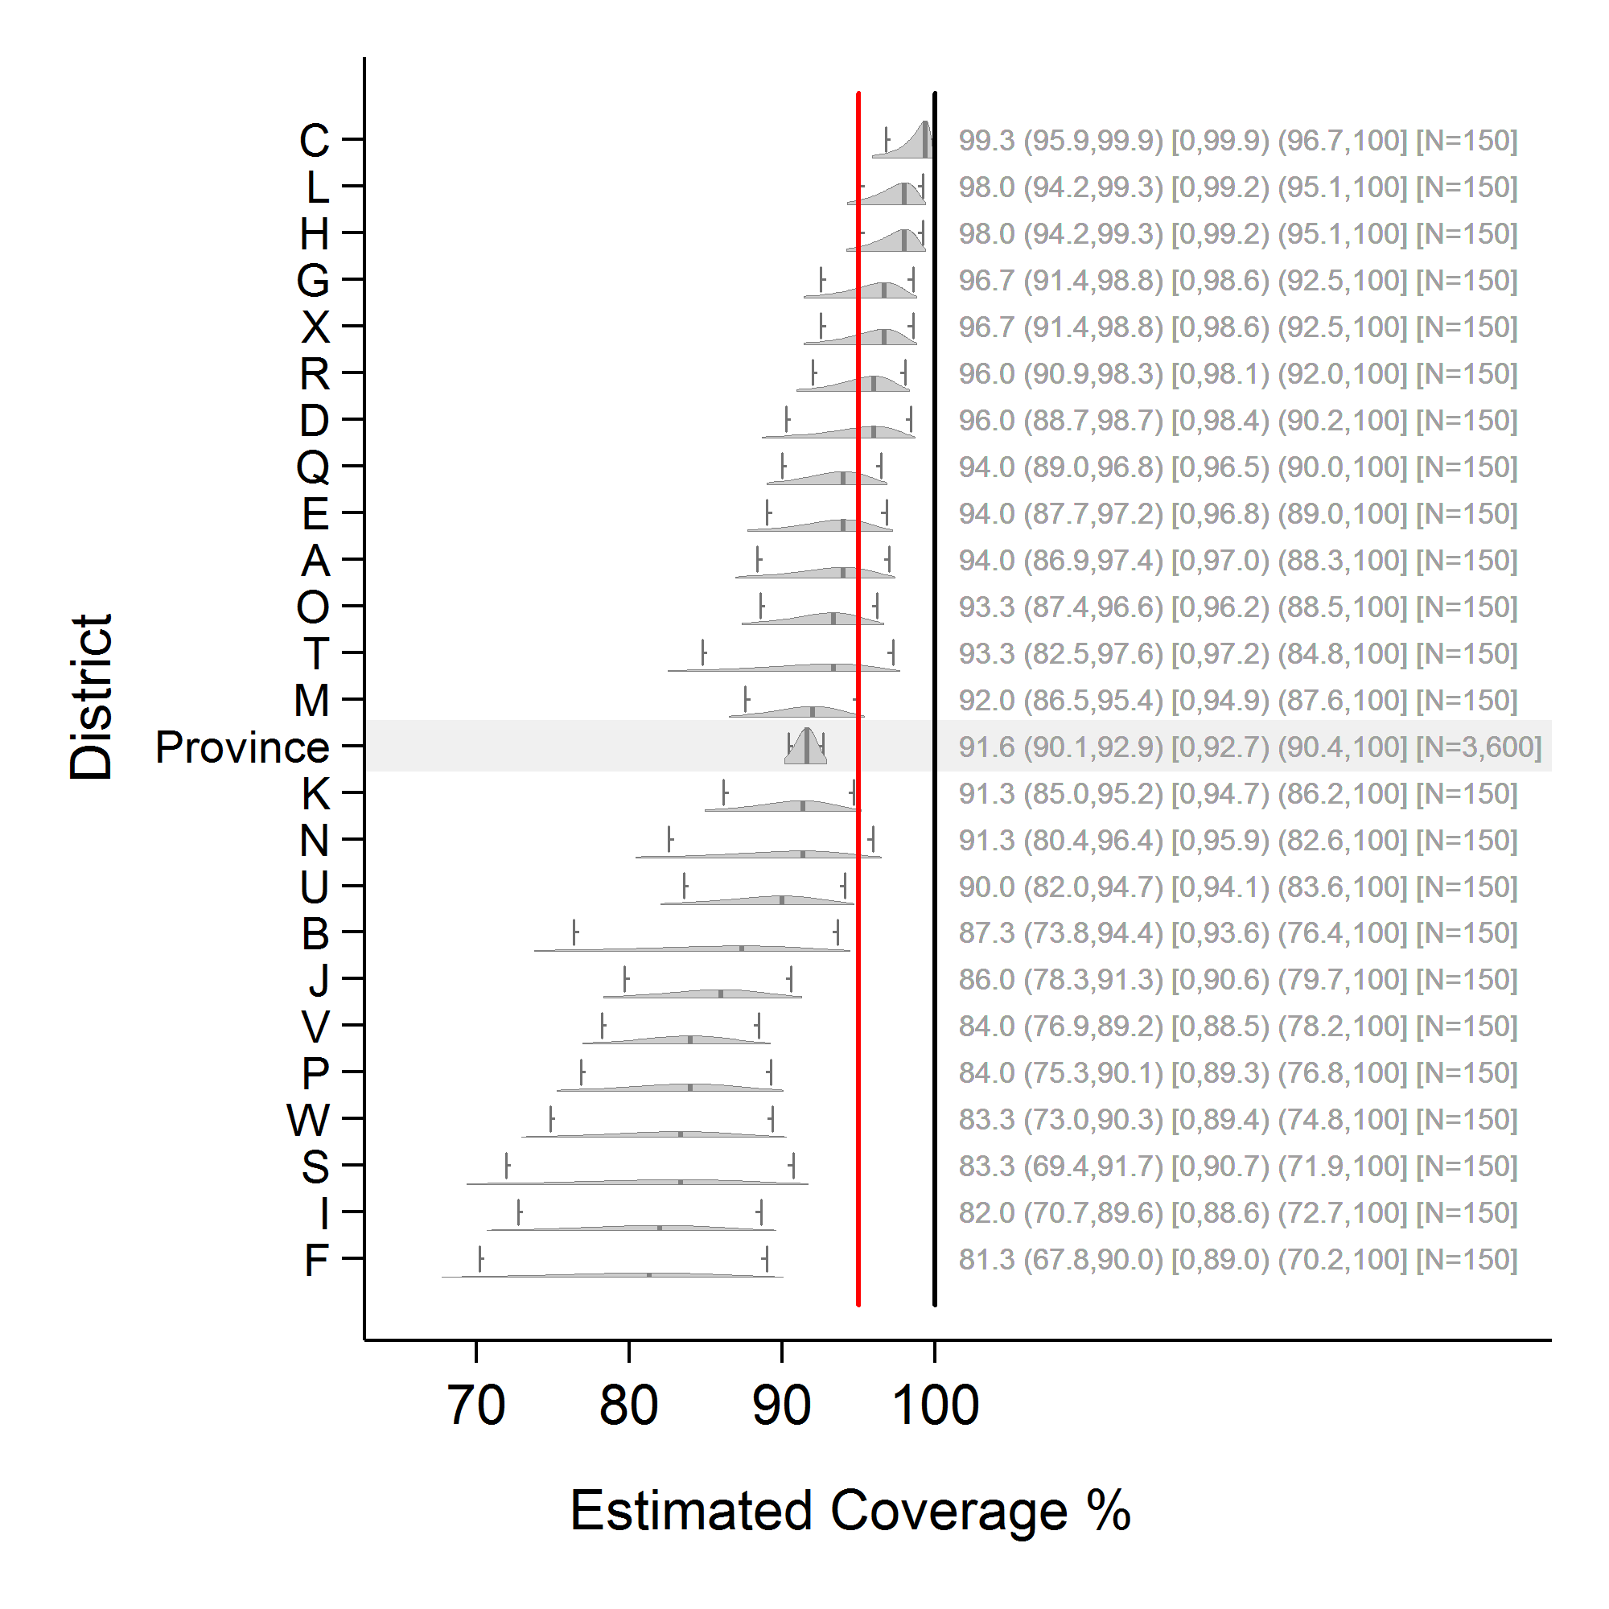

# Annex N: Examples of classifying vaccination coverage

In this annex we apply four different classification rules to the same coverage estimation results, and consider the merits of:

1. classifying into three categories, high, low and intermediate, rather than using only two categories
2. portraying classification results graphically rather than using only tabular output.

## N.1 Classifying coverage into categories

This manual recommends using upper and lower confidence bounds (usually 95% confidence bounds) to accomplish classification. This is an implementation of a 1-sided hypothesis test. If we apply a single test then we obtain two classification categories, which may be given different labels depending on the context. In this annex we call them *pass* for high coverage and *fail* for low coverage. If two hypothesis tests are applied instead, then there could be three outcome categories: high, low, and intermediate.

Figures N-1 through N-4 portray the same data as those in Figure 9 in section 6.5.2 of this manual: estimated measles SIA coverage for 24 fictional districts, based on samples of 15 clusters and 10 respondents per cluster in each district. For each district, the 95% confidence interval is indicated using a coloured probability distribution that has been clipped at the upper and lower limits of the interval. The 95% upper and lower confidence bounds are indicated with small black tick marks.

Three intervals are listed at the right side of each distribution. The first is the classic 2-sided 95% confidence interval. The second is the interval that extends from 0% coverage up to the 95% upper confidence bound. The third is the interval that extends from the 95% lower confidence bound up to coverage of 100%. All three intervals are equally valid for drawing conclusions with 95% confidence. The regions are plotted in increasing order of coverage point estimate, from bottom to top. The red vertical line marks the spot where coverage is 95%, an important programmatic threshold for measles. The district data are aggregated to estimate province coverage (shaded with a light gray bar) very precisely.

The following four classification rules could be applied to the results:

1. A simple rule might use only the point estimate to classify, assigning the label *pass* to districts where the estimated coverage is greater than or equal to 95% and *fail* to those with estimated coverage below 95%. See Figure N-1.
2. Another rule might say that districts where the lower 95% confidence bound is greater than or equal to 95% coverage should be designated as *pass*, and all others should be designated *fail*. See Figure N-2.
3. Conversely, we could say that any district where the upper 95% confidence bound is less than 95% is designated as *fail*, and all others are designated *pass*. See Figure N-3.
4. The final alternative has some important advantages over the previous three: it assigns three labels instead of two. If the lower 95% confidence bound is greater than or equal to 95%, call it *pass*; if the upper 95% confidence bound is below 95%, call it *fail*; and otherwise call the results *intermediate*. See Figure N-4.

#### Figure N-1. The 24 districts, with coverage color-coded into two categories: *pass* if point estimate ≥ 95% and *fail* otherwise

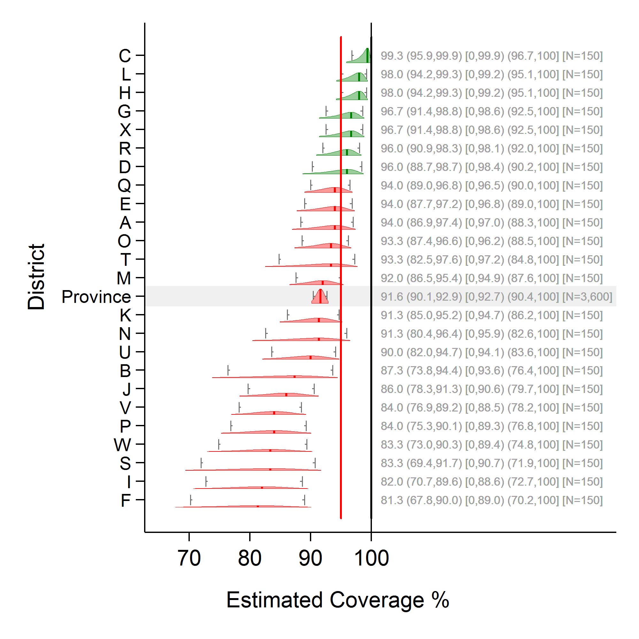

In Figure N-1, the green districts denote any stratum with a survey-weighted coverage point estimate equal to or above 95%, regardless of the precision of the estimate. Red districts similarly denote any stratum with a survey-weighted coverage point estimate below 95%, regardless of the precision of the estimate. Both classifications are very clear but comparatively weak in that they do not incorporate any information about the precision of the estimate. Districts with coverage very near the threshold of 95% could easily be misclassified, and the labels do not distinguish between those areas like district F, which clearly falls well below the threshold, and districts A, E, and Q, which have about one-third of their probability distributions falling above the threshold.

Figure N-2. The same 24 districts, with coverage colour coded into two categories: pass if LCB ≥ 95% and fail otherwise

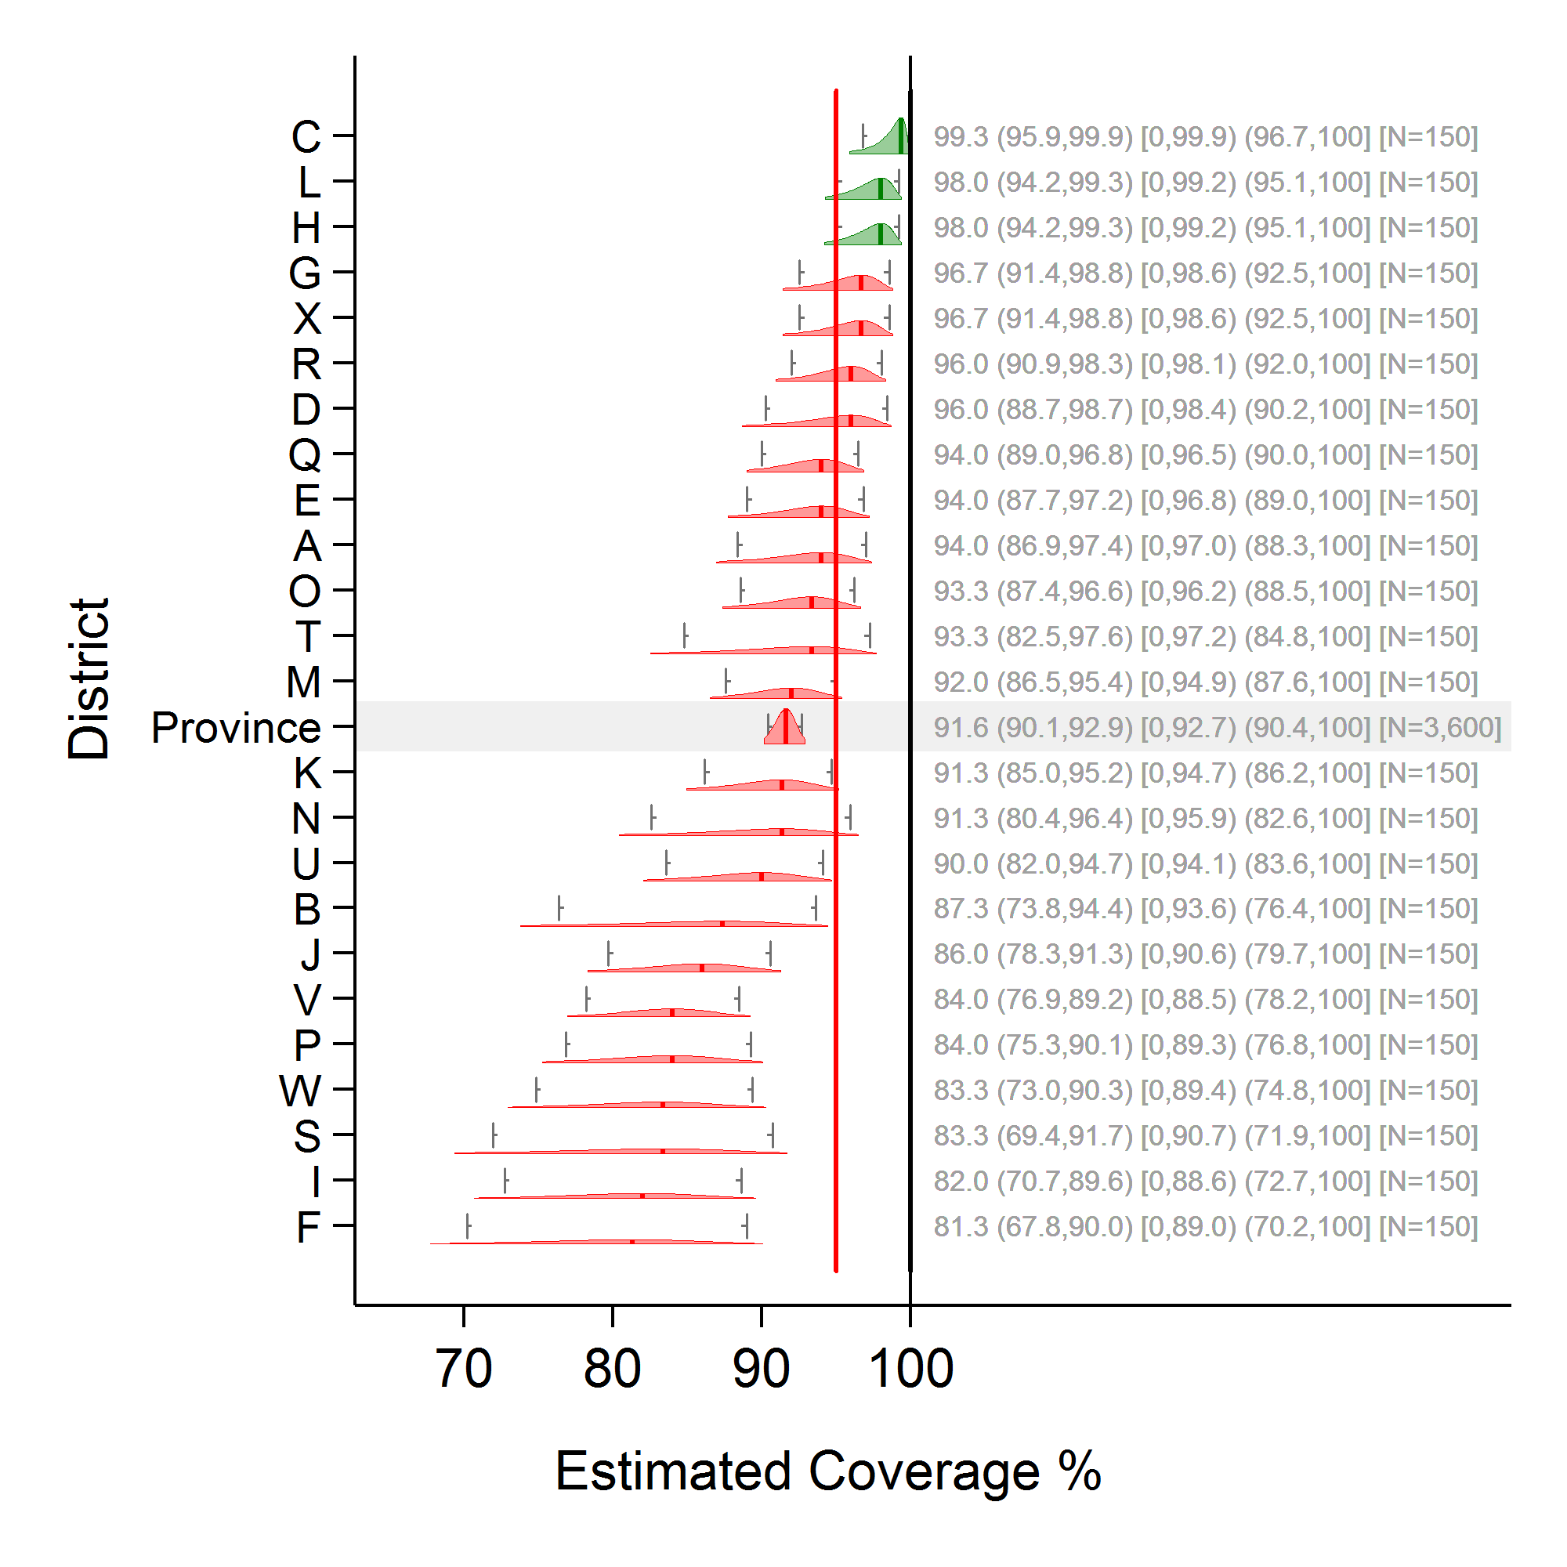

In Figure N-2, the green distributions indicate strata (districts) where the 95% lower confidence bound is equal to or above 95%. These districts are classified as *pass*, and we can be 95% confident that the campaign coverage there is at least 95%. This is a strong conclusion with α = 5%.

The red districts show any stratum that was not classified as *pass*. These are locations where we cannot be 95% confident that the campaign coverage was at least 95%. This is a comparatively weak conclusion. Note especially districts X and G; they may very well have achieved campaign coverage equal to or above 95%, but they simply did not reach the strict criterion to be classified as *pass* according to this rule. Thus its categorization as *fail*, along with that of districts like F, I, S, W, P, V, and J that are clearly below 95%, is a weak categorization because they are all categorized together even though their campaign performances appear to be quite different.

In some cases this conservative categorization is desirable because it continues to assume that coverage may be low until there is very strong evidence to the contrary. That may be prudent and in the best interest of the children of these districts. But it would be unfortunate to simply report the pass/fail status of the districts, and disregard the information contained in the confidence intervals and boundaries. Even when confidence intervals are wide, they may still be very informative, so we recommend portraying results graphically in this manner, along with the results of the classification rule.

#### Figure N-3. The same 24 districts, with coverage colour coded into two categories: *fail* if upper confidence bound ≤ 95% and *pass* otherwise

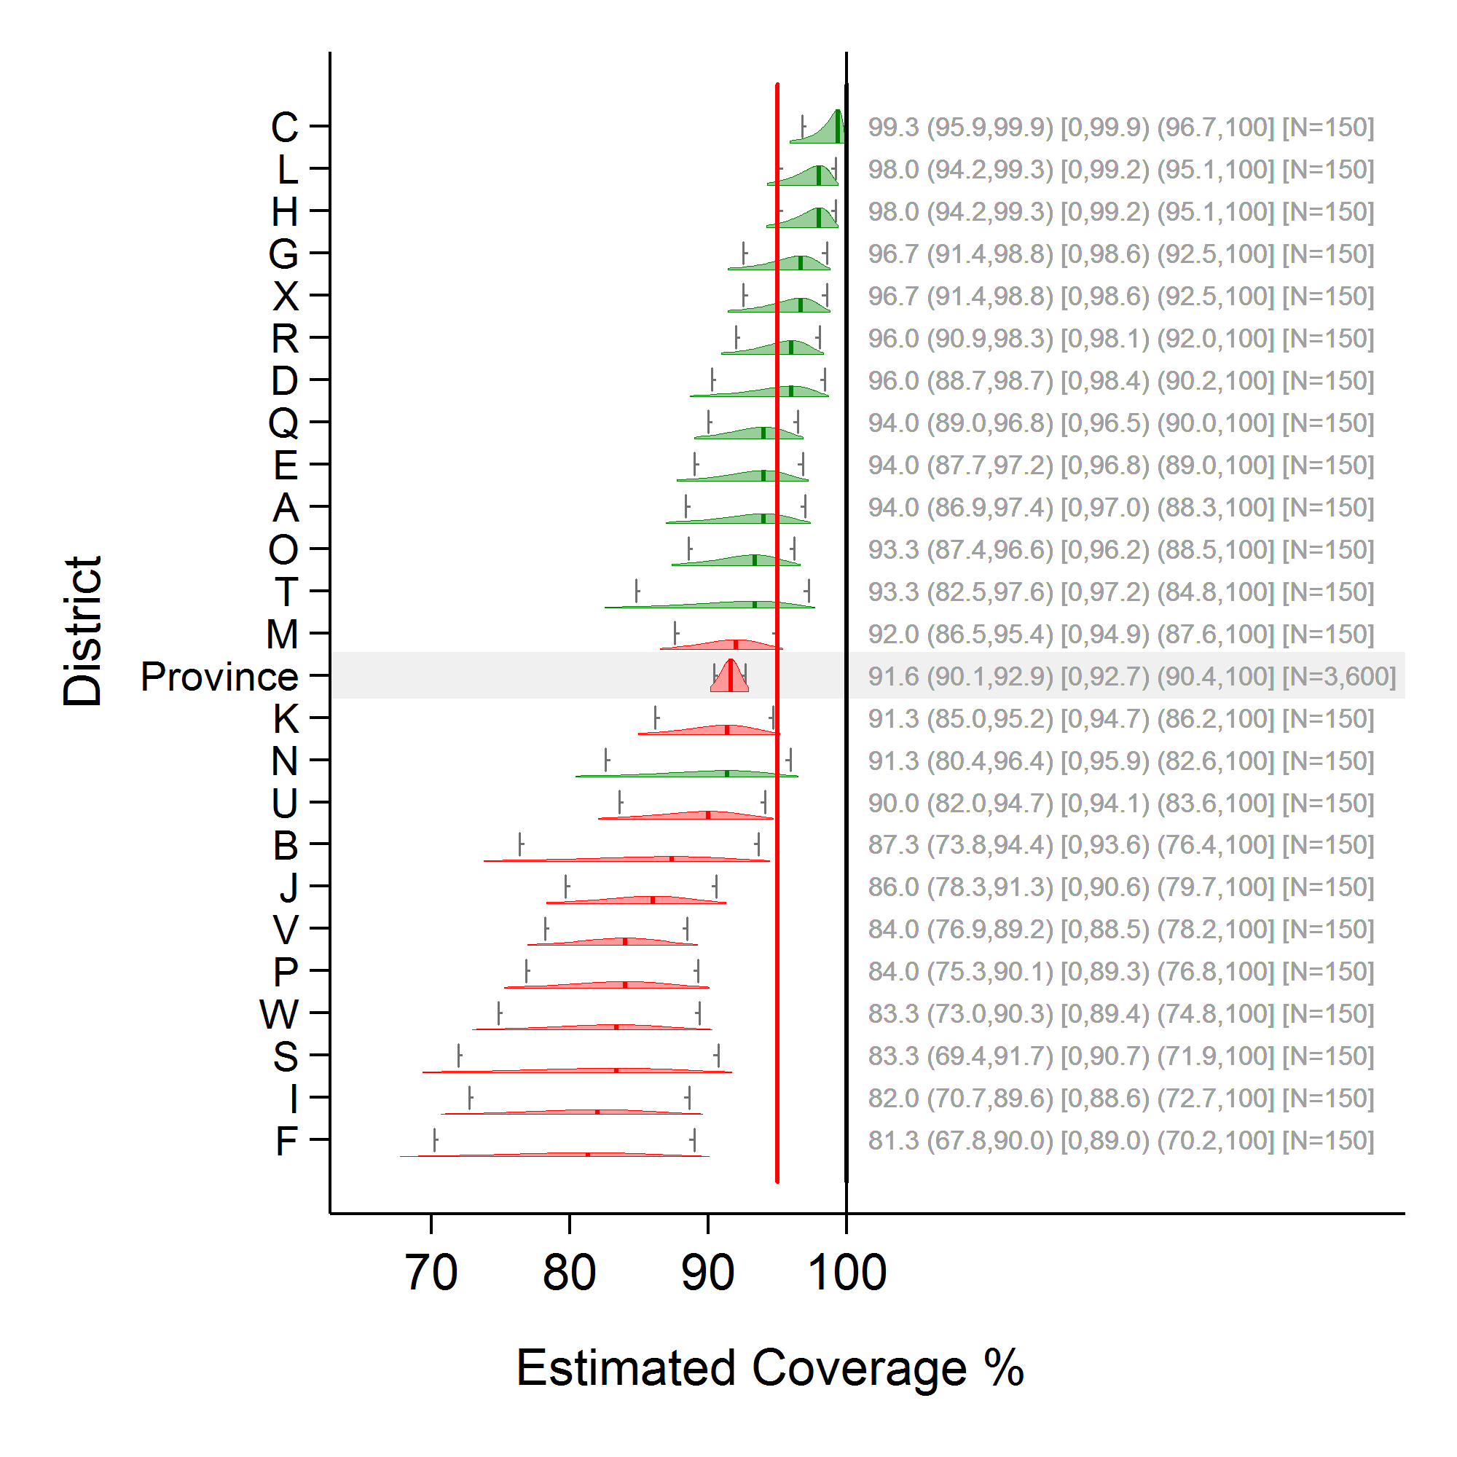

In Figure N-3, the red districts denote any stratum with an upper 95% confidence bound that is above 95%. We can be 95% confident that campaign coverage in these strata is above 95%. This is a strong conclusion with α = 5%.

Green districts denote strata where the upper 95% confidence bound is at or above 95%. The green *pass* classification does not guarantee that their coverage is at or above 95%, but only that we cannot say that their coverage is below 95% with α = 5%. This characterization of *pass* is weak compared to that in figure N-2. Note especially districts N, T, and O. The classification scheme assigns them green distributions, and yet the vast majority of their confidence bands fall below the 95% coverage threshold.

Again, it would be unfortunate and possibly misleading to report only the results of the classification rule. Show the coverage graphically with confidence intervals, along with the classification outcomes.

The rules used in Figures N-1 through N-3 each result in a two-outcome classification, in which each district either passes or fails and the criterion is clear. In each case, one or more of the categorizations is comparatively weak in conveying confidence that coverage is above or below 95%.

A three-outcome scheme that can be informative is portrayed in Figure N-4. The classification rules are as follows:

* If the lower 95% confidence bound is at or above the threshold of interest (for example, 95%), conclude that district coverage is very likely to be at or above 95%.
* If the upper 95% confidence bound is below 95%, conclude that the district coverage is very likely to be below 95%.
* If 95% falls between the lower and upper confidence bounds, conclude that the sample size is too small to say confidently whether the district coverage is above or below 95%. Call this category *intermediate*.

In Figure N-4, green distributions indicate strata (districts) where the 95% lower confidence bound is at or above 95%. These districts are classified as *pass*. This is a strong conclusion, and we can be 95% confident that the campaign coverage there is at least 95%.

Red distributions indicate districts where the 95% upper confidence bound is below 95%. These districts are classified as *fail*. This is a strong conclusion, and we can be 95% confident that the campaign coverage there is below 95%.

Yellow distributions indicate districts with confidence bounds that straddle the 95% threshold, so these data cannot be used to classify them the districts as higher or lower than 95% (pass or fail) at α = 5%. We might say that coverage is either too close to 95% or estimated too imprecisely to confidently categorize the district as above or below that important threshold. Depending on your perspective, this might be considered either a strong or weak conclusion.

Note that the number of yellow districts will be a function of true coverage, sample size, ICC (intraclass correlation) and α (alpha). If we relaxed alpha to 10% (results not shown here), districts N and O would likely be classified as *fail*, and no additional districts would be likely to pass.

Annex B1 helps survey designers select a sample size that increases the likelihood that coverage at the district-level will be far enough from the threshold to be classified correctly as *pass* or *fail*. If the coverage is very near the threshold, a large and expensive survey would be required to classify those districts confidently and give policymakers a conclusion that is both strong and accurate. If you restrict the classification to two levels (pass or fail), the results will appear to be simpler, but one or both of the two classifications will always be imprecise, and therefore weak and probably misleading for some districts, when communicated without the corresponding confidence interval.

#### Figure N-4. The same 24 districts, with coverage color-coded into three categories: *fail* if upper confidence bound ≤ 95%, *pass* if lower confidence bound ≥ 95%, and *intermediate* otherwise

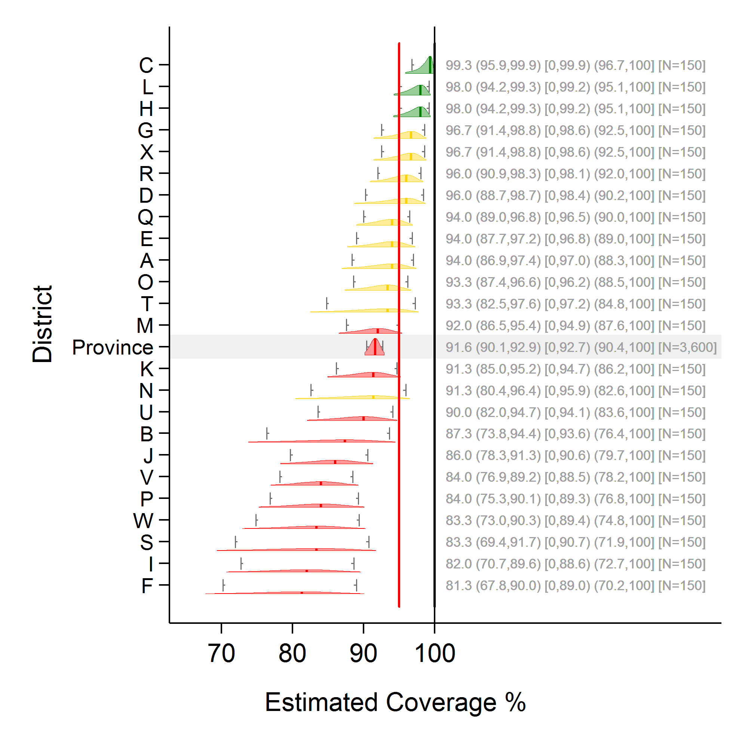

## N.2 Improving clarity of results by using graphs

Regardless of how the sample size was originally determined, the scheme for assigning labels like *pass* and *fail* should be clear as long as the classification logic is described clearly, and the point estimates and confidence intervals or bounds are listed. We recommend that plots similar to those in this annex be constructed and reported for each antigen and dose of interest, for each level of administrative hierarchy in the survey, showing the 95% confidence interval, the upper and lower 95% confidence bounds, and the coverage point estimate. Much of what needs to be inferred about coverage will be self-evident with these plots, and any classification schemes should be easy to understand as well.

# Annex O: Missed opportunities for vaccination (MOV) analysis

## O.1 Introduction

A broad variety of authors in the peer-reviewed literature have calculated reasonable and logical measures for missed opportunities for vaccination (MOV) based on survey datasets. As far as we are aware, however, there is no definitive guide or consensus document regarding which measures are clearest and most helpful to EPI programme managers.

Some measures are likely to be better than others for specific purposes. This annex provides some details and worked examples of MOV analysis, working through vaccination records for five children and precisely calculating the numerators and denominators for the measures suggested in this manual. Furthermore, this annex illustrates that the calculations are complicated by whether and how one addresses the topic of doses administered too early (either before the minimum age of eligibility or before the minimum intra-dose interval has elapsed). If the calculations utilize a crude dose analysis and count all doses that are administered, the calculations will yield one set of MOV results. If, instead, a valid dose analysis is conducted and the calculations do not include doses that were administered early, children who received early doses will be considered to be under-vaccinated, and as having missed more opportunities for vaccination than would be counted for them in a crude dose analysis. Whether you prefer the crude or valid dose MOV analysis may depend on the main objective of your analysis.

The calculations for the valid dose analysis are substantially more complicated than those for crude doses, so it may suffice to do the crude calculations and then include language in the survey report explaining that the MOV results represent a lower bound, and that higher rates of MOV would likely result from a valid-dose analysis. The document can point to the difference between crude and valid dose coverage, which is calculated as part of the standard coverage survey analysis, to demonstrate the degree to which a crude dose MOV analysis might underestimate what would be obtained in a valid dose analysis.

Alternately, if the survey analyst is familiar with the analysis and able to work through the many combinations of how to count doses in the valid dose analysis; the survey report might include a valid dose MOV analysis.

WHO intends to provide open-source software to accompany this manual. This software will implement and automate many of the analyses described here, but it has not yet been determined whether the valid dose MOV analysis can be made generic enough to fit a wide variety of vaccination schedules and data quality issues with vaccination dates. At the time of this writing, a valid dose MOV analysis is best conducted in collaboration with someone who has worked through the difficult issues and done a similar analysis before.

## O.2 Examples

Two examples will be worked through to illustrate an MOV analysis. The first example consists of faux data for five children, and the second example uses actual data from a recent Demographic and Health Survey (DHS).

First, consider the following dates of vaccination for five children in a country whose vaccination schedule is:

1. DTPCV, OPV, and RV (three-dose formulation of RV) beginning at a minimum age of six weeks and with a minimum interval of four weeks between doses;
2. OPV0 from birth to two weeks and BCG from birth; and
3. MCV1 from age 9 months. Note that in this example, for simplicity, no vaccines were received early (that is, before the child was eligible to receive them) and all vaccines were received before the child was 12 months old.

#### Table O-1: Dates of vaccination for five children

|  |  |  |  |  |  |  |
| --- | --- | --- | --- | --- | --- | --- |
|  |  | Child A | Child B | Child C | Child D | Child E |
|  | Date of birth (d/m/y) | 05/05/2012 | 15/08/2012 | 20/09/2012 | 18/07/2012 | 17/05/2012 |
| From birth | BCG | 07/05/2012 | 25/08/2012 | 19/12/2012 | 17/04/2013 | 29/05/2012 |
| From birth to two weeks | OPV0 | 07/05/2012 | 29/08/2012 |  |  | 29/05/2012 |
| From six weeks | DTPCV1 | 16/06/2012 | 26/09/2012 | 01/11/2012 | 29/08/2012 | 06/07/2012 |
| OPV1 | 16/06/2012 | 06/10/2012 | 08/11/2012 | 29/08/2012 | 06/07/2012 |
| RV1 | 16/06/2012 | 26/09/2012 | 08/11/2012 | 29/08/2012 | 20/07/2012 |
| At least four weeks after previous dose | DTPCV2 | 16/07/2012 | 03/11/2012 | 29/11/2012 | 26/09/2012 | 19/08/2012 |
| OPV2 | 16/07/2012 | 03/11/2012 | 29/11/2012 | 26/09/2012 | 18/09/2012 |
| RV2 | 16/07/2012 | 24/10/2012 | 29/11/2012 | 26/09/2012 | 19/08/2012 |
| At least four weeks after previous dose | DTPCV3 | 13/08/2012 | 13/12/2012 | 20/06/2013 |  | 16/09/2012 |
| OPV3 | 13/08/2012 | 13/12/2012 | 20/06/2013 |  | 16/10/2012 |
| RV3 | 13/08/2012 | 13/12/2012 | 20/06/2013 |  | 16/10/2012 |
| From nine months | MCV1 | 02/02/2013 | 11/06/2013 |  | 17/04/2013 | 14/02/2013 |
|  | Fully vaccinated | Yes | Yes | No | No | Yes |

Child A received all vaccines at or close to the recommended age with no MOV. This child had been seen on five separate occasions, none of which resulted in MOV.

Child B had a MOV for OPV0 which could have been given on the same day as BCG, another MOV for OPV1 which could have been given on the same date as DTPCV1 and RV1, and a third MOV for DTPCV2 which could have been given on the same date as RV2. (Note that OPV2 could not have been given on that date because fewer than 28 days had passed since OPV1.) The child had been seen on eight separate occasions, three of which resulted in at least one MOV. All MOVs were corrected by the time of the survey.

Child C had three MOVs for BCG, which could have been given on the same date as DPTCV1, OPV1/RV1, or DPTCV2/OPV2/RV2. There was also an MOV for OPV1 and RV1, which could have been given on the same date as DTPCV1, and another MOV for MCV1, which could have been given on the same date as the third dose of DTPCV, OPV, and RV. The child had still not received MCV1 by the time of the survey (an uncorrected MOV), but all other MOVs were corrected by the time of the survey. The child had been seen on five separate occasions, four of which resulted in at least one MOV. (Note that although the child did not receive OPV0, there had been no opportunity for it because the other vaccines were all given after 14 days of age.)

Child D had two MOVs for BCG, which could have been given at the time of the first or second dose of DTPCV. This child also had an MOV for the third dose of DTPCV, OPV, and RV, which could have been received at the same time as MCV1. The child had not received the latter vaccinations by the time of the survey (an uncorrected MOV). The child had been seen on three separate occasions, all three of which resulted in at least one MOV. (Note that although the child did not receive OPV0, there had been no opportunity for it because the other vaccines were all given after 14 days of age.)

Child E had an MOV for RV1, which could have been received on the same date as DTPCV1 and OPV1; , two MOVs for OPV2, which could have been received on the same date as DTPCV2 or DPTCV3; , and two MOVs for RV3, which could have been received on the same date as DTPCV3 or OPV2. This child had been seen on eight separate occasions, four of which resulted in at least one MOV. All MOVs were corrected by the time of the survey.

Data from all the children in the survey can be cumulated to develop tables such as those shown below. Table O-2 through O-4 are intermediate calculations for the latter three summary tables (Tables O-5 through O-7), and are shown for illustrative purposes. Summing across all five children for each vaccine in the intermediate tables produces counts in the latter three summary tables. The summary tables, O-5 through O-7, are the tables we suggest should be shown in an MOV analysis report. Add rows to the table for other vaccines in the survey that are not listed in these example tables (for example, HBV0, PCV1–3, YF1).

### Visit-based analyses

The visit-based (VB) analysis consists of three calculations: the proportion of visits resulting in MOV for each vaccine (VB1), the proportion of visits resulting in at least one MOV across all vaccines (VB2), and the rate of MOVs per visit across all vaccines (VB3).

*(VB1) Proportion of visits resulting in an MOV for a given vaccine:*

Numerator: Number of visits where a child received another vaccine (proven by card or register) and was eligible for the considered dose, but did not receive the considered dose

Denominator: Number of visits where a child was eligible to receive the considered dose

*(VB2) Proportion of visits with at least one MOV (across all vaccines)*

Numerator: Number of visits with at least one MOV (for any vaccine)

Denominator: Number of visits where a child was eligible to receive at least one vaccine

*(VB3) Rate of MOVs per visit (across all vaccines)*

Numerator: Number of MOVs summed across all vaccines (i.e., sum of VB1 numerator across all vaccines)

Denominator: Same denominator as (VB2)

Note: This calcuation is a rate, and so results greater than one are plausible.

#### Table O-2: Number of visits resulting in an MOV for a given vaccine, broken out by child ID (intermediate step for visit-based analysis)

|  |  |  |  |  |  |  |  |  |  |  |  |  |
| --- | --- | --- | --- | --- | --- | --- | --- | --- | --- | --- | --- | --- |
| Vaccine | Child ID: Contribution to the Numerator | | | | |  | Child ID: Contribution to the Denominator | | | | |  |
| A | B | C | D | E | Total numerator | A | B | C | D | E | Total denominator |
| BCG | 0 | 0 | 3 | 2 | 0 | 5 | 1 | 1 | 4 | 3 | 1 | 10 |
| OPV0 | 0 | 1 | - | - | 0 | 1 | 1 | 2 | - | - | 1 | 4 |
| DTPCV1 | 0 | 0 | 0 | 0 | 0 | 0 | 1 | 1 | 1 | 1 | 1 | 5 |
| OPV1 | 0 | 1 | 1 | 0 | 0 | 2 | 1 | 2 | 2 | 1 | 1 | 7 |
| RV1 | 0 | 0 | 1 | 0 | 1 | 2 | 1 | 1 | 2 | 1 | 2 | 7 |
| DTPCV2 | 0 | 1 | 0 | 0 | 0 | 1 | 1 | 2 | 1 | 1 | 1 | 6 |
| OPV2 | 0 | 0 | 0 | 0 | 2 | 2 | 1 | 1 | 1 | 1 | 3 | 7 |
| RV2 | 0 | 0 | 0 | 0 | 0 | 0 | 1 | 1 | 1 | 1 | 1 | 5 |
| DTPCV3 | 0 | 0 | 0 | 1 | 0 | 1 | 1 | 1 | 1 | 1 | 1 | 5 |
| OPV3 | 0 | 0 | 0 | 1 | 0 | 1 | 1 | 1 | 1 | 1 | 1 | 5 |
| RV3 | 0 | 0 | 0 | 1 | 2 | 3 | 1 | 1 | 1 | 1 | 3 | 7 |
| MCV1 | 0 | 0 | 1 | 0 | 0 | 1 | 1 | 1 | 1 | 1 | 1 | 5 |

#### Table O-3: Number of visits with at least one MOV (across all vaccines), broken out by child ID (intermediate step for visit-based analysis)

|  |  |  |  |  |  |  |  |  |  |  |  |  |
| --- | --- | --- | --- | --- | --- | --- | --- | --- | --- | --- | --- | --- |
| Vaccine | Child ID: Contribution to the Numerator | | | | |  | Child ID: Contribution to the Denominator | | | | |  |
| A | B | C | D | E | Total numerator | A | B | C | D | E | Total denominator |
| BCG | 0 | 3 | 4 | 3 | 4 | 14 | 5 | 8 | 5 | 3 | 8 | 29 |
| OPV0 |
| DTPCV1 |
| OPV1 |
| RV1 |
| DTPCV2 |
| OPV2 |
| RV2 |
| DTPCV3 |
| OPV3 |
| RV3 |
| MCV1 |

### Child-based analyses

The child-based (CB) analysis consists of two calculations: the proportion of children who had at least one MOV for a given vaccine (CB1), and the proportion of children with at least one MOV across all vaccines (CB2). CB1 can be further subdivided into the proportion of children who never received the particular vaccine (an uncorrected MOV) vs. those who did receive it by the time of the survey (a corrected MOV). Similarly, CB2 can be subdivided into the proportion of children for whom none, all or some of the MOVs were corrected by the time of the survey.

*(CB1) Proportion of children who had at least one missed opportunity for a given vaccine:*

Numerator: Number of children with at least one vaccination date recorded who were eligible to receive the considered dose, but did not receive the considered dose

Denominator: Number of children with at least one vaccination date recorded who were eligible to receive the considered dose

Subdividing (CB1):

*(CB1a) Proportion of children with uncorrected MOVs*

Numerator: Children in (CB1) numerator who had not received the given vaccine by the time of the survey

Denominator: Same denominator as (CB1)

*(CB1b) Proportion of children with corrected MOVs*

Numerator: Children in (CB1) numerator who had received the given vaccine at a later visit as evidenced by the vaccination card

Denominator: Same denominator as (CB1)

*(CB2) Proportion of children who had at least one missed opportunity for any vaccine:*

Numerator: Number of children with at least one vaccination date recorded who did not receive a vaccine/dose when they were eligible for it

Denominator: Number of children with at least one vaccination date recorded who were eligible to receive at least one vaccine/dose

Subdividing (CB2):

*(CB2a) Proportion of children with no corrected MOVs corrected*

Numerator: Children in (CB2) numerator who had not received the vaccine(s) by the time of the survey

Denominator: Same denominator as (CB2)

*(CB2b) Proportion of children with all corrected MOVs corrected*

Numerator: Children in (CB2) numerator who had received the vaccine(s) at a later visit as evident on the vaccination card

Denominator: Same denominator as (CB2)

*(CB2c) Proportion of children with some corrected MOVs corrected*

Numerator: Children in (CB2) numerator who had received some, but not all, of the vaccine(s) at a later visit, as evidenced by the vaccination card

Denominator: Same denominator as (CB2)

#### Table O-4: Number of children who had at least one missed opportunity for a given vaccine, broken out by child ID (intermediate step for child-based analysis)

|  |  |  |  |  |  |  |  |  |  |  |  |  |
| --- | --- | --- | --- | --- | --- | --- | --- | --- | --- | --- | --- | --- |
| Vaccine | Child ID: Contribution to the Numerator | | | | |  | Child ID: Contribution to the Denominator | | | | |  |
| A | B | C | D | E | Total Numer-ator | A | B | C | D | E | Total Denom-inator |
| BCG | 0 | 0 | 1 | 1 | 0 | 2 | 1 | 1 | 1 | 1 | 1 | 5 |
| OPV0 | 0 | 1 | - | - | 0 | 1 | 1 | 1 | - | - | 1 | 3 |
| DTPCV1 | 0 | 0 | 0 | 0 | 0 | 0 | 1 | 1 | 1 | 1 | 1 | 5 |
| OPV1 | 0 | 1 | 1 | 0 | 0 | 2 | 1 | 1 | 1 | 1 | 1 | 5 |
| RV1 | 0 | 0 | 1 | 0 | 1 | 2 | 1 | 1 | 1 | 1 | 1 | 5 |
| DTPCV2 | 0 | 1 | 0 | 0 | 0 | 1 | 1 | 1 | 1 | 1 | 1 | 5 |
| OPV2 | 0 | 0 | 0 | 0 | 1 | 1 | 1 | 1 | 1 | 1 | 1 | 5 |
| RV2 | 0 | 0 | 0 | 0 | 0 | 0 | 1 | 1 | 1 | 1 | 1 | 5 |
| DTPCV3 | 0 | 0 | 0 | 1 | 0 | 1 | 1 | 1 | 1 | 1 | 1 | 5 |
| OPV3 | 0 | 0 | 0 | 1 | 0 | 1 | 1 | 1 | 1 | 1 | 1 | 5 |
| RV3 | 0 | 0 | 0 | 1 | 1 | 2 | 1 | 1 | 1 | 1 | 1 | 5 |
| MCV1 | 0 | 0 | 1 | 0 | 0 | 1 | 1 | 1 | 1 | 1 | 1 | 5 |

#### Table O-5: Visit-based analysis: Missed opportunities for vaccination among (n = 5) children with a documented date of vaccination for at least one vaccine

|  |  |  |  |  |  |  |  |
| --- | --- | --- | --- | --- | --- | --- | --- |
|  | Number of visits where a child is eligible to receive the vaccine | Number of visits resulting in a MOV | Percent of visits resulting in a MOV | Number of visits where child was eligible to receive at least one vaccine | Number of visits resulting in 1+ MOV | Percent of visits resulting in 1+ MOV | Rate of MOVs per visit (# of vaccines missed per visit) |
|  | VB1 Denominator | VB1 Numerator | VB1 | VB2  Denominator | VB2  Numerator | VB2 | VB3 |
| Vaccine/dose |
| BCG | 10 | 5 | 50.0 | 29 | 14 | 48.3 | 19/29=0.66 (Implies 1 MOV per (1/0.66)=1.5 visits) |
| OPV0 | 4 | 1 | 25.0 |
| DTPCV1 | 5 | 0 | 0.0 |
| OPV1 | 7 | 2 | 28.6 |
| RV1 | 7 | 2 | 28.6 |
| DTPCV2 | 6 | 1 | 16.7 |
| OPV2 | 7 | 2 | 28.6 |
| RV2 | 5 | 0 | 0.0 |
| DTPCV3 | 5 | 1 | 20.0 |
| OPV3 | 5 | 1 | 20.0 |
| RV3 | 7 | 3 | 42.9 |
| MCV 1 | 5 | 1 | 20.0 |

**Note**: A child can have more than one MOV for a given vaccine. For example, a child who received three doses of DTPCV, but whose date of BCG was the same date as the measles vaccine, had at least three previous visits that were missed opportunities to administer BCG.

Table O-6: Child-based analysis (by vaccine): Missed opportunities for vaccination among (n = 5) children with a documented date of vaccination for at least one vaccine – child-based analysis

|  |  |  |  |  |  |  |  |
| --- | --- | --- | --- | --- | --- | --- | --- |
|  | Number of children with 1+ eligible visit date | Number of children with 1+ MOV | Percent of children with 1+ MOV | Number of children with an uncorrected MOV | Percent of children with an uncorrected MOV | Number of children with a corrected MOV | Percent of children with a corrected MOV |
|  | CB1 Denominator | CB1 Numerator | CB1 | CB1a Numerator | CB1a | CB1b Numerator | CB1b |
| Vaccine/dose |
| BCG | 5 | 2 | 40.0 | 0 | 0.0 | 2 | 40.0 |
| OPV0 | 3 | 1 | 33.3 | 0 | 0.0 | 1 | 33.3 |
| DTPCV1 | 5 | 0 | 0.0 | 0 | 0.0 | 0 | 0.0 |
| OPV1 | 5 | 2 | 40.0 | 0 | 0.0 | 2 | 40.0 |
| RV1 | 5 | 2 | 40.0 | 0 | 0.0 | 2 | 40.0 |
| DTPCV2 | 5 | 1 | 20.0 | 0 | 0.0 | 1 | 20.0 |
| OPV2 | 5 | 1 | 20.0 | 0 | 0.0 | 1 | 20.0 |
| RV2 | 5 | 0 | 0.0 | 0 | 0.0 | 0 | 0.0 |
| DTPCV3 | 5 | 1 | 20.0 | 1 | 20.0 | 0 | 0.0 |
| OPV3 | 5 | 1 | 20.0 | 1 | 20.0 | 0 | 0.0 |
| RV3 | 5 | 2 | 40.0 | 1 | 20.0 | 1 | 20.0 |
| MCV 1 | 5 | 1 | 20.0 | 1 | 20.0 | 0 | 0.0 |

#### Table O-7: Child-based analysis (across all vaccines): Missed opportunities for vaccination among (n = 5) children with a documented date of vaccination for at least one vaccine

|  |  |  |  |  |  |  |  |  |  |
| --- | --- | --- | --- | --- | --- | --- | --- | --- | --- |
|  | Number of children with 1+ eligible visit date | Number of children with 1+ MOV | Percent of children with 1+ MOV | Number of children with 1+ MOV who had no MOV corrected | Percent of children with 1+ MOV who had no MOV corrected | Number of children with 1+ M.O. who have all MOVs corrected | Percent of children with 1+ MOV who have all MOVs corrected | Number of children with 1+ MOV who have some, but not all, MOVs corrected | Percent of children with 1+ MOV who have some, but not all, MOVs corrected |
|  | CB2 Denominator | CB2 Numerator | CB2 | CB2a Numerator | CB2a | CB2b Numerator | CB2b | CB2c Numerator | CB2c |
|  |
| All doses | 5 | 4 | 80.0 | 0 | 0.0 | 2 | 40.0 | 2 | 40.0 |

In the example above, no vaccines were received early (that is, before the child was eligible to receive them). This is not always the case, as sometimes early (invalid) doses are administered. Early could mean either before the child was old enough or before enough time had elapsed since the last dose.

An MOV analysis could be conducted in two ways: (1) treating all early doses as valid or (2) treating them as invalid.

If early doses are considered invalid, later visits would have potentially offered a chance to correct for the invalid dose by repeating it. For example, consider a country where DPTCV1 is scheduled to be given at 6 weeks of age. Imagine a child who received the first documented dose of DPT at 5 weeks of age instead of 6. In the analysis of coverage according to valid doses (section 6.3), DTPCV1 would be discounted, and if the child had received DTPCV2 it would count as DTPCV1, while DTPCV3 would count as DTPCV2. There may have been an opportunity to compensate for the invalid DTPCV1 doses prior to the actual date of DTPCV2, and there may have been an opportunity to give an additional dose at an older age (for example, at the time of the measles vaccination), which would mean the child had three valid doses. Analysing MOVs where early doses are considered invalid is a complicated task when considering vaccines that are part of a series (for example, DTPCV and OPV), as there are many combinations of how doses might be received early. A manuscript in preparation at the time of this writing will describe in detail this latter analysis in detail to illustrate how the two different approaches to MOV analysis can give markedly different results in contexts where there are many invalid doses, a subset of data from a recent Demographic and Health Survey (DHS) was analysed. Results for the two different approaches appear in the tables below. For this country, the vaccination schedule is OPV0 from birth to 2 weeks, BCG from birth, DTPCV and OPV beginning at a minimum age of 6 weeks and with a minimum interval of four weeks between doses, and MCV1 from age 9 months.

The only children included in the analysis were those who were alive at the time of the survey, had at least one vaccination date recorded on their cards, and had a card with plausible vaccination dates for all vaccines (for example, the day of vaccination was not larger than 31 or and the month of vaccination was not larger than 12). a total of 2,704 children were included in the MOV analysis. These children were aged 0 to 5 years old and had a total of 10,606 visit dates.

For these 2,704 children, only vaccines that corresponded to a date on the card or that had not been received were included in the MOV analysis. Vaccines that were reported by the caretaker as having been received, or that had a mark on the card as evidence of being received, were not included in the analysis, as it cannot be determined whether these were valid doses or if opportunities to receive other vaccinations were present at that vaccination. This is why the number of children with an eligible date to receive BCG is 2,666, not the number of children analysed (2,704); there were 38 children with either a record of receiving BCG by caretaker recall or as a mark on card.

Tables O-8 to O-10 present results when all doses are considered valid (early doses count). If a child received a dose too early, before he or she was eligible by age or time interval between doses, the dose was counted as having been received and no penalty for a missed opportunity occurred (that is, visit/child appears in denominator but not in the numerator).

Tables O-11 to O-13 show results when only valid doses go into the measure calculations (not all doses are valid). If a child received a dose too early (before he or she was age-eligible or interval-eligible), then the dose was NOT counted as having been received. If the dose was part of a series vaccine, then in some instances a subsequent dose may be eligible to replace the invalid earlier dose. The visit in which the early dose was received is not counted in the denominator and therefore not eligible to appear in the numerator. Visit dates for the child that occurred after the child was eligible to receive a valid dose will count in the denominator as an eligible visit date, and in the numerator as a missed opportunity.

Note that results for BCG and OPV0 are equivalent in the two approaches, as expected. Neither of these vaccines can be given too early, and so early doses were not of concern. OPV0 is not valid if it is received after 14 days from birth in either analysis. If the child received OPV0 after the child was 14 days old, then the vaccine was not entered into the either side of the MOV analysis in either analysis (that is, not in the denominator and therefore not eligible for the numerator).

Comparing the visit-based tables between these two analysis methods (Table O-8 and Table O-11), the percent of visits resulting in an MOV significantly increased for DTPCV3 and OPV3, from 3.5% to 16.5% and from 2.6% to 15.1%, respectively. The percent of visits resulting in one or more MOV across all vaccines increased from 11.3% to 14.9% when early doses were not counted in the analysis. The rate of MOVs per visit decreased from one MOV per 5.9 visits to one MOV per 4.3 visits when early doses were not counted. This is because in the analysis that does not count early doses, there were more visits resulting in MOVs (numerator) and fewer visits where the child was eligible to receive at least one vaccine (denominator), so the reciprocal produces a smaller rate compared to the “all doses are considered valid” analysis.

In the child-based analysis by vaccine (Table O-9 and Table O-12), these two methods differed considerably in the percent of children with at least one MOV calculation for DTPCV3 and OPV3, from 3.3% to 16.3% and from 2.4% to 14.8%, respectively. The child-based analysis across all vaccines tables (Tables O-10 and O-13) estimated 29.4% of children had at least one MOV when early doses were counted, compared to 36.7% when early doses were not counted. The percent of children with at least one MOV who had no MOVs corrected went from 5.3% to 12.3% when early doses were not counted.

#### Table O-8: Visit-based analysis: Recent DHS missed opportunities for vaccination among (n = 2,704) children with a documented date of vaccination for at least one vaccine – all doses valid (early doses count)

|  |  |  |  |  |  |  |  |
| --- | --- | --- | --- | --- | --- | --- | --- |
|  | Number of visits where a child is eligible to receive the vaccine | Number of visits resulting in an MOV | Percent of visits resulting in an MOV | Number of visits where child was eligible to receive at least one vaccine | Number of visits resulting in 1+ MOV | Percent of visits resulting in 1+ MOV | Rate of MOVs per visit (# of vaccines missed per visit) |
|  | VB1 Denominator | VB1 Numerator | VB1 | VB2  Denominator | VB2  Numerator | VB2 | VB3 |
| Vaccine/dose |
| BCG | 2,798 | 152 | 5.4 | 10,606 | 1,203 | 11.3 | 0.17 (Implies 1 MOV per (1/0.17)=5.9 visits) |
| OPV0 | 1,678 | 39 | 2.3 |
| DTPCV1 | 2,978 | 550 | 18.5 |
| OPV1 | 2,932 | 491 | 16.7 |
| DTPCV2 | 2,222 | 49 | 2.2 |
| OPV2 | 2,219 | 31 | 1.4 |
| DTPCV3 | 1,978 | 70 | 3.5 |
| OPV3 | 1,972 | 51 | 2.6 |
| MCV 1 | 1,807 | 319 | 17.7 |

**Note:** A child can have more than one MOV for a given vaccine. For example, a child who received three doses of DTPCV, but whose date of BCG was the same date as the measles vaccine, had at least three previous visits that were missed opportunities to administer BCG.

#### Table O-9: Child-based analysis (by vaccine): Recent DHS missed opportunities for vaccination among (n = 2,704) children with a documented date of vaccination for at least one vaccine – all doses valid (early doses count)

|  |  |  |  |  |  |  |  |
| --- | --- | --- | --- | --- | --- | --- | --- |
|  | Number of children with 1+ eligible visit date | Number of children with 1+ MOV | Percent of children with 1+ MOV | Number of children with an uncorrected MOV | Percent of children with an uncorrected MOV | Number of children with a corrected MOV | Percent of children with a corrected MOV |
|  | CB1 Denominator | CB1 Numerator | CB1 | CB1a Numerator | CB1a | CB1b Numerator | CB1b |
| Vaccine/dose |
| BCG | 2,666 | 109 | 4.1 | 20 | 0.8 | 89 | 3.3 |
| OPV0 | 1,671 | 39 | 2.3 | 21 | 1.3 | 18 | 1.1 |
| DTPCV1 | 2,499 | 490 | 19.6 | 71 | 2.8 | 419 | 16.8 |
| OPV1 | 2,486 | 462 | 18.6 | 45 | 1.8 | 417 | 16.8 |
| DTPCV2 | 2,182 | 41 | 1.9 | 9 | 0.4 | 32 | 1.5 |
| OPV2 | 2,191 | 30 | 1.4 | 3 | 0.1 | 27 | 1.2 |
| DTPCV3 | 1,926 | 63 | 3.3 | 18 | 0.9 | 45 | 2.3 |
| OPV3 | 1,933 | 47 | 2.4 | 12 | 0.6 | 35 | 1.8 |
| MCV 1 | 1,535 | 172 | 11.2 | 47 | 3.1 | 125 | 8.1 |

#### Table O-10: Child-based analysis (across all vaccines): Recent DHS missed opportunities for vaccination among (n = 2,704) children with a documented date of vaccination for at least one vaccine – all doses valid (early doses count)

|  |  |  |  |  |  |  |  |  |  |
| --- | --- | --- | --- | --- | --- | --- | --- | --- | --- |
|  | Number of children with 1+ eligible visit date | Number of children with 1+ MOV | Percent of children with 1+ MOV | Number of children with 1+ MOV who had no MOVs corrected | Percent of children with 1+ MOV who had no MOVs corrected | Number of children with 1+ M.O. who had all MOVs corrected | Percent of children with 1+ MOV who had all MOVs corrected | Number of children with 1+ MOV who had some, but not all, MOVs corrected | Percent of children with 1+ MOV who had some, but not all, MOVs corrected |
|  | CB2 Denominator | CB2 Numerator | CB2 | CB2a Numerator | CB2a | CB2b Numerator | CB2b | CB2c Numerator | CB2c |
|  |
| All doses | 2,704 | 796 | 29.4 | 142 | 5.3 | 605 | 22.4 | 49 | 1.8 |

#### Table O-11: Visit-based analysis: Recent DHS missed opportunities for vaccination among (n = 2,704) children with a documented date of vaccination for at least one vaccine – not all doses valid (early doses DO NOT count)

|  |  |  |  |  |  |  |  |
| --- | --- | --- | --- | --- | --- | --- | --- |
|  | Number of visits where a child is eligible to receive the vaccine | Number of visits resulting in an MOV | Percent of visits resulting in an MOV | Number of visits where child was eligible to receive at least one vaccine | Number of visits resulting in 1+ MOV | Percent of visits resulting in 1+ MOV | Rate of MOVs per visit (# of vaccines missed per visit) |
|  | VB1 Denominator | VB1 Numerator | VB1 | VB2  Denominator | VB2  Numerator | VB2 | VB3 |
| Vaccine/dose |
| BCG | 2,798 | 152 | 5.4 | 10,106 | 1,510 | 14.9 | 0.23 (Implies 1 MOV per (1/0.23) = 4.3 visits) |
| OPV0 | 1,678 | 39 | 2.3 |
| DTPCV1 | 2,963 | 562 | 19.0 |
| OPV1 | 2,918 | 503 | 17.2 |
| DTPCV2 | 2,187 | 81 | 3.7 |
| OPV2 | 2,167 | 44 | 2.0 |
| DTPCV3 | 1,828 | 302 | 16.5 |
| OPV3 | 1,844 | 279 | 15.1 |
| MCV 1 | 1,599 | 332 | 20.8 |

**Note**: A child can have more than one MOV for a given vaccine. For example, a child who received three doses of DTPCV, but whose date of BCG was the same date as the measles vaccine, had at least three previous visits that were missed opportunities to administer BCG.

#### Table O-12 Child-based analysis (by vaccine): Recent DHS missed opportunities for vaccination among (n = 2,704) children with a documented date of vaccination for at least one vaccine – not all doses valid (early doses DO NOT count)

|  |  |  |  |  |  |  |  |
| --- | --- | --- | --- | --- | --- | --- | --- |
|  | Number of children with 1+ eligible visit date | Number of children with 1+ MOV | Percent of children with 1+ MOV | Number of children with an uncorrected MOV | Percent of children with an uncorrected MOV | Number of children with a corrected MOV | Percent of children with a corrected MOV |
|  | CB1 Denominator | CB1 Numerator | CB1 | CB1a Numerator | CB1a | CB1b Numerator | CB1b |
| Vaccine/dose |
| BCG | 2,666 | 109 | 4.1 | 20 | 0.8 | 89 | 3.3 |
| OPV0 | 1,671 | 39 | 2.3 | 32 | 1.9 | 7 | 0.4 |
| DTPCV1 | 2,473 | 502 | 20.3 | 72 | 2.9 | 430 | 17.4 |
| OPV1 | 2,461 | 473 | 19.2 | 46 | 1.9 | 427 | 17.4 |
| DTPCV2 | 2,134 | 68 | 3.2 | 28 | 1.3 | 40 | 1.9 |
| OPV2 | 2,143 | 42 | 2.0 | 20 | 0.9 | 22 | 1.0 |
| DTPCV3 | 1,783 | 290 | 16.3 | 257 | 14.4 | 33 | 1.9 |
| OPV3 | 1,799 | 266 | 14.8 | 234 | 13.0 | 32 | 1.8 |
| MCV 1 | 1,326 | 184 | 13.9 | 59 | 4.4 | 125 | 9.4 |

#### Table O-13: Child-based analysis (across all vaccines): Recent DHS missed opportunities for vaccination among (n = 2,704) children with a documented date of vaccination for at least one vaccine – Not all doses valid (early doses DO NOT count)

|  |  |  |  |  |  |  |  |  |  |
| --- | --- | --- | --- | --- | --- | --- | --- | --- | --- |
|  | Number of children with 1+ eligible visit date | Number of children with 1+ MOV | Percent of children with 1+ MOV | Number of children with 1+ MOV who had no MOVs corrected | Percent of children with 1+ MOV who had no MOVs corrected | Number of children with 1+ M.O. who had all MOVs corrected | Percent of children with 1+ MOV who had all MOVs corrected | Number of children with 1+ MOV who had some, but not all, MOVs corrected | Percent of children with 1+ MOV who had some, but not all, MOVs corrected |
|  | CB2 Denominator | CB2 Numerator | CB2 | CB2a Numerator | CB2a | CB2b Numerator | CB2b | CB2c Numerator | CB2c |
|  |
| All doses | 2,704 | 993 | 36.7 | 333 | 12.3 | 524 | 19.4 | 136 | 5.0 |

After the visit-based and child-based MOV analyses are conducted, it is possible to calculate the potential coverage that could have been achieved if there had been no missed opportunities. This is done by counting the children with an uncorrected MOV for a given vaccine as if they had received the vaccine. This essentially moves these children from the “did not receive vaccine” group in the original coverage estimate calculation to the “documented from card” group. The coverage estimate is then recalculated.

Continuing the above example of the five children, coverage could have increased for DTPCV3, OPV3, and RV3 from 80% to 100% if Child D had not missed opportunities for those vaccines. Coverage for MCV1 could have increased from 80% to 100% if Child C had not missed an opportunity. The proportion fully vaccinated would not have reached 100%, however, because Child C and Child D did not have a documented opportunity for OPV0.

Returning to the example using the recent DHS data, Table O-14 shows for each vaccine the valid coverage among 12–23 month-old children for each vaccine, and compares it to valid coverage among 12–23 month-old children if there had been no MOVs (that is, if all opportunities to receive a valid dose were successful in adminstering vaccines). The MOV anlaysis considered 2,704 children ages 0–5 years in the dataset who had at least one vaccination date on their card. Table O-14 only looks at a subset of these children, namely 682 children ages 12–23 months, as coverage for this cohort of children is typically summarised. Coverage estimates would have increased about 10% for OPV3 and DPT3 if there had been no MOVs.

Note that the MOV visit-based and child-based summary tables are not weighted for the population of interest. Those tables provide summary counts and proportions of the sample only. The potential coverage that could have been achieved if there had been no MOV calculations should be weighted, as described in Chapter 6.

#### Table O-14: Recent DHS data potential coverage achievable by time of survey among (n = 682) children with a documented source of information (card or clinic register), if all doses had been valid and all opportunities taken

|  |  |  |  |  |  |  |
| --- | --- | --- | --- | --- | --- | --- |
|  | Documented vaccination at correct ages and with correct intervals (only including valid doses) | | | % coverage possible if no MOVs (only including valid doses) | | |
| Vaccine/dose | N  (unweighted) | % | 95% CI | N  (unweighted) | % | 95% CI |
| BCG | 675 | 99.1 | (97.6, 99.7) | 677 | 99.6 | (98.3, 99.9) |
| OPV0 | 419 | 57.2 | (51.6, 62.6) | 429 | 59.1 | (53.7, 64.4) |
| DTPCV1 | 653 | 95.5 | (92.7, 97.3) | 663 | 96.9 | (94.1, 98.3) |
| OPV1 | 651 | 95.2 | (92.3, 97.0) | 658 | 96.0 | (93.0, 97.7) |
| DTPCV2 | 617 | 89.5 | (86.1, 92.2) | 626 | 90.7 | (87.3, 93.2) |
| OPV2 | 625 | 90.6 | (87.1, 93.3) | 631 | 91.7 | (88.3, 94.1) |
| DTPCV3 | 489 | 73.4 | (69.1, 77.3) | 567 | 83.6 | (79.9, 86.7) |
| OPV3 | 503 | 74.8 | (70.6, 78.7) | 572 | 83.3 | (79.4, 86.6) |
| MCV1 | 445 | 63.4 | (57.8, 68.7) | 472 | 67.0 | (61.7, 72.0) |

Additional potential analyses include the reduction in time-at-risk of disease that could be achieved if all opportunities to vaccinate had been taken. That is, children who had a corrected missed opportunity were at risk of infection for longer than they needed to have been. Survival analysis reverse-Kaplan-Meier curves can be constructed, comparing the time until receipt of all recommended doses of vaccines, according to the dates when the vaccines were actually received and the dates they could have been received if there had been no MOVs (Dayan et al, 2006).

1. The parameters D and E will be defined in steps 4 and 5 respectively.
2. In this manual we use half-widths because they are more familiar in conversations about coverage survey design. We are more likely to say that we want to estimate coverage with a 95% CI no wider than ± 5% than to say that we want a 95% CI no wider than 10%.
3. If there is insufficient information at hand to allocate the households based on data, split them evenly between the segments and then if the EA is selected, visit it and use what you learn in the visit to draw segment boundaries that accomplish the even allocation of households into each segment.
4. It is possible to introduce another pre-specified sort order that mixes up the portions of large split EAs, so that it is no longer certain that one portion or the other will be selected. The primary importance of a clear and consistent sorting pattern is to make auditing very straightforward.
5. This number is different from the household number later given to all of the households listed in the whole cluster just prior to household selection.
6. If the weights have not been post-stratified and do not sum up to the total eligible population (or are not proportional to the eligible population in each stratum) then this calculation can be conducted within a stratum, but should not be combined across aggregated strata.